## VALVES AND ACTUATORS

**Topic Description Page no**

* [SOLENOID VALVES… 2](#_TOC_250006)
* [SAUNDERS DIAPHRAGM VALVES… 14](#_TOC_250005)
* [BUTTERFLY VALVES… 23](#_TOC_250004)
* [BALL VALVES… 32](#_TOC_250003)
* [PLUG VALVES… 42](#_TOC_250002)
* SHUT DOWN VALVES 51
* [MOTOR OPERATED VALVES… 54](#_TOC_250001)
* PROPORTIONAL CONTROL VALVES… 60
* [ROTARY ACTUATORS 76](#_TOC_250000)
* DIAPHRAM ACTUATORS 89
* DAMPER WITH LOUVERS 98

# SOLENOID VALVES

### DESCRIPTION

The solenoid valve as a control valve accessory is used (1) to operate on/off pneumatic actuators or (2) to interrupt the action of modulating valves by switching air or hydraulic pressures. It is common practice to use a solenoid valve as the pilot for a pneumatically operated on/off valve because of the wide choice of features and capabilities available in the solenoid valve. Solenoid valves are primarily used as parts of start-up or shutdown, interlock, or batch systems to cause the control valve to take some predetermined action under certain conditions. The direct acting or pilot operated solenoid valves may have two functions: normally closed (NC) and the normally open (NO) solenoid valves

### SYMBOL

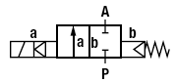 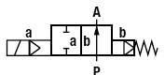

### (b)

**Figure 1: (a) Normally closed solenoid valve (b) Normally open solenoid valve**

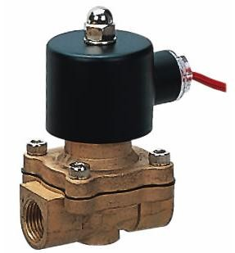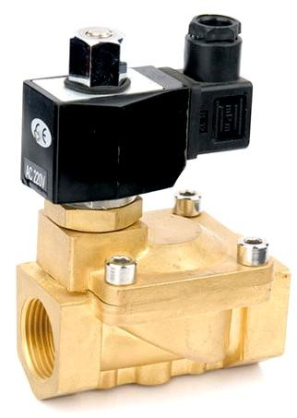

**Figure 2: Solenoid valves**

### SPECIFICATIONS

* **Technical Specification for 2 ports 2 positions’ solenoid valve-direct action:**
  + Working Fluid: Air, water, Steam, Oil (below 20cst).
  + Action Method: Direct action.
  + Function type: Normally Closed (N/C), Normally Open (N/O).
  + Fluid Viscidity: <20 CST.
  + Pressure: Normally Closed 16 bar, Normally Open 8bar.
  + Working pressure: 0-0.7Mpa.
  + Temperature: ≤80C.
  + Rated voltage range: ±10%.
  + Mode of action: Pilot operated.
  + Body material: Brass.
  + Sealing material: PTFE,NBR,EPDM or VITON
  + Protection class: IP54.

### 2 Way Solenoid Valve Orifices:

− 025:2.5mm 040:4.0mm 160:16mm 200:20mm

− 250:25mm 350:35mm 400:40mm 500:50mm

* [Solenoid](http://www.pneumaticpart.com/solenoid-valve.html) **[Valve](http://www.pneumaticpart.com/solenoid-valve.html) Port Size:**

− model 06:18/‖

− model 08:1/4‖

− model 10:3/8‖

− model 15:1/2"

− model 20:3/4"

− model 35:11/4‖

− model 40:11/2‖

* + model 50:2"

### Voltage:

* + DC24V AC110V 50Hz/60Hz
  + DC12V AC24V 50Hz/60Hz;

− AC220V 50Hz/60Hz;

− AC380V 50Hz/60Hz

### Operating Voltage:

The main advantage of the DC solenoid is its constant current consumption, which leads to smooth switching and a coil that can cope with mechanical obstructions. Voltage surges (inductive peaks) can be avoided by connecting a resistor, diode or RC-network in parallel. Voltage tolerances permitted are10

%. If AC solenoids designed for 50 Hz have to be used with 60 Hz, this entails a reduction in performance. DC coils supplied via rectifiers can be operated between 40 and 60 Hz.

**Table 1: Solenoid Valves without Differential Pressure**

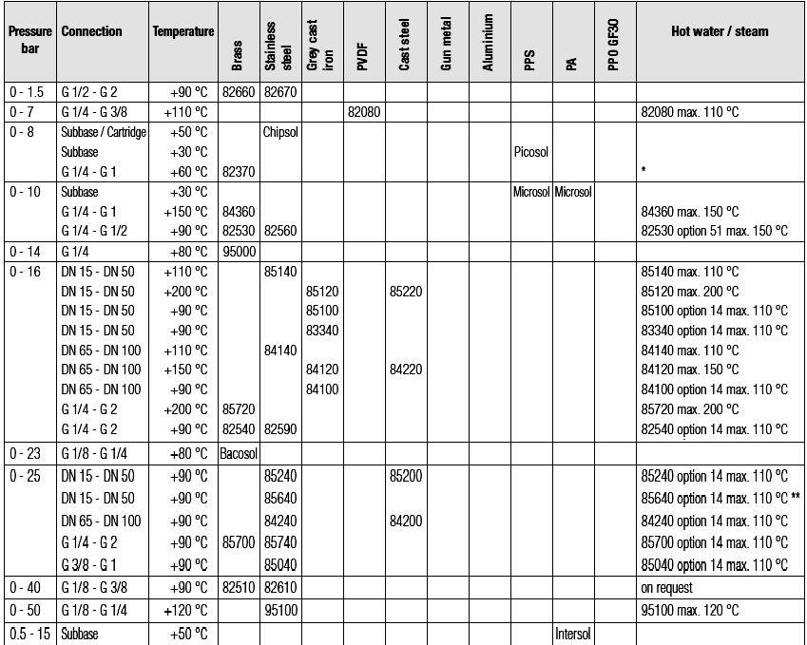

**Table 1: Solenoid Valves with Differential Pressure**

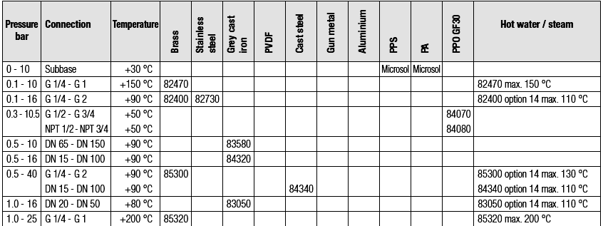

### PRINCIPLE OF OPERATION

A solenoid is an electromechanical device which allows for an electrical device to control the flow of a gas or liquid. The electrical device causes a current to flow through a coil located on the solenoid valve. This current flow in turn results in a magnetic field which causes the displacement of a metal actuator.

The actuator is mechanically linked to a mechanical valve inside the solenoid valve. The valve then changes state, either opening or closing to allow a liquid or gas to either flow through or be blocked by the solenoid valve. A spring is used to return the actuator and valve back to their resting state when the current flow is removed.

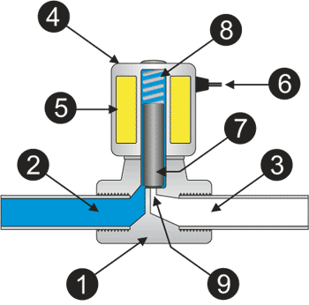

**Figure 3: Internal parts of Solenoid valve**

* 1. Valve Body 4. Coil/Solenoid 7. Plunger

|  |  |  |
| --- | --- | --- |
| 2. Inlet Port | 5. Coil Windings | 8. Spring |
| 3. Outlet Port | 6. Lead Wires | 9. Orifice |

The media controlled by the solenoid valve enters the valve through the inlet port (Part 2 in the illustration above). The media must flow through the orifice (9) before continuing into the outlet port (3). The orifice is closed and opened by the plunger (7).

The valve pictured above is a normally-closed solenoid valves. Normally-closed valves use a spring (8) which presses the plunger tip against the opening of the orifice. The sealing material at the tip of the plunger keeps the media from entering the orifice, until the plunger is lifted up by an electromagnetic field created by the coil.

Most solenoid valves operate on a digital principle. They therefore possess two distinct states. (1) When the coil is activated by an electrical current, and (2) when the valve is resting (without electricity). Valve functions are defined from the resting position. The direct acting or pilot operated solenoid valves may have two functions, normally closed and normally open.

**Normally closed (NC):** A solenoid valve is normally closed (abbreviated as NC) if there is no flow across the valve in its resting position.

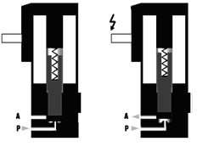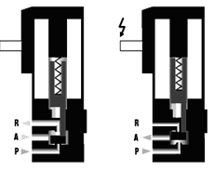

**(a) (b)**

**Figure 4: (a)Example of 2/2-way normally closed Solenoid valve (b)Example of 3/2-way normally closed Solenoid valve**

Please note that in the case of 3-way solenoid valves, port A is open to port R which, for example, enables the valve‘s single-action cylinder to be exhausted to atmosphere.

**Normally open (NO):** A solenoid valve is said to be ―normally open‖ (abbreviated NO) when it enables fluid to pass in its resting position (with no current on the solenoid contacts).

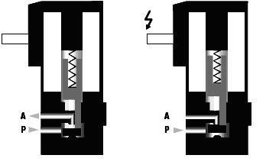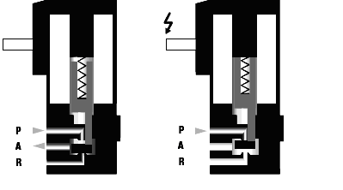

1. **(b)**

**Figure 5: (a)Example of 2/2-way normally open Solenoid valve (b)Example of 3/2-way normally open Solenoid valve**

A specific choice of entry ports can change a valve‘s function. However, since balanced- force calculations take rebound effects, coil effects and the effects of pressure exerted on the seal into account, the performance of an NC valve fitted in an NO position would be reduced. In this configuration it would be better to choose a universal solenoid valve.

### INSTALLATION

Be sure to adhere to the following when installing your solenoid valve: Arrow on valve body indicates direction of flow.

Apply wrench only on end of valve being connected; (Leverage on other valve parts can cause damage) Install in horizontal position with solenoid vertical.

Make electrical connections in compliance with electrical code.

### Caution: Be certain that electric power is of the same voltage and cycles as marked on solenoid.

**SELECTION CRITERIA**

The following factors are important in making the right commercial and technical choice: Valve actuation

* solenoid
* pressure
* proportional
* motorized Number of ways
* 2/2 Valve
* 3/2 Valve Switching function
* normally closed (NC)
* normally open (NO) Connection size
* flow rate
* kv (flow coefficient) value Type of connection
* threaded
* flanged
* weld ends Working pressure
* upstream of valve
* downstream of valve
* differential pressure
* vacuum Process fluid
* neutral to aggressive
* gas to liquid
* filtered to contaminated

Fluid temperature and ambient temperature

* range from - to + ｰC
* ambient atmosphere Solenoid power supply
* voltage
* frequency Protection classification
* IP
* EEx

Control fluid supply

* control fluid
* control pressure
* temperature of control fluid from - to + ｰC
* ambient temperature from - to + ｰC Safety requirements
* TÜV approval/test certificates
* specific certifications

### DESIGN

Solenoid valves are control units which, when electrically energized or de-energized, either shut off or allow fluid flow. The actuator takes the form of an electromagnet. When energized, a magnetic field builds up which pulls a plunger or pivoted armature against the action of a spring. When de-energized, the plunger or pivoted armature is returned to its original position by the spring action. A solenoid valve consists of the valve body, a magnetic core attached to the stem and disc, and a solenoid coil Figure. The magnetic core moves in a tube that is closed at the top and is sealed at the bottom; this design eliminates the need for packing. A small spring assists the release and initial closing of the valve.

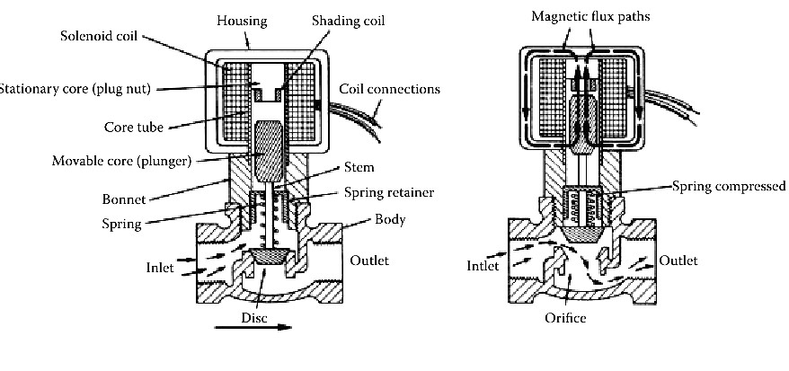

* 1. (b)

**Figure 6: (a) Direction of flow through energized**

* 1. **Direction of flow through de-energized**

### Direct acting 2-way solenoid valves

One inlet and one outlet, and are used to permit and shut off fluid flow. In the de- energized condition, the core spring, assisted by the fluid pressure, holds the valve seal on the valve seat to shut off the flow. When energized, the core and seal are pulled into the solenoid coil and the valve opens. The electro-magnetic force is greater than the combined spring force and the static and dynamic pressure forces of the medium **Direct-acting 3-way solenoid valves**

Three-way valves have three port connections and two valve seats. One valve seal always remains open and the other closed in the de-energized mode. When the coil is energized, the mode reverses. The 3-way valve shown in Fig. 2 is designed with a plunger type core. Various valve operations can be obtained according to how the fluid medium is connected to the working ports in Fig. 2. The fluid pressure builds up under the valve seat. With the coil de-energized, a conical spring holds the lower core seal tightly against the valve seat and shuts off the fluid flow. Port A is exhausted through R. When the coil is energized the core is pulled in, the valve seat at Port R is sealed off by the spring- loaded upper core seal. The fluid medium now flows from P to A. As a control valve accessory, usually a three-way (three ports) solenoid valve is required. Some designs require that pressure be always applied to one certain port and that another certain port always be used as the vent. This does not always suit the required logic, but valves can be found designed for ―universal‖ operation where there is more freedom in assigning port function.

### Internally piloted solenoid valves

With direct-acting valves, the static pressure forces increase with increasing orifice diameter which means that the magnetic forces required overcoming the pressure forces, become correspondingly larger. Internally piloted solenoid valves are therefore employed for switching higher pressures in conjunction with larger orifice sizes; in this case, the differential fluid pressure performs the main work in opening and closing the valve.

### Internally piloted 2-way valves

Internally piloted solenoid valves are fitted with either a 2- or 3-way pilot solenoid valve. A diaphragm or a piston provides the seal for the main valve seat. The operation of such a valve is indicated in Fig. 4. When the pilot valve is closed, the fluid pressure builds up on both sides of the diaphragm via a bleed orifice. As long as there is a pressure differential between the inlet and outlet ports, a shut-off force is available by virtue of the larger effective area on the top of the diaphragm. When the pilot valve is opened, the pressure is relieved from the upper side of the diaphragm. The greater effective net pressure force from below now raises the diaphragm and opens the valve. In general, internally piloted valves require a minimum pressure differential to ensure satisfactory opening and closing.

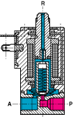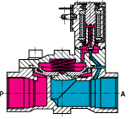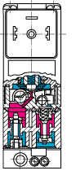

### (a) (b) (c)

**Figure7: (a) Two way solenoid valve (b) Three way solenoid valve (c) Four way solenoid valve**

### Four-Way Solenoids:

Internally piloted 4-way solenoid valves are used mainly in hydraulic and pneumatic applications to actuate double-acting cylinders. These valves have four port connections: a pressure inlet P, two cylinder port connections A and B, and one exhaust port connection R. An internally piloted 4/2-way poppet valve is shown in Fig. 6. When de- energized, the pilot valve opens at the connection from the pressure inlet to the pilot channel. Both poppets in the main valve are now pressurized and switch over. Now port connection P is connected to A, and B can exhaust via a second restrictor through R.

For on/off cylinder-operated valve actuators, four-way solenoids are often used (Figure 6.2w). They are fast, provide positive operation, and are available for a variety of AC or DC voltage services and with Class F coils for up to 310F (154 C) temperature services.

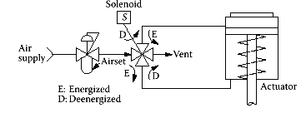

**Figure 8: ON/OFF cylinder actuator operated by four-way solenoid**

### Solenoid Capacity

Each approach must consider the flow capacity of these solenoid valves. The desired solenoid valve *Cv* must be greater than the *Cv* of the positioner to avoid a reduction in stroke speed. If they are equal, then the valve speed will be roughly half of that without the solenoid. It is typical of solenoid valves that small valves are directly operated and the larger ones are pilot operated. In pilot-operated valves, a small direct-operated valve uses air pressure to switch the larger main valve. Pilot-operated valves require a certain minimum air pressure differential in order to operate the main valve. If the solenoid valve is tripped while the air pressure is less than this pressure, the main valve will not change state and tripping the pilot will have no effect. The valve will trip later when the pressure differential becomes high enough to operate it. Where full pressure is always present this is not an issue.

### CONSTRUCTION

All materials used in the construction of the valves are carefully selected according to the varying types of applications. Body material, seal material, and solenoid material are chosen to optimize functional reliability, fluid compatibility, service life and cost.

### Body materials

Neutral fluid valve bodies are made of brass and bronze. For fluids with high temperatures, e.g., steam, corrosion-resistant steel is available. In addition, polyamide material s used for economic reasons in various plastic valves.

### Solenoid materials

All parts of the solenoid actuator which come into contact with the fluid are made of austenitic corrosion-resistant steel. In this way, resistance is guaranteed against corrosive attack by neutral or mildly aggressive media.

### Seal materials

The particular mechanical, thermal and chemical conditions in an application factors in the selection of the seal material. The standard material for neutral fluids at temperatures up to 194°F is normally FKM. For higher temperatures EPDM and PTFE are employed. The PTFE material is universally resistant to practically all fluids of technical interest.

### Pressure ratings - pressure range

All pressure figures quoted in this section represent gauge pressures. Pressure ratings are quoted in PSI. The valves function reliably within the given pressure ranges. In the case of vacuum operation, care has to be taken to ensure that the vacuum is on the outlet side while the higher pressure, i.e. atmospheric pressure, is connected to the inlet port

### Flow rate values

The flow rate through a valve is determined by the nature of the design and by the type of flow. The size of valve required for a particular application is generally established by the Cv rating. This figure is evolved for standardized units and conditions i.e. flow rate in GPM and using water at a temperature of between 40°F and 86°F at a pressure drop of 1 PSI. Cv ratings for each valve are quoted. A standardized system of flow rate values is also used for pneumatics. In this case the air flow in SCFM upstream and a pressure drop of 15 PSI at a temperature of 68°F.

### CONFORMATION TO STANDARDS

DIN 50 049 / EN 10 204 - Test Certificates

EN 10 204 - 2.1 - General confirmation based on performance of-Operating and leak tests- Pressure test- Voltage test

EN 10 204 - 3.1 - Approval test certificate

DIN 3230 Part 3 - Operating and leak tests

DIN 3230 Part 3 - Pressure test

DIN VDE 580 ｧ38 - Voltage test

EN 10 204 - 3.1.A and 3.1.B - Material quality certificate for valve body, cover, body screws and plunger tube

EN 10 204 - 2.2 - Material quality certificate for parts in contact with fluid EN 10 204 - 3.1 - Operating and leak tests

### Quality and Environmental Management

ISO TS 16949:2002 - quality standard

DIN EN ISO 9001 - quality management system DIN EN ISO 14001:2005.

### Agency Valve Classifications and Code Reference

General Purpose Valve – a Normally Open or Normally Closed valve intended to control the fluid flow, but not to be depended upon to act as a safety valve. This is a UL and CSA classification, and is not intended to indicate valve service or application.

Safety Shutoff Valve – a Normally Closed valve of the ―on‖ and ―off‖ type, intended to be actuated by a safety control or emergency device, to prevent unsafe fluid delivery. It may also be used as a General Purpose valve. A multiple port valve may be designated as a Safety Shutoff valve only with respect to its Normally Closed port. This is a UL, FM, and CSA valve classification. Safety shutoff valves are listed in UL index under Guide YIOZ or YIOZ2 for ordinary locations and YTSX or YTSX2 for hazardous locations.

Process Control Valve – an FM approved valve to control flammable gases, not to be relied upon as a Safety Shutoff valve. Refer to note under individual valve listing. Unless otherwise stated under the individual Series numbers, valves are listed as General Purpose valves

### Underwriters Laboratories, Inc.

UL429 - Electrically operated valves,‖

UL1002 - Electrically operated valves for use in hazardous locations.

UL1604 - Electrical equipment for use in Class I and II, Division 2 and Class III hazardous classified locations.

### UL provides two “Listing” categories for solenoid valves:

General Use: Valves authorized for general use are complete in their requirements; therefore, they may be installed in the field. They are identified by the UL symbol, followed by the word ―Listed‖ and the valve classification. UL Listings for ASCO

―General Use‖ valves and solenoids can be found in the ―UL Gas and Oil Equipment Directory‖ (gray book) under Electrically Operated Valves, Guide No. YIOZ or YI0Z2 (File MP-618), and in the ―UL Hazardous Location Equipment List‖ (red book) under

Electric Valves, Guide No. YTSX or YTSX2 (File E25549) or under Solenoids, Guide No. VAPT (File E12264).

Component: Valves in this category are intended for use as factory-installed components of equipment where final acceptability must be determined by UL. They are not intended for installation in the field. Component valves are termed ―UL Recognized‖ and use UL‘s special Recognized Component mark. UL Listings of ASCO Component Valves can be found in the ―UL Recognized Component Index‖ (yellow book) under Electrically Operated Valves, Guide No. YIOZ2 and YSY12 (File MP-618).

### Canadian Standards Association

Standard C22.2 No.139 - Electrically Operated Valves,‖ covers the standards governing solenoid valves.

Standard C22.2 No.213 - Electrical equipment for use in Class I, Division 2 hazardous locations.

CSA certified valves and solenoids are listed in the ―CSA Certified Electrical Equipment Book‖ under Valves, Guide No. 440-A-0 (File 10381) and Guide No. 440-A-0.8 (File13976). CSA valves require special handling, testing, and marking. They are supplied only when specified on an order.

### Factory Mutual Research Corporation

FM ―approves‖ and lists in the ―Factory Mutual Approval Guide‖ fuel oil and fuel gas safety shutoff valves, process control valves, explosion proof / dust-ignition proof, and intrinsically safe valves for hazardous locations. Valves designated for other fluids and operational characteristics, although not subject to FM approval, are usually ―accepted‖ by FM on specific equipment installations.

### European Directives – CE

The Council of the European Communities, under the treaty establishing the European Economic Community (EEC), adopted into law a series of directives to harmonize technical standards.

### APPLICATIONS

* Solenoid valves are used for the emergency shutting down of the control valve.

### PARTIAL LIST OF SUPPLIERS

* Honeywell
* Danfoss
* Siemens
* ASCO
* Sporlan
* Valcor
* Avcon
* Magnatrol
* Festo

# SAUNDERS DIAPHRAGM VALVES

### DESCRIPTION

The Saunders valve is also referred to as a diaphragm valve or less often as a weir valve. Saunders valves are of relatively low costs, tight shut-off, and suitability for corrosive, dirty, viscous, or slurry services. Their limitations include their poor control characteristics, although the use of the dual-range design improves it. They are also limited in their temperature (high and low) and pressure (high) ratings and are not suited for cavitating or flashing services.

### SYMBOL

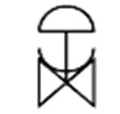

**Figure 9: Diagram of flow sheet symbol**

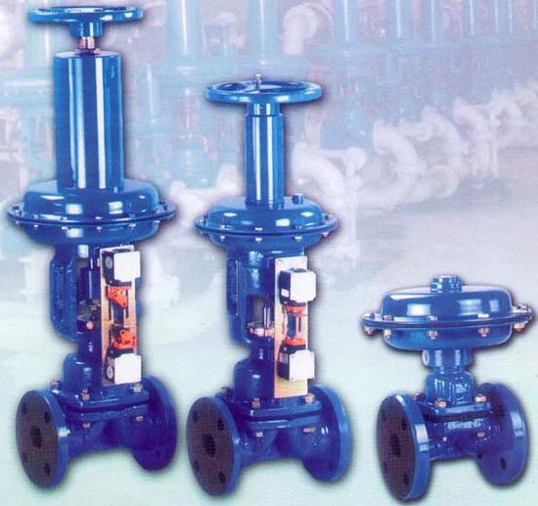

**Figure 10:**

### SPECIFICATIONS

* **Design Types:**

1. Weir, full-bore
2. Straight-through
3. Dual-range

### Sizes:

* + Standard units from 1/2 to 12 in. (12 to 300 mm)
  + special units up to 20 in. (500 mm)

### Maximum Operating Pressure:

* + In sizes up to 4 in. (100 mm), 150 PSIG (10.3 bar); 6 in. (150 mm), 125 PSIG

(8.6 bar).

– 8 in. (200 mm), 100 PSIG (6.9 bar); and 10 or 12 in. (250 or 300 mm), 65

PSIG (4.5 bar).

### Vacuum Limits:

* + Mechanical damage can occur when opening valve against process vacuum

### Temperature Limits:

* + With most elastomer diaphragms from 10 to 15°F (–12 to 65°C); with PTFE diaphragm from –30 to 350°F (–34 to 175°C).

### Materials of Construction:

* + Body materials: iron, ductile iron, steel, 302 to 316 stainless steel, Alloy 20, bronze,
  + Monel, Hastelloy C, aluminum, titanium, graphite, plastic such as PTFE lining or solid plastics
  + Diaphragm materials: Teflon, Buna-N, neoprene, hypalon

### Rangeability:

* + About 10:1

### Leakage:

* + ANSI Class IV or V

### Capacity:

– Cv = 20 d2

**Table 3: Valve coefficients of conventional Saunders valve**

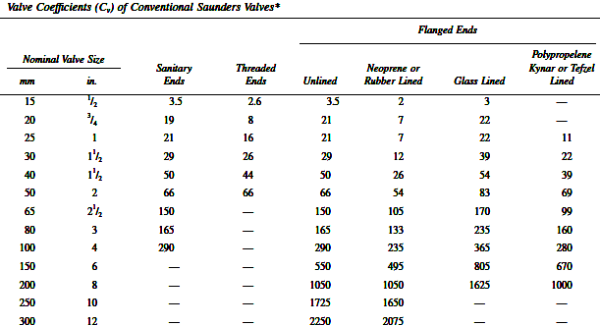

### PRINCIPLE OF OPERATION

Conventional Saunders valves utilize both the diaphragm and the weir for controlling the flow of the process fluid (Figure 4.1), while straight through and dual-range ones do not necessarily use a weir. The conventional Saunders valve is opened and closed by moving a flexible or elastic diaphragm toward or away from a weir. The elastic diaphragm is moved toward the weir by the pressure applied by a compressor element on the diaphragm. The compressor is connected to the valve stem, which is moved by the actuator. The diaphragm, which at its center is attached to the compressor, is pulled away from the weir when the compressor is lifted. For high-vacuum service it is often desirable to evacuate the bonnet of the Saunders valve in order to reduce the force that is pulling the diaphragm away from the compressor. This is especially desirable for large valves, where the vacuum might be sufficient to tear the diaphragm from the compressor.

### Figure 11: The main components of a weir-type Saunders valve

The compressor is designed to clear the finger plate, or diaphragm support plate, and to contour the diaphragm so that it matches the weir (Figure 4.1). The purpose of the finger plate is to support the diaphragm when the compressor has been withdrawn. The finger plate is utilized for valve sizes 1 in. (25 mm) and larger. For valves larger than 2 in. (50 mm), the finger plate is built as part of the bonnet. A Saunders valve can be considered as a half pinch valve. The pinch valve operates as if two diaphragms were moved toward or away from each other, whereas the Saunders valve has only one diaphragm and a fixed weir.

Figure(12) below shows the three basic positions of a conventional Saunders valve.

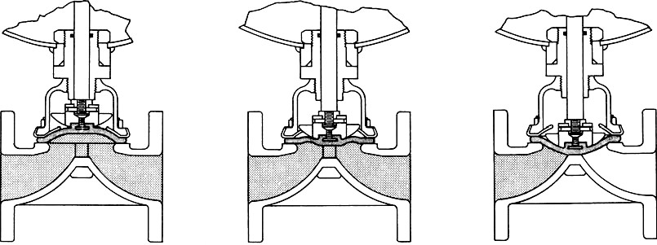

|  |  |  |
| --- | --- | --- |
| Streamline flow | Leak-tightness | Flow control |
| in open position | in throttling position | in closed position |

**Figure12: The open, throttling, and closed positions of a conventional Saunders valve**

### INSTALLATION

Saunders diaphragm valves can be installed in any orientation and are fully bi-directional. Hash marks on the tube or clamp ends indicate self drain position. Two way valves should be installed with these hash marks in the 12 o‘clock position, if the valve is to fully drain. Refer to drawings for orientation of tandem valve assemblies and block valves.

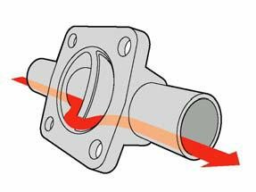

**Figure13:**

Saunders buttweld valves may be welded in line while assembled without damage to diaphragm or top works providing standard orbital welding procedures are used and heat source is localized.

### Important: System drainability is a function of many factors in addition to proper valve selection and installation and is the responsibility of the system designer and fabricator or installer

**DESIGN AND CONSTRUCTION**

The body of a conventional Saunders valve, because of its simple and smooth interior, lends itself well to lining with plastics, glass, titanium, zirconium, tantalum, and other corrosion-resistant materials (Figure 14). Valve bodies are available in iron, stainless and cast steels, alloys, and plastics. Iron bodies are lined with plastic, glass, special metals, and ceramics. The diaphragm for the conventional Saunders valve is available in a wide range of materials. These include polyethylene, Tygon, white nail rubber, gum rubber, hycar, natural rubber, neoprene, hypalon, black butyl, KEL-F, and Teflon, with various backings, including silicone. Some of these diaphragms also contain reinforcement fibers. Maintenance requirements of Saunders valves are mainly determined by the diaphragm life, which is a function of the diaphragm‘s resistance to the controlled process fluid (which may be corrosive or erosive) and also of the operating pressure and temperature

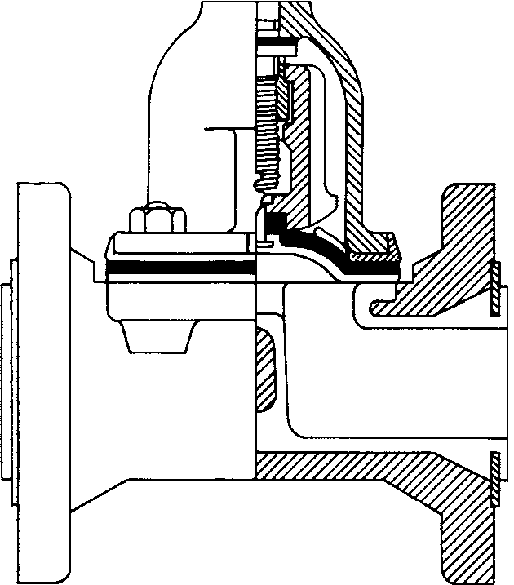

**Figure 14: Teflon-lined Saunders valve**

### Straight-Through Design

The valve seat of the straight-through diaphragm valve is not the conventional weir. Here the compressor is contoured to meet the walls of the body itself (Figure 15). The longer stem stroke of the straight-through valve necessitates a very flexible diaphragm. The increased flexure requirement tends to shorten the life of the diaphragm, but the valve‘s smooth, self-draining, straight-through flow pattern makes it applicable for hard-to- handle materials, such as slurry.

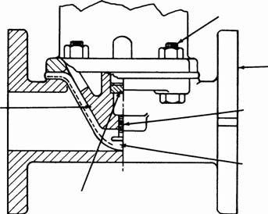

**Figure15: The design of a straight-through Saunders valve**

### Full Bore Valve

The body of a full-bore Saunders valve is modified to provide a special shape to the weir. As a result, the opening of the internal flow path is fully rounded at all points, permitting ball brush cleaning (Figure 16). This is an important feature in the food industry, where a smooth, easy-to-clean interior surface is required.

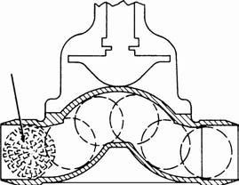

### Dual-Range Design

**Figure16: Full-bore Saunders valve**

The rangeability and flow characteristics of a conventional Saunders valve are rather poor, and so it is not suitable if high precision control is required. The flow characteristics of the dual-range design are an improvement, in comparison to the characteristics of the conventional Saunders. The dual-range valve contains two compressors, which provide independent control over two areas of the diaphragm (Figure 17). The first increments of stem travel raise only the inner compressor from the weir.

This allows flow through a contoured opening in the center of the valve. This is superior to the operation of the single-range design, where the corresponding flow is the result of a slit across the entire weir. This improvement in the shape of the value opening helps prevent clogging and the dewatering of stock and it also keeps abrasion at a minimum. In this dual-range design, while springs hold the outer compressor firmly seated, the inner compressor may be positioned independently to provide accurate control over small amounts of flow. When the inner compressor is opened to its limit, the outer compressor begins to open. From this point on, both compressors move as a unit. When wide open, this valve provides the same flow capacity as its conventional counterpart

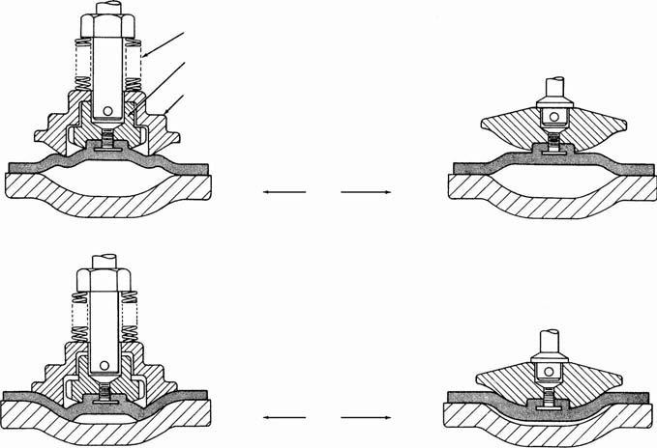

Springs

Inner compressor Outer compressor

75% open

10% open

Dual-range design

Conventional design

**Figure 17: The shape of the openings of a 10 and 75% open Saunders valves are compared in the dual-range (left) and single-range (right) designs.**

### CHARACTERISTICS

The characteristics of conventional Saunders valves are nearly quick opening, while the characteristics of dual-range Saunders valve designs are closer to linear. The flow characteristic of the straight-through design is more nearly linear than those of the conventional Saunders valves.

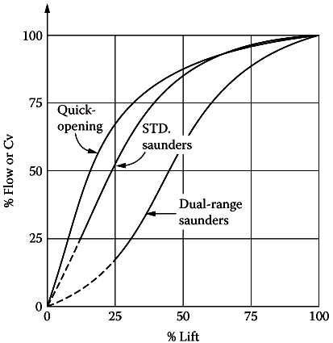

**Figure18: Characteristics curve of saunders diaphragm valve**

### CONFORMATION TO STANDARDS

* ANSIB16.5 rated 150 #,300#

### APPLICATIONS

* Slurries, corrosive fluids at low pressure drops

### PARTIAL LIST OF SUPPLIERS

* ABB Inc.
* Emerson Process Management
* Foxboro-Invensis
* ITT Industries, Engineered Valves
* McCanna/Marpac
* Nibco Inc.
* Teledyne Engineering
* Velan Valve Corp.

# BUTTERFLY VALVES

### DESCRIPTION

Butter fly valves also called a butterfly damper are used to control the flow of fluids where a disk controls flow through the port. The rotary valves such as butterfly, ball, and plug valves were once considered to be only on/off valves. Recently, the rotary valves in general and the butterfly design in particular have been used more and more as throttling control valves. Relative to the traditional globe control valve, the butterfly valves have the advantages of lower cost and weight, two to three times the flow capacity of globe valves, fire-safe designs, and low stem leakage. Some of them can also be provided with near-equal-percentage characteristics and tight shut-off.

### SYMBOL

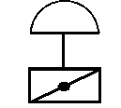

**Figure 19:**

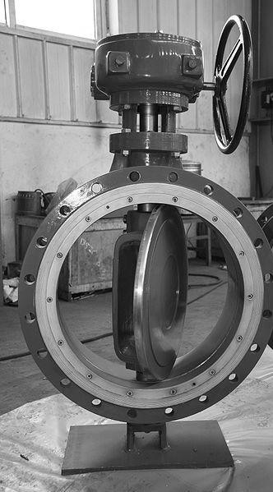

**Figure 20:**

### SPECIFICATIONS

* **Types of Designs:**

1. General-purpose, aligned shaft
2. High-performance offset (eccentric) shaft

### Sizes:

1. 2 to 48 in. (51 mm to 1.22 m) is typical, but units have been made in sizes from0.75 to 200 in. (19 mm to 5 m)
2. 4 to 16 in. (0.1 to 0.4 m) is common, but units are available from 2 to 80 in. (50 mm to 2 m)

### Design Pressures:

1. Most are available through ANSI Class 300 ratings and for up to 200 psid (1.4MPa) pressure drop. Special units have been designed for up to 6000 PSIG design pressure
2. For installation purposes most are available through ANSI 600 ratings and for up to 720 psid (5 MPa) pressure drop

### Design Temperature:

1. −450 to 1000°F (−268 to 538°C). Special refractory lined units have been made for up to 2200°F (1204°C)
2. −320 to 450°F (−196 to 232°C) for Teflon-seated valves; 1200°F (649°C) for metal- seated ones. Special units are available up to 1700°F (927°C)

### Body/Disc Materials:

1. Iron, ductile iron, carbon or alloy steels, stainless steel (302–316), aluminum bronze, Alloy 20, Monel, Hastelloy C, titanium, chrome plating, nickel plating, Kynar, Nordel, Viton, EPDM, Buna-N, neoprene elastomer lining, TFE encapsulation
2. Steel,316 stainless steel, alloy steel, Durimet 20, aluminum bronze, Alloy 20,Monel, Hastelloy C, titanium, tungsten titanium carbide (TTC) coating

### Seal Materials:

1. TFE, Kel-F, EPT, polyethylene, PTFE with titanium, Inconel, or 316 stainless steel or other metals
2. TFE, Kel-F, EPT, polyethylene, PTFE with titanium, Inconel, or 316 stainless steel or other metals

### Capacity:

A. With 60° rotation, Cv = (17 to 20) d2. Typical for throttling with 75° rotation, Cv = (25 to 30) d2; with 90° rotation, Cv = (35 to 40) d2.

B. Cv = (20 to 25) d2;

* **Rangeability:**

Generally claimed as 50:1

* **Leakage:**

1. Unlined, 2 to 5%; lined, ANSI V
2. Metal seat, ANSI IV; soft (toggle) seat, ANSI VI

### Special Features:

Reduced torque disc designs, fire-tested seals, reduced noise disc, special disc seal designs.

### PRINCIPLE OF OPERATION

Butterfly valve operation is basically simple, because it involves only rotating the vane, disc, louver, or flapper by means of the shaft to which it is fastened. This may be done manually by a lever handle on smaller valves or by a hand wheel and rotary gear box on larger sizes. Automatic operation may be accomplished by pneumatic, hydraulic, or electrical motor drives attached to the shaft by various methods.

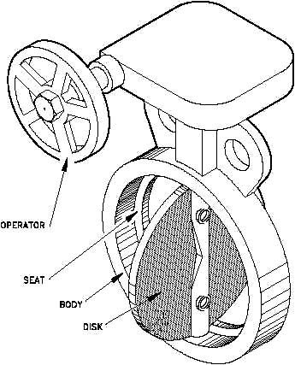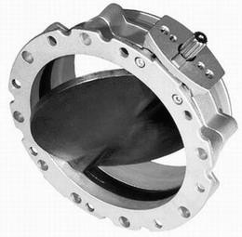

**Figure21: Typical butter fly valve**

A butterfly valve is from a family of valves called **quarter-turn valves**. It is a ―damper or throttle valve in a pipe consisting of a disc turning on a diametric axis‖ (Figure 22). As the disc moves through a 90° rotation, the valve moves from fully closed to fully open.

When the valve is fully open, the disc is rotated a quarter turn so that it allows an almost unrestricted passage of the fluid. The valve may also be opened incrementally to [throttle](http://www.answers.com/topic/throttle) flow. The area open to flow increases as the disc rotates from closed to open, and this variation is used for throttling. Unlike a ball valve, the disc is always present within the flow; therefore a [pressure](http://www.answers.com/topic/pressure) drop is always induced in the flow, regardless of valve position.

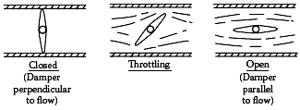

**Figure 22: The vane positions of butterfly valve when closed, throttling, or open**

### High-performance butterfly valves

The most significant design advance in butterfly valves was the development of the high- performance butterfly valve. This design concept combined the tight shut-off of the lined valves, the reduced operating torque and excellent throttling capabilities of the swing- through disc shapes, and the ability to operate with relatively high pressure drops. The compact size, reduced weight, and lower cost have made the HPBV a formidable competitor to other control valve designs in sizes 3 in. (75 mm) and larger. There are many designs available, which usually all have the characteristics of 1) a separable seat ring contained in the body and 2) an eccentric cammed disc (Figure 23). This camming action enables the disc to back out of and into the seat before and after the disc rotation when throttling. This is accomplished by having the shaft offset from both the centerlines of the disc and the valve body (Figure 24)

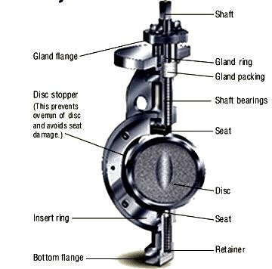

**Figure 23: Soft seated high performance valve by sure seal**

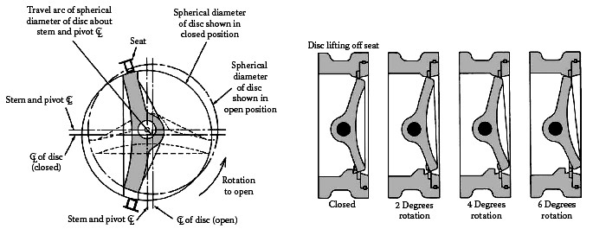

**Figure 24: The high-performance butterfly valve with eccentric shaft and cam action disc operation is shown on the left. On the right it is illustrated how the disc is lifting off the seat as the valve begins to open.**

### BUTTERFLY VALVE INSTALLATION

NIBCO butterfly valves are bi-directional and may be installed with flow in either direction. Flanged, lug and wafer style valves are designed and suitable for installation between ANSI Class 125 or 150 flanges. Cast iron flat-face, steel raised-face, both slip- on and weld-neck, and bronze or plastic flanges may be used (See Table I below).

Because of the unique seat design, NIBCO (2"-48") butterfly valves do not require the use of flange gaskets and can be used for dead end service without a downstream flange. Grooved style valves connect to metallic pipe of IPS per AWWA C606.

The valve can be installed in any horizontal or vertical position. If a choice of stem positions exists, the valve should be installed with the stem in the horizontal position; this will minimize seat wear by distributing the stem and disc weight evenly. Also, if the media is abrasive, the horizontal stem position is highly preferred.

These valves have been designed so that the disc, in the open position, will clear the inside diameter of schedule 40 and 80 steel pipe. Care should be taken when installing a butterfly valve adjacent to lined pipe, as-cast fittings, or schedule 80 plastic pipe. In some cases the disc in the opened position will interfere with the adjacent component. Butterfly valves should be installed a minimum of six (6) pipe diameters from other line components. This is not always practical but it is important to design in as much distance as possible. Interference may occur when valves are installed directly to the outlet flange of a swing check, silent check, or reducing flange. Check valve and butterfly valve combinations are very popular; normally a short spool piece is required between the valves. When using a valve with gear operator attached, it may be desirable to have the hand wheel positioned to allow easy access, or for use of an optional adjustable sprocket rim (chain wheel) for remote operation.

**Table 3: Piping/Flange /inside diameter requirements**

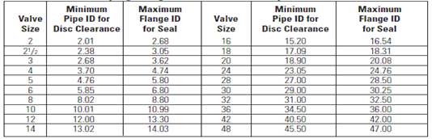

### Ref: Installation guide for NIBCO butterfly valves CONSTRUCTION

Mechanically, butterfly valves vary widely in their construction features. However, common to all are the valve body, the disc and shaft, shaft support bushings or bearings, shaft packing, and a means of attaching an operator to the shaft. Butterfly valves also fall into two basic categories, swing through and shut-off designs. Most swing-through designs (Figure 2.5) have a symmetrical disc and shaft design with a certain clearance required between disc and body. The body is usually the solid ring type, which is mounted between pipe flanges. It can be either the wafer type or the single flange lug pattern, where the flange bolting also goes through the valve body.

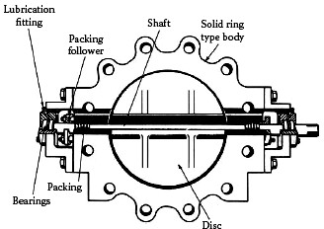

**Figure 25: The design of a swing-through butterfly valve**

Discs are cast in one piece. The thickness of the disc and hub along with the diameter of the shaft is a function of the maximum pressure drop and torque required. Careful alignment of the body, bushings, shaft, and disc eliminates binding. Hard facing materials can be applied to the disc edge and body bore where erosive fluids such as steam are involved. Refractory-type linings are also available for the body. The swing-through butterfly valve designs are available with a variety of disc shapes that serve to reduce the required torque and to increase throttling angle range (Figure 26).

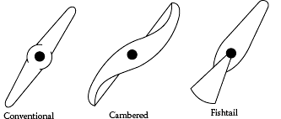

**Figure 26: Cambered and fishtail disc shapes are used to reduce the torque and to increase the throttling angle range**

### Tight Shut-off Designs

Butterfly valves designed for tight shut-off fall into two categories. One is the valve that is provided with an elastomer or plastic liner. In this configuration, the disc is also encapsulated in some cases (Figure 27).

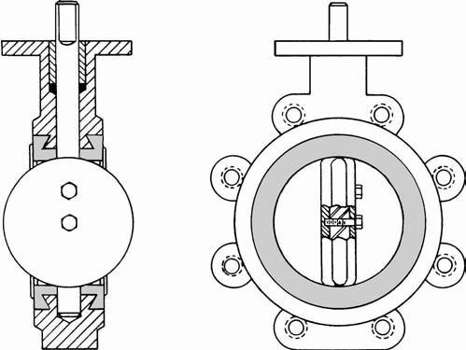

**Figure 27: Lined butterfly valve design**

The other tight shut-off design is the HPBV with the cammed disc and a separate seal ring clamped into the body (Figure 28).

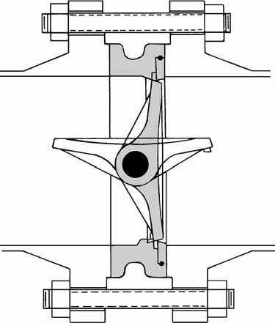

**Figure 28: High-performance butterfly valve design provided with cammed disc.**

In addition, there are some special designs with laminated seal rings located on the disc edge that wedge into a conical seat in the valve body. These laminated seal designs are especially suitable for high pressure and temperature shut-off. Sealing in these valves is usually accomplished by a wedging action of the disc edge into the elastomeric or plastic seat. The discs may be symmetrical on the shaft (similar to swing-through), offset from the shaft, or canted on the shaft. The objective of the latter two designs is to give a 360° seal contact on the disc edge.

### Characteristics

Characteristic curve, which is a plot of the free area vs. percentage vane rotation, is shown in (Figure 29) are somewhere between linear and quick-opening for a general- purpose butterfly valve and for some high performance designs.

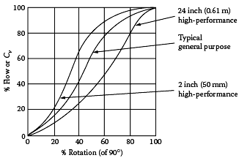

**Figure 29: Characteristic curve for general purpose and high performance butter fly valves**

The flow characteristics of butterfly valves are affected by the location of the shaft (aligned or eccentric) and by the relative size of the shaft compared to the valve. The characteristics of high-performance designs are also slightly affected if the shaft is moved from the upstream to the downstream side of the disc. For throttling purposes the rotation of the valve is usually limited to move between the 0° and 60° positions.

### CONFORMATION TO STANDARDS

* SAA - Standards Association of Australia.
* ANSI - American National Standards Institute.
* API - American Petroleum Institute.
* ASME - American Society of Mechanical Engineers.
* ASTM - American Society for Testing and Materials.
* MSS - Manufacturers Standardization Society of the Valve & Fittings Industry.
* NACE - National Association of Corrosion Engineers.
* PNGS - Papua New Guinea Standards.

### APPLICATIONS

* Butterfly valves are not only used in industry, but variations are found in consumer products such as furnace dampers, automobile carburetors, and shower heads.
* The valve was particularly applicable to the low-pressure on/off service usually encountered in waterworks applications.
* Today‘s modern butterfly valve designs are suitable for a wider variety of fluid applications, including those with higher pressure drops, tight shut-off and corrosive characteristics.

### PARTIAL LIST OF SUPPLIERS

* ABB Kent Inc.
* AMRI, Inc
* Bray Controls
* Cashco Inc.
* Circle Seal Controls
* DeZurik/SPX Valves & Controls
* Fisher Controls International Inc.
* Flowserve, Flow Control Div.—Valtek
* FMC Blending & Transfer
* Foxboro-Invensys
* George Fischer Inc.
* Halliburton Energy Services
* Honeywell Industry Solutions
* ITT Industries, Engineered Valves
* Keystone International
* Love Controls Corp.
* MKS Instruments Inc.

# BALL VALVES

### DESCRIPTION

The rotary ball, butterfly, and plug valves, which in the past were considered only as on/off shut-off valves, are extensively used today as control valves. Today, globe valves are still widely used, but their dominance is being challenged by the less expensive rotary (ball, butterfly, and plug) valves, which are usually actuated by cylinder operators.

Relative to the traditional globe valves,their advantages include their lower cost and weight and higher flow capacity (two to three times that of the globe valve). Other features, such as tight shutoff, fire-safe designs, and low stem leakage, make it easier to meet governmental regulatory requirements from OSHA and EPA in the United States and the Pressure Equipment Directive (PED) in the EEC. Some ball valve designs, such as the characterized ball valve, also provide a near equal-percentage characteristic.

### SYMBOLS

    

*Standard ball valve Three-way ball valve Full-ported ball valve Characterized Cage*

**Figure 30:**

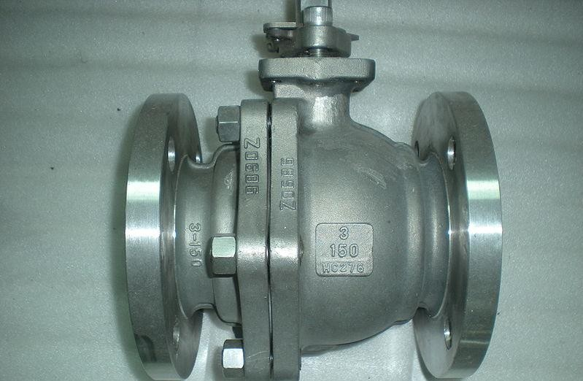

**Figure 31:**

### SPECIFICATIONS

* **Types of Ball Valves** : A. Conventional

: B. Characterized

: C. Cage

### Size and Design Pressure:

1. 1/2 to 42 in. (12 to 1180 mm) in ANSI Class 150; to 12 in. (300 mm) in ANSI Class 2500
2. Segmented ball—1 to 24 in. (25 to 600 mm) in ANSI Class 150; to 16 in. (400mm) in ANSI Class 300; to 12 in. (300 mm) in ANSI Class 600
3. 1/4 to 14 in. (6 to 350 mm) up to ANSI Class 2500

### Design Temperature:

1. Varies with size and material, typically from −250 to 600°F (−155 to 315°C), with special designs available from −300 to 1800°F (−185 to 1020°C)
2. From −50 to 300°F (−45 to 150°C); special units available from cryogenic to 1000°F (540°C)

C. From −425°F to 1800°F (−255°C to 980°C)

### Capacity:

1. Standard ball: Cv = 30 d2 to Cv = 45 d2; segmented ball: Cv = 24 d2 to Cv =30 d2; full bore ball: Cv = 35 d2 to Cv = 100 d2
2. Standard ball: Cv = 30 d2 to Cv = 45 d2; segmented ball: Cv = 24 d2 to Cv =30 d2; full bore ball: Cv = 35 d2 to Cv = 100 d2
3. Cv = 20 d2 (noncritical flow)

### Rangeability:

Generally claimed to be about 50:1

### Materials of Construction:

1. *Body-* Cast or bar stock brass or bronze, carbon steel, stainless steel, ductile iron, aluminum, Monel, titanium, Hastelloy C, plastics, glass; also hafnium- free zirconium (for nuclear applications) and ceramic for abrasives. *Ball-* Forged naval bronze, carbon steel (also plated), stainless steel, plastics, glass, ceramics, Alloy20, Monel, Hastelloy C, aluminum, titanium. *Seats-* Teflon, Kel-F (both tetra fluoro ethylene), Delrin, buna-N, neoprene, Perbunan, Hypalon, natural rubber, graphite.
2. *Body-* ball, seal ring, and shaft are available in 316 stainless steel. Chrome and tungsten carbide plating available for ball and carbon steel for valve bodies. All ceramic valves are also available.
3. *Body-* Stainless steel, other materials available

### Special Features:

1. Full-ported, three-way, split body, two-directional.
2. Depending on contour edge of ball the flow characteristics vary slightly between suppliers. Slurry design provides for continuous purging of low- activity zone of valve to prevent build-up of solids, dewatering, or entrapment.
3. Good resistance to cavitation and vibration.

### PRINCIPLE OF OPERATION

In a ball valve, critical flow occurs when the pressure drop through the valve rises to about 15% of the inlet pressure to the valve. In operating rotary valves, the linear movement of cylinder- or spring/diaphragm-type actuators must be converted by linkages, which introduces hysteresis and dead play. In addition, a nonlinear relationship exists between actuator movement and the resulting rotation. These considerations make the use of positioners essential, which on fast processes can lower the quality of control. The torque characteristics of these valves are also highly nonlinear and because of the high ―break torque‖ requirement, the actuator is usually oversized for the operation in the throttling range. The ball valve contains a spherical plug that controls the flow of fluid through the valve body. The three basic types of ball valves manufactured are (1) the conventional or quarter-turn pierced ball type, (2) the characterized type, and (3) the cage type.

### Conventional ball valves

The quarter-turn (90°) required to fully uncover or fully cover an opening in the valve body can be imparted to the ball either manually by turning a handle, or mechanically by an automatic valve actuator. Actuators used for ball valves may be the same as those used to control other valve types. They can be pneumatic, electric (including electronic or digital), hydraulic, or a combination. The latter types include electro pneumatic, electro hydraulic, electromechanical, and pneumohydraulic actuations. The spherical plug lends itself not only to precise control of the flow through the valve body but also to tight shut- off. Thus the ball valve may assume the double role of control and block valve.

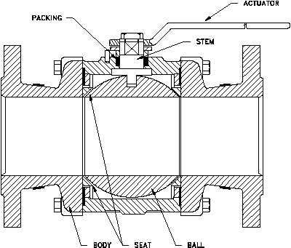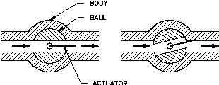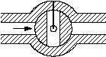

**Figure 32: Open, throttled and closed positions of the top entry pierced ball valve**

### Characterized Ball valves

A typical characterized ball valve is shown in Figure 33, in its end and side views. The main parts of a characterized ball valve are described below.

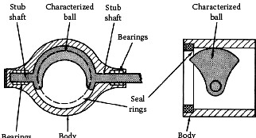

**Figure 33:** *The component parts of a characterized ball valve*

The controlling edge of the ball can be notched or contoured to produce the desired flow characteristics. The characterized ball valves can be V-notched, U-notched, parabolic, and anticavitation antinoise designs. The notched trim valves and the partial-ball trim valves were introduced partially in an effort to solve the problem of valve clogging and dewatering in paper stock applications. Since then these valves have come into more widespread use as a result of increased valve rangeability and the shearing action at the sharp edges of the valve as it closes.

In essentially all characterized ball valves, the ―ball‖ has been modified so that only a portion of it is used (Figure 34). The edge of the partial ball can be contoured or shaped to obtain the desired valve characteristics. The V-notching of the ball in Figure 6.16k serves this purpose as well as the purpose of shearing the process stream. This shape or contour of the valve‘s leading edge is the main difference between the various manufacturers‘ products. The ball is usually closed as it is rotated from top to bottom, although this action can be reversed.

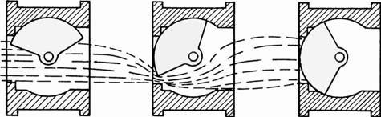

**Figure 34: The open, throttling, and closed positions of the characterized ball valve**

Early bodies were not designed for high-pressure services or for installations other than insertion between flanges. Today they are available with up to 12 in. (300 mm) flanges with up to ANSI Class 600 ratings.

The seal ring and seal-retaining ring are usually held in place by companion flanges. Damage due to over tightening of flange bolts sometimes occurs.

### Ball and cage valves

Positioning of a ball by a cage, in relation to a seat ring and discharge port, is also used for control (Figure 35). This valve design consists of a venturi-ported body, two seat rings, a ball that causes closure, a cage that positions the ball, and a stem that positions the cage. Seat rings are installed in both inlet and discharge, but only the discharge ring is active. The body can be reversed for utilization of the spare ring.

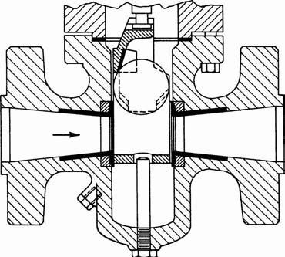

**Figure 35: The ball is positioned by a cage in this valve design.**

The cage rolls the ball out of the seat as it is lifted by the stem, positions it firmly during throttling, and lifts it out of the flow stream for full opening (Figure36). The cage is contoured for unobstructed flow in the open position. Cage design includes four inclined control surfaces. The two surfaces next to the downstream seat lift the ball out of the seat and roll it over the top edge of the seat ring as the valve is opened. As the valve opens farther, the ball rolls down the first two inclined surfaces to the center of the cage to rest on all four inclined surfaces. The Bernoulli Effect of the flowing stream holds the ball cradled in this position throughout the rest of the stroke. A non-rotating slip stem is guided by a bushing at the bottom and by a gland at the top of the bonnet. A machined bevel near the base of the stem acts as a travel limit and allows for back-seating

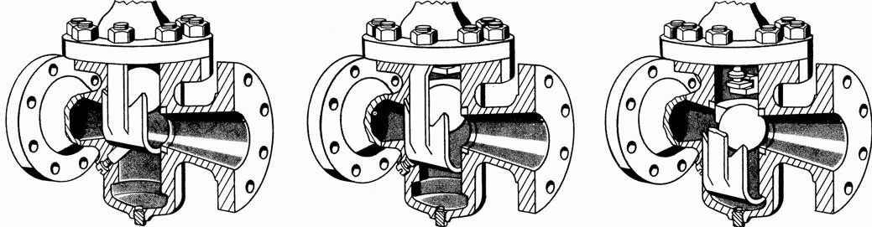

**Figure 36: The open, throttling, and closed positions of a cage-positioned ball valve**

### INSTALLATION

Install the Flanged Ball Valves with the actuator at or above the centerline of the horizontal piping, as shown in Figure 37. To minimize heat transfer in steam applications, wrap the valve and piping with insulation. Allow at least 4 in. (102 mm) of clearance from the top of the shaft to remove the actuator .When mounting the actuator in the field and before installing the actuator, use an adjustable wrench to manually rotate the valve stem several times. This rotation breaks the torque that may have built up during long- term storage.

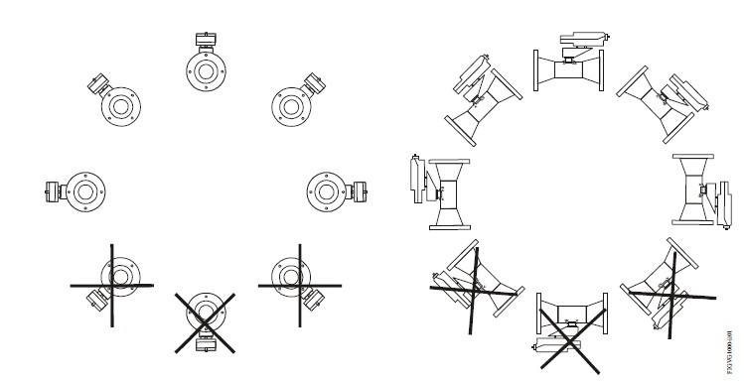

**Figure 37:**

### INSPECTION AND TESTING

Every ball valve is factory tested with nitrogen at 1000 psig (69 bar) or its maximum working pressure if less than 1000 psig (69 bar). Seats have a maximum allowable leak rate of 0.1 std cm3/min, lower than allowable in FCI 70-2 Specification Class VI. Shell testing with nitrogen at 1000 psig (69 bar) or the maximum rated pressure if less than 1000 psig (69 bar) is performed to a requirement of no detectable leakage with a liquid leak detector. Shell testing at 1.5 times the maximum working pressure is performed on CE marked 67 and 68 series valves.

### DESIGN AND CONSTRUCTION

Ball valve body can be configured as two-way, three-way, or split-body. Their tight shut- off characteristics correspond to ANSI Class IV and VI. (Figure 38) illustrates some of the available multiport configurations.

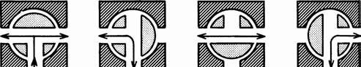

Tee ports

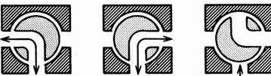

Angle ports

**Figure 38: Porting arrangements of various multiport ball valve designs**

**Valve trim and Seats**: The ball in a ball valve is cradled by seats on the inlet and the outlet side. The seats are usually made of plastic and are identical on both sides, especially in double-acting valves. Tetrafluroethylene materials are preferred for seat materials, because of their good resilience and low-friction properties (Figure 39). In some valve designs the plastic seats are backed up by metallic seats in order to ensure tightness in the event that the soft seat gets damaged by high temperature, such as in a fire. Such precautions are imperative on shipboard, for nuclear installations, and in cryogenic applications.

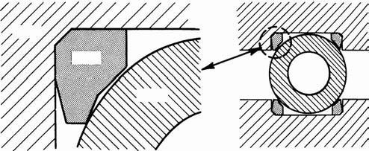

**Figure 39: The design of ball valve seats**

Other seat designs utilize the flexing of metal seals or soft PTFE seats, usually backed up by stainless steel or Inconel metal seals. Where fluids of high temperature are handled, graphite seats are recommended. They hold tight up to 1000°F (540°C). The ball valves are designed so that lubrication is unnecessary and the torque required to turn the ball is negligible. Both upstream and downstream seats of the pierced ball can sometimes be freely rotated in order to reduce wear. In some designs the seats are forcibly rotated a fraction of a turn with each quarter turn of the ball. Thus seat wear, which is concentrated at the points where the flow begins or ends on opening or closing of the valve, is distributed over the periphery of the seat. To facilitate cleaning or replacing worn seats in some designs the whole seating assembly is made in the form of a tapered cartridge. If the valve has top-entry design, the cartridge can be removed without disturbing the valve arrangement. O-rings usually close off stem and seats, and thrust washers made of tetrafluoroethylene compensate for axial stem thrust due to line pressure and reduce stem friction to a minimum. Some seats are preloaded by springs or are made tapered for wear compensation and leak-tight closure. Ball and stem are often machined from one piece.

Other designs use square ends on the stem to engage in square recesses of the ball. In this case, the ball is made floating in fixed seats, while other designs provide a fixed location of ball and stem through the application of top and bottom guiding and ball bearings.

Balls are subject to wear by friction. Where long life and dead-tight closures are of

paramount importance, the design is recommended that provides for lifting the ball off its seat before it is turned. This measure also prevents freezing or galling. Liftoff is achieved by mechanical means such as an eccentric cam. Valves of this design facilitate the handling of slurries and abrasive fluids, and they can be used for high pressures. The proper materials for body and trim depend on the application. For handling chemicals or corrosive fluids, all wetted parts will possibly require stainless steel, plastics, or glass (borosilicate glass is preferred for impact strength). Ball valves are made with the same connections as used in all other valve types. Where screwed connections must be used, valves with ends that take the place of unions are preferred.

The characteristics of the conventional ball valves are also modified by the anticavitation and antinoise designs. One such design approach is that the attenuator is placed inside the ball, so that when the valve is throttling, the fluid has to pass the attenuators, creating a number of pressure drop stages. The size, location, and distribution of perforations on the attenuator plates can be modified to obtain changes in the valve characteristics. These valves can also handle impurities in the process fluid.

Another approach to the anticavitation, antinoise designs is to add a multistep tortuous trim feature in the ball so that, because of the small openings, the fluid velocity is maintained below damaging levels. Such a design having 16 discrete stages of pressure drop is shown in Figure 40. This design provides a rangeability of up to 300:1 and operating noise levels of less than 75 dBA. The flow passages are designed to continually expand so that any solids that enter the trim will pass through and solids that are blocked will be swept through the valve at larger openings.

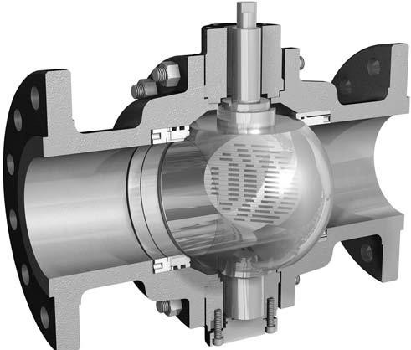

**Figure 40: Multistage low-flow control valve design with anti cavitation and anti noise capability**

### Flow Characteristics

The flow characteristics of a ball valve approximate those of an equal-percentage plug (Figure 41). These characteristic curves compare favorably with those of other rotary- stem valves. The flow characteristics are dependent upon the shape of the edge of the partial ball and on the installed flow direction. The shape of the V-notch at the edge of the valve varies from concave for small openings to convex for large openings. The flow characteristics for parabolic, U-notched, and V-notched valves are given in (Figure 41). These curves are based on water flow and are also applicable to compressible fluid flow

at less than critical (choking) velocities. If the characteristics were evaluated using compressible fluids at critical velocities, these curves would be flatter, closer to linear.

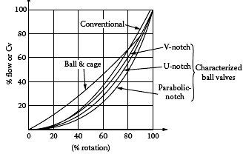

**Figure 41: characteristic curve of v-notched, u-notched and parabolic notch ball valves**

The above curve shows that the characterized ball valve with a parabolic notch is near- equal percentage, while the ball-and-cage valve characteristics are closer to linear, when used on water service. On gas service at critical velocities, the characterized ball valve‘s performance lines move closer to linear.

### COFORMATION TO STANDARDS

* SAA - Standards Association of Australia.
* ANSI - American National Standards Institute.
* API - American Petroleum Institute.
* ASME - American Society of Mechanical Engineers.
* ASTM - American Society for Testing and Materials.
* MSS - Manufacturers Standardization Society of the Valve & Fittings Industry.
* NACE - National Association of Corrosion Engineers.
* PNGS - Papua New Guinea Standards.

### APPLICATIONS

[Ball valve,](http://en.wikipedia.org/wiki/Ball_valve) are used for on/off control without pressure drop, and ideal for quick shut-off since a 45º turn offers complete shut-off angle, compared to multiple turns required on most manual valves. The following are some typical applications of ball valves:

* Air, gaseous, and liquid applications
* Drains and vents in liquid, gaseous, and other fluid services
* Steam service

### PARTIAL LIST OF SUPPLIERS

* Actuation Valve & Control Ltd.
* Armstrong International Inc.
* Assured Automation Inc. (A)
* Bardiani Valvole SpA
* Circor Int., Inc. (Circle Seal controls)
* Cole-Parmer Instrument Co.
* Combraco Industries Inc.
* Control Components Inc.
* Cooke Vacuum Products Inc.
* Cooper Cameron Valves
* Crane Valve Group (Stockham, Xomox)
* Cyclonic Valve Co. Inc.
* Dresser (Masoneilan)
* Derex Company (C)
* Emerson Process Management (Fisher)
* Eurovalve s.r.l.
* Flowdyne Controls, Inc.
* Fujikin of America
* Hartmann KG
* Hoke Inc.
* Honeywell
* Kitz Corporation of America
* Spirax Sarco Ltd.
* Wier Valves and Controls
* Zurn Industries

# PLUG VALVES

### DESCRIPTION

The rotary plug valves (similar to ball and butterfly valves) used to be considered only as on/off shutoff valves and also used as control valves. Plug valves are well suited for corrosive, viscous, dirty, fibrous, or slurry services, while they are generally not recommended for applications where cavitation or flashing is expected.

### SYMBOL

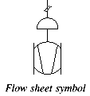

**Figure 42:**

### FIGURE

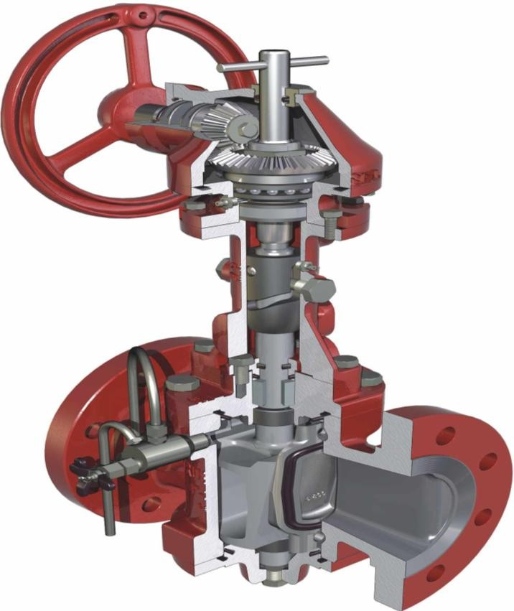

**Figure 43:**

### SPECIFICATIONS

* **Types:**

1. V-ported,
2. Three-way,
3. Four-way,
4. Five-way,
5. Fire-sealed

### Design Pressure:

* Typically from ANSI Class 125 to ANSI Class 300 ratings and up to 720 PSIG (5MPa) pressure, with special units available for ANSI Class 2500. The retractable seat design is suited for 10,000 PSIG (69 MPa) service.

### Design Temperature:

* Typically from −100 to 400°F (−73 to 204°C), with special units available from −250 to 600°F (−157 to 315°C)

### Capacity:

− Cv = (25 to 35)d2;

−

**Table 4:Valve coefficient valves of standard and characterized plug valve design**

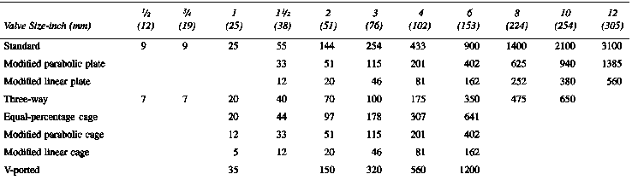

### Materials of Construction:

* Iron, forged and alloy steel, chrome plating, 302 through 316 stainless steel, Alloy20, Ni-resist, Monel, nickel, Hastelloy B and C, and zirconium, plus rubber or plastic, including PTFE linings

### PRINCIPLE OF OPERATION

A plug valve is a rotational motion valve used to stop or start fluid flow. The name is derived from the shape of the disk, which resembles a plug. A plug valve is shown in (Figure 3.1). The simplest form of a plug valve is the petcock. The body of a plug valve is machined to receive the tapered or cylindrical plug. The disk is a solid plug with a bored passage at a right angle to the longitudinal axis of the plug. In the open position, the passage in the plug lines up with the inlet and outlet ports of the valve. When the plug is turned 90° from the open position, the solid part of the plug blocks the ports and stops fluid flow.

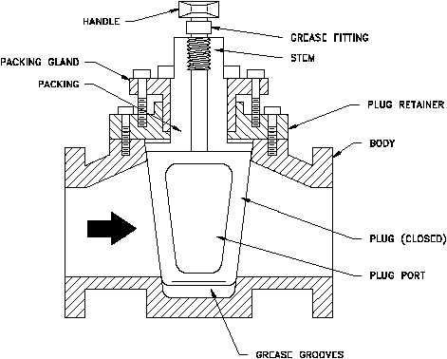

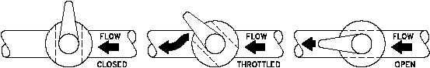

**Figure 44: Closed, throttled and open positions of a typical plug valve**

The plug valve is a type of quarter-turn valve. Plug valves afford quick opening or closing with tight, leak proof closures under conditions ranging from vacuum to pressures as high as 10,000 PSIG (69 MPa). Plug valves are normally used in non-throttling, on-off operations, particularly where frequent operation of the valve is necessary Some, including the various characterized and Y-ported or diamond design can be used for throttling, while others, like the multiport, are used for diverting and bypass applications.

**INSTALLATION OF MANUALLY OPERATED PLUG VALVE**

When installing plug valves, care should be taken to allow room for the operation of the handle, lever, or wrench. The manual operator is usually longer than the valve, and it rotates to a position parallel to the pipe from a position 90 to the pipe.

### Characteristics

Plug valve characteristics are a function of the type of the particular V-port or of the shape of the throttling plate used.

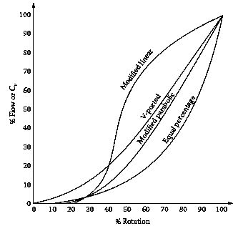

**Figure 45: Characteristics curve of plug valves**

### SELECTION CRITERIA

Refer Specifications

**DESIGN & CONSTRUCTION**

The first plug valves consisted of a tapered or straight vertical cylinder containing a horizontal opening or flow-way inserted into the cavity of the valve body (Figure 46). Within that plug, however, the ports may be round, oval, rectangular, V-, or diamond- shaped, and can be the flow-through type two-way valves or multiport. These make up the special designs described in subsequent paragraphs. Plug valve designs can be categorized as lubricated or non lubricated. In the lubricated type, the thin film of lubricant serves not only to reduce friction between the plug and the body, but also to form an incompressible seal to prevent gas or liquid leakage. Because the seating surfaces are not exposed in the open position, gritty slurries may be handled. The lubricant hydraulically lifts the plug against the resilient packing to prevent sticking. A special lubricant must be injected periodically while the valve is either fully open or fully closed.

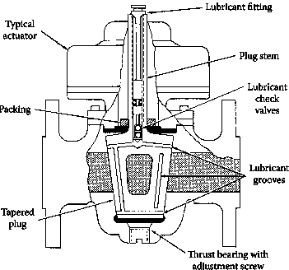

**Figure 46: Conventional, lubricated plug valve with tapered plug**

The plugs of non lubricated plug valves are treated with coatings such as Teflon or are specially heat-hardened and polished to prevent sticking. Often they are constructed so the tapered plug may be lifted mechanically from the seat for easier operation.

### Characterized Plug Valves

Plug valves can be characterized by the use of characterizing cage or plate inserts (Figure 47). The resulting characteristics are a function of the shape of the opening on the cage or plate. Some examples of available plug valve characteristics are illustrated in (Figure 48). Rotation of the plug is inside a TFE sleeve, which is locked into the body in such a way that recessed areas minimized. Although a rangeability of 20:1 is claimed, this is made possible only if the valve can be fully open in order to provide full flow. The valve is available in 1 /2–12 in. (12.5–300 mm) sizes and up to 600 PSIG ANSI (4.1 MPa) rating for use up to 400°F (204°C).

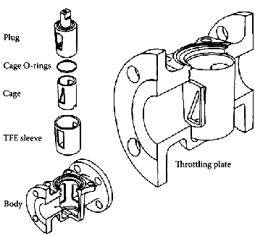

**Figure 47: Throttling plates and characterizing cages can both be used to modify the inherent characteristics of plug valves**

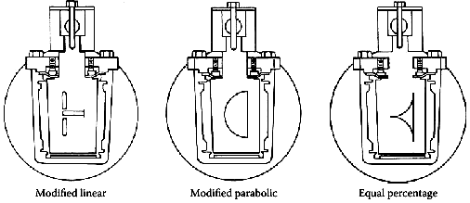

**Figure 48: Plug valve characteristics can be modified to linear, parabolic, equal-percentage, and so on.**

### Ported Design

The V-ported plug valve (Figure 49) is used for both on/off and throttling control of slurries and fluids containing solid concentrations in suspensions greater than 2%. These applications occur principally in the chemical and pulp and paper industries. A diamond- shaped opening is created by matching a V-shaped plug with a V-notched body. Straight- through flow occurs on 90° rotation, when the plug is swung out of the flow stream.

Shearing action and a pocket less body make the valve applicable for use on fibrous or viscous materials. The opening develops a modified linear flow characteristic with *Cv* capacities approximating 17d2 .Valves are flanged from 3–16 in. (75–400 mm) in bronze, corrosion-resistant bronze, or stainless steel. The body may be rubber-lined with a

rubber-coated plug. A cylinder actuator and valve positioner are used for throttling control. A variation is the true V-port opening (Figure 50). It is obtained by a rotating segment that is closing against a straight edge. The valve can be smoothly throttled on thick stock flows without the stock packing or interfering. The valve is available in sizes from 4–20 in. (100–500 mm) and with *Cv* stated as more than 20d2. The valves are available in much body and trim materials for use in the chemical or pulp and paper industries. A cylinder-operated rack and pinion is used for on/off service with the addition of a valve positioner for throttling services.

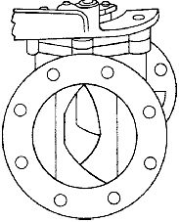

**Figure 49: The design of a V-ported plug valve**

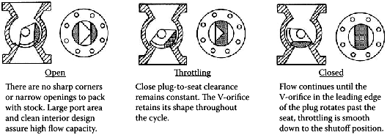

**Figure 50:Illustration of how throttling is provided by a V-ported plug valve**

### Multi port Design

As shown in (Figure 51), a three-way plug valve is obtained by providing the plug with an extra port at 90° from the inlet, so that flow can be directed in either of two destinations. A multitude of directions can be achieved by nesting combinations of the simple multiport valves or by using more complex designs. These include a multistoried arrangement with the plug extending upward to connect to a series of tiered outlets. In such multistoried configurations, the plug has a long, vertical passageway connecting the horizontal ports. Another method of increasing the number of flow-directions is to design the plug with a diameter that is sufficiently larger than the ports so that intermediate ports can be placed at 45° or even 30 and 60°. In that case, the actuators can be programmed to serve a variety of process applications.

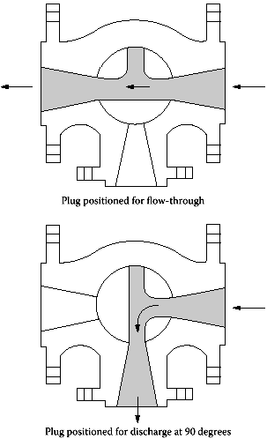

**Figure 51: The design of a three-way plug valve**

### CONFORMATION TO STANDARDS

* ASME - American Society of Mechanical Engineers.
* ASTM - American Society for Testing and Materials.
* MSS - Manufacturers Standardization Society of the Valve & Fittings Industry.
* NACE - National Association of Corrosion Engineers.
* PNGS - Papua New Guinea Standards.

•

### APPLICATIONS

Plug valves are used on gas, liquid and nonabrasive slurry services. Lubricated plug valves can also be used for abrasive slurries, and eccentric plugs are also used on applications involving sticky fluids. Plug valves are also used for applications requiring the contamination-free handling of foods and pharmaceuticals. In general, plug valves can handle applications with the following requirements:

* + High flows at low pressure drops
  + Low flow control
  + Flow diversion
  + High- or low-temperature applications
  + Vibration-free operation
  + Throttling control, only with eccentric and V-ported characterized designs

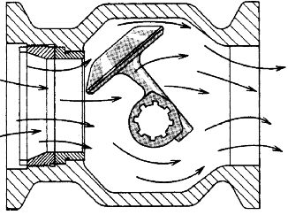

**Figure 52: The self-cleaning nature of eccentric rotating plug valve makes it a good option for slurry service applications**

The conventional plug valves are generally undesirable for the following types of applications:

* + Flow modulation or continuous, exact flow throttling
  + Maintenance-free operation (occasional lubrication is usually required and plugs may wear)

### PARTIAL LIST OF SUPPLIERS

* + ABB Inc.
  + Anchor/Darling Valve Co.
  + Cashco Inc.
  + Circle Seal Controls Inc.
  + Dezurik/ SPX Valves & Controls
  + Emerson Process Management
  + FMC Fluid Control Div.
  + Halliburton Services
  + Honeywell Industrial Controls
  + Hydril Co.
  + Jordan Valve
  + Mar-In Controls
  + Nordstrom Valves Inc.
  + Offshore Technology
  + Spirax Sarco Inc.
  + Xomox/Tufline

### SHUT DOWN VALVE

**DESCRIPTION**

Shutdown valves are used as safety shutdown valves typically for fuel gas valve trains. Available in a wide range of operating voltages with extremely low power consumption, they are suitable for use at remote locations where an adequate power supply may be a concern.

### FIGURE

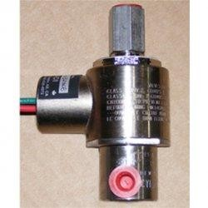

***Acl-sv-sso series safety shutdown solenoid valves 1/8" npt; 1/32"***

### SPECIFICATIONS

***Functional***

* Power supply: 12 or 24 VDC and 120 VAC
* Explosion proof: (Class 1, Div 1)
* Low temp operation: (-40°C to +65°C)
* Material of construction: Stainless steel body and internals

### PRINCIPLE OF OPERATION

Emergency shut down valves are activated when certain specified conditions are violated in the process. The BPCS (Basic Process control system) tries to maintain the process variable within limits. In emergency cases, when PV shoots beyond controllable limits, an ESD system is activated. E.g., pressure in the boiler/vessel - if it exceeds a set value, a pressure relief valve is opened. The ESD system is usually a PLC which is connected to transmitters/logic solvers that work together and tell the PLC whether the specified conditions are violated. The PLC then sends a signal to a ESD valve to activate it (close or open). The devices (transmitters , valves, etc.) installed in the ESD system are dedicated for this purpose and usually have a high value of reliability, which is specified by the PFD value (Probability of failure on demand) and usually indicated by a SIL (Safety Integrity Level).

### INSTALLATION

* Piping should be flushed clean of dirt, burrs, and welding residue that may collect in or damage the seat/orifice
* Place a strainer upstream of the valve with a porosity < 400 microns
* Mount the valve preferably on a horizontal pipeline with the coil upright
* CAUTION: 12 VDC valves are polarity sensitive - incorrect wiring may cause equipment malfunction/damage

### EMERGENCY SHUT-OFF VALVES (ESV)

Emergency shut-off valves (ESV) automatically close in the event of an emergency to prevent the loss of handled media. Emergency shut-off valves (ESV) are installed on fuel lines, steam and hot water pipes, vapor lines, and hoses carrying caustic or hazardous liquids and gases.

Emergency shut-off valves (ESV) are frequently installed on residential water and gas lines. Water shut off valve ensures that if there is a pipe leak or burst pipe somewhere in the house, the water supply to the pipe can be shut off at the source to minimize damage. Homes that are served by a well typically have an emergency shut-off valve outside to cut off the supply to the entire house. Homes heated with natural gas usually have a gas shut off valve located near the gas meter or gas service pipe coming into the house.

Appliances such as a hot water heater or oven may also have a gas valve to shut off the supply.

Emergency shut-off valves (ESV) are vital safety components of any fuel-based system or manufacturing process that uses liquid or gas media in production. Emergency shut-off valves (ESV) are used in engines to cut off the supply of fuel and shut down the engine. Diesel engines may also use an air intake emergency shut off valve since a diesel engine can continue to run for a short period of time on hydrocarbon fumes even when the fuel supply is cut off. A fuel shut off valve is also commonly used in a gas pump to shut off the flow of gas when the car‘s tank is full.

Emergency shut-off valves (ESV) used in industrial processing applications can be electromechanical or electro pneumatic and can respond quickly to a variety of processing parameters such as flow rate, temperature, and pressure. Emergency shut off valves (ESV) are typically calibrated for a particular media, such as the type of gas or liquid being used.

### CONFORMATION TO STANDARDS

* CSA 6.5-2000-C/I (ANSI Z21.21-2000)
* CGA 3.9-M94 (ANSI/UL Standard 1002)
* CSA C22.2 #30-M1986 (R1999)

### PARTIAL LIST OF SUPPLIERS

* Malema Sensors (Mfg.)
* Metso (Mfg.)
* Spectrum Associates, Inc. (Mfg.)
* A Blair Powell Company (Dist.)
* Advantage Refrigeration, LLC (Dist.)
* Automatic Engineering, Inc. (Dist.)
* AVR Valve Industries Inc. (Dist.)
* Clayton Controls (Dist.)
* Continental NH3 Products Co., Inc. (Mfg.)
* DBJ Corporation (Dist.)
* Dresser Masoneilan (Mfg.)
* Essex Manufacturing (Mfg.)
* FBIC, Inc. (Dist.)
* Festo Inc. (Mfg.)
* Flomax Products, Inc. (Dist.)
* Gas Equipment Co., Inc. (Dist.)
* Halogen Valve Systems, Inc. (Mfg.)
* HLR Controls (Mfg.)
* LUNOR, G. Kull AG (Mfg.)
* MOGAS Industries, Inc. (Mfg.)
* Montreal Valve (Dist.)
* OPW Fueling Components (Mfg.)
* Outsource Industries
* Petroleum Equipment Manufacturing Company, Inc.(Mfg.)
* Powell Fabrication & Manufacturing, Inc. (Mfg., Dist.)
* Rupture Pin Technology (Mfg.)
* Sanders Industrial Supply (Dist.)
* Sharpe Valves (Mfg.)
* Snap-tite, Inc. / Quick Disconnect & Valve Division (Mfg.)
* Specialty & Ball Valve Engineering, Inc. (SBVE) (Mfg.)
* Stream-Flo Industries Ltd. (Mfg.)
* Summit Controls Ltd. (Dist.)
* T.D. Williamson, Inc. (Mfg.)
* VOSS Automotive (Mfg.)
* Waters Equipment, Co. (Mfg.)
* William E. Williams Valve Corp. (Mfg.)
* Yokota Manufacturing Co., Ltd. (Mfg.)
* Morrison Bros. Co. (Mfg.)

# MOTOR OPERATED VALVES

### DESCRIPTION

Motor operated valves are operated by electric motors controlled by signals coming from adjacent or remote locations. Position or torque controlled limit switches are normally used to automatically stop motors when valves reach full open or closed positions.

Operators or conditions may also stop motors in mid-cycle. Motor operators are often used on large size or high pressure valves or when safety conditions, difficult accessibility, or plant automation dictates their use. Motor operated valves are hence valves operated (opened & closed) by a motor. This is done for several reasons: Repetitive operation, say a valve has to be opened and shut hundreds or thousands of times a day which would be difficult to manually operate it. On larger valves (say something like a 64" gate valve), it takes hundred of revolutions to open the valve fully. This would be tough for one person to do. Inaccessible or out of the way valves. Such as a valve out in the middle of a field for a large water line. Don't want to have to send someone out in a truck to open & close when needed, so a remote operator is attached to the valve and you can open it from a control room.

### SYMBOLS

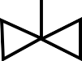

**M**

*Flow sheet symbol*

### FIGURE

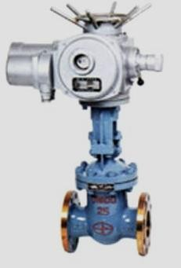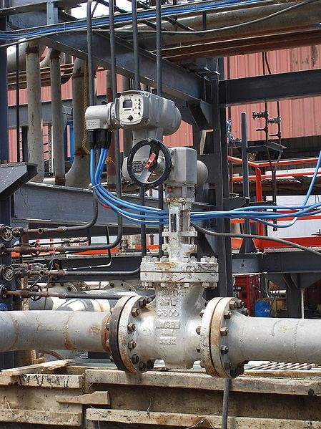

***Motor operated valve Motor operated gate valve***

### SPECIFICATIONS

***Functional***

* Service : Liquid, gas, and vapor.
* Range : 2:0–50 to 0–250 inH2O (0–12.4 to 0–62.2 kPa).

: 3:0–200 to 0–1,000 inH2O (0–49.7 to 0–248.6 kPa).

* Output : 4–20 mA dc.

: 1–5 V dc, low power.

* Power Supply : External power supply required.
* System electric supply: 415 6% volt, 3 phases, 50 Hz2.5%.

: 24 volt DC (control circuits)

***Temperature Limits***

* + Process : > –20 to 220 °F (–29 to 104 °C)
  + Ambient : > –40 to 185 °F (–40 to 85 °C)(1)
  + Storage : > –50 to 185 °F (–46 to 85 °C)

### PRINCIPLE OF OPERATION

Motor-operated valves are in general operated by having a gear mechanism to amplify the motor torque into a driving torque required to open/close the valves. It means that the ongoing operating condition and performance of a motor-operated valve can be known by measuring its driving torque

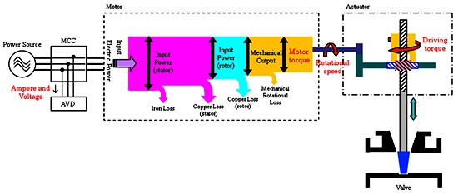

Figure shows One Type of Motor-operated Valve Actuator

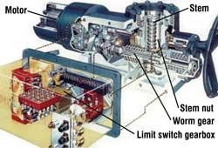

### DESIGN AND CONSTRUCTION

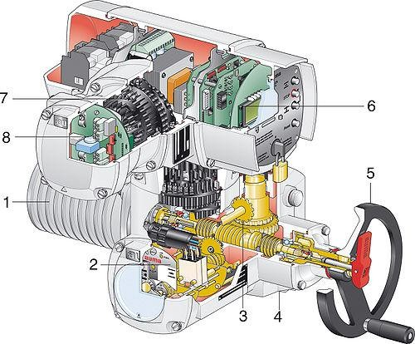

**Motor (1):** Robust asynchronous three-phase [AC motors](http://en.wikipedia.org/wiki/AC_motor) are mostly used as the driving force, for some applications also single-phase AC or DC motors are used. These motors are specially adapted for valve automation as they provide higher torques from standstill than comparable conventional motors, a necessary requirement to unseat sticky valves. The actuators are expected to operate under extreme ambient conditions, however they are generally not used for continuous operation since the motor heat buildup can be excessive.

**Limit and torque sensors (2):** The limit switching measures the travel and signals when an end position has been reached, the torque switching measures the torque present in the valve. When exceeding a set limit, this is signaled in the same way. Actuators are often equipped with a remote position transmitter which indicates the valve position as continuous current or voltage signal.

**Gearing (3):** Often a [worm gearing](http://en.wikipedia.org/wiki/Worm_drive) is used to reduce the high output speed of the electric motor. This enables a high reduction ratio within the [gear](http://en.wikipedia.org/wiki/Gear) stage, leading to a low efficiency which is desired for the actuators. The gearing is therefore self-locking i.e. it prevents accidental and undesired changes of the valve position by acting upon the valve‘s closing element. This is of major importance for multi-turn actuators which are axially loaded with the weight of the gate valve disc

**Valve attachment (4):** The valve attachment consists of two elements. First: The [flange](http://en.wikipedia.org/wiki/Flange) used to firmly connect the actuator to the counterpart on the valve side. The higher the torque to be transmitted, the larger the flange required. Second: The output drive type used to transmit the torque or the thrust from the actuator to the valve shaft. Just like there is a multitude of valves there is also a multitude of valve attachments. Dimensions and design of valve mounting flange and valve attachments are stipulated in the standards EN ISO 5210 for multi-turn actuators or EN ISO 5211 for part-turn actuators. The design of valve attachments for linear actuators is generally based on DIN 3358.

**Manual operation (5):** In their basic version most electric actuators are equipped with a hand wheel for operating the actuators during commissioning or power failure. The hand wheel does not move during motor operation.

**Actuator controls (6):** Both actuator signals and operation commands of the DCS are processed within the actuator controls. This task can be assumed by external controls, e.g. a [PLC.](http://en.wikipedia.org/wiki/Programmable_logic_controller) Modern actuators include integral controls which process signals locally without any delay. The controls also include the switchgear required to control the electric motor. This can either be reversing [contactors](http://en.wikipedia.org/wiki/Contactor) or [thyristors](http://en.wikipedia.org/wiki/Thyristor) which, being an electric component, are not subject to mechanic wear. Controls use the switchgear to switch the electric motor on or off depending on the signals or commands present. Another task of the actuator controls is to provide the DCS with feedback signals, e.g. when reaching a valve end position.

**Electrical connection (7):** The supply cables of the motor and the signal cables for transmitting the commands to the actuator and sending feedback signals on the actuator status are connected to the electrical connection. The electrical connection is ideally designed as plug/socket connector. For maintenance purposes, the wiring can easily be disconnected and reconnected.

**Field bus connection (8):** [Field bus](http://en.wikipedia.org/wiki/Fieldbus) technology is increasingly used for data transmission in process automation applications. Electric actuators can therefore be equipped with all common field bus interfaces used in process automation. Special connections are required for the connection of field bus data cables.

### There are six basic types of MOV

**Valve type T1** - used on product blending service. Can be automatically activated from blending logic or manually activated from DCS.

**Valve type T2** - used on tank inlet. Can be automatically tripped by tank level or locally activated from safe location

**Valve type T3** - used on export tank. Can be manually activated at the valve. Locally from safe location, from DCS or via another DCS from depot

**Valve type T4** - same as type T3 with out local push button stations

**Valve type T5** - used on export line where MOV interlocks are required to prevent possible hydraulic shock on valve closures. Valve normally activated at valve, from DCS or via another DCS from a depot.

**Valve type T6** - used on tank outlets. Can be activated automatically from blending, manually from DCS, manually from the valve or locally activated from safe location

### CONFORMATION TO STANDARDS

BP Engineering Standards

* + RP 30-1 - Instrumentation and control – design and practice
  + RP 32-1 - Inspection and testing of new equipment in manufacture International codes and standards
  + IEC 600334-1 – rotating electrical machines-rating and performance
  + IEC 60947-4-1- low voltage control gear-(BS 5424) specification for control gear
  + IEC 60079-electrical apparatus for explosive gas atmosphere (BS 5501)
  + IEC 60269-low voltage fuses- (BS 88)
  + IEC 60529-degrees of protection provided by enclosures (IP Code)
  + BS 5345-codes of practice for selection, installation and maintenance of electric apparatus for use in potentially explosive atmospheres
  + EN 50014-electrical apparatus for potentially explosive atmospheres-general requirement
  + EN 50018- electrical apparatus for potentially explosive atmospheres-flame proof enclosure‗d‘
  + UL 1709-rapid rise fire test of protection material for structural material
  + BS EN 10204-metallic products-types of inspection documents
  + ISO 9001-quality systems-model for quality assurance in design, development, production, installation and services

### ABBREVIATIONS

* + BP RP - British Petroleum- Recommended Practices
  + BS - British standard
  + ISO - International Standards Organization
  + NACE - National Association Of Corrosion Engineers

### APPLICATIONS

* Oil and Gas
* Chemical
* Petrochemical
* Food
* Paper
* Pharmaceutical
* Refining
* Large Valves
* Storage Tanks
* Intakes
* Filter Beds
* Outlets
* Booster Stations
* Pump Discharge

### PARTIAL LIST OF SUPPLIERS

* + [Capro Valves & Controls Pvt. Ltd.](http://www.indiamart.com/caprovalves/)
  + [Cair Euromatic Automation](http://www.indiamart.com/caireuromatic/)

# PROPORTIONAL CONTROL VALVE

### DESCRIPTION

Control valves are the most common final control element which does any of the following three functions: 1. Dispensing application (regulate flow)

* 1. Dissipating application (pressure let down)
  2. Distributing application (divide process flow)

The control valves in the process control industries are used to control conditions such as [flow,](http://en.wikipedia.org/wiki/Fluid_dynamics) [pressure,](http://en.wikipedia.org/wiki/Pressure) [temperature,](http://en.wikipedia.org/wiki/Temperature) and [liquid](http://en.wikipedia.org/wiki/Liquid) level by fully or partially opening or closing in response to signals received from controllers that compare a "set point" to a "process variable" whose value is provided by [sensors](http://en.wikipedia.org/wiki/Sensors) that monitor changes in such conditions.

Control valve manipulates a flowing fluid, such as gas, steam, water, or chemical compounds, to compensate for the load disturbance and keep the regulated process variable as close as possible to the desired set point.

### SYMBOL

**M**

FCV

TCV

LCV

PCV

*Control Valve Flow Control Valve Temp. Control Valve Level Control Valve Press. Control Valve*

### FIGURE

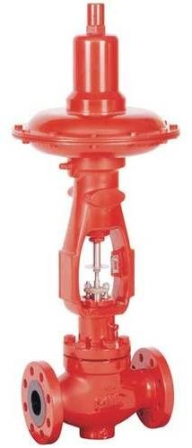 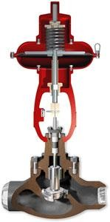

***MIL 21000 top guided single seated control valve***

### MIL21000 top guided single seated control valve description

21000 series single ported, heavy top guided control valves are designed with built-in versatility making them the most widely used control valve, well-suited to handle a wide variety of process applications.

### Standard features include:

**Top Guiding:** Rugged, heavy top guiding provides maximum support to ensure plug stability. Valve plug shank is guided within the lower portion of the bonnet and such guiding minimizes the effect of lateral thrust on the valve plug and eliminates trim vibration.

**Anticavitation / Lo-dB Trim:** Replacing conventional plug with the Lo-dB plug provides excellent noise attenuation and cavitations control.

**Hardened / Exotic Trims:** For severe service, in lieu of standard SS410 / SS 316 trims, hard faced trims, precipitation hardened stainless steel 17.4 PH, martensitic stainless steel CA6NM, 440 C etc. are used. For corrosive service, trims in Alloy 20, Monel, Hastelloy, Nickel, Urea Grade SS316LN, Ferralium-255, HVD1, APX etc. are used.

**Reduced Capacity:** Series of reduced area trim is available to provide wide flow range capabilities in all valve sizes. Reduced trim also permits larger outlet-to-orifice area relationship which result in lower exit velocities.

**Tight Shut-off:** Class IV leakage is standard. Optional constructions meet ANSI/FCI

* 1. Class V & Class VI leakage.

**Quick-Change Trim:** Optional clamped seat ring facilitates easy seat removal. The retaining cage and seat ring are held in place by the bonnet.

**Extension Bonnet:** Standard bonnet for 21000 series valves are designed for a temperature range of –27 deg C to 427 deg C. Optional constructions with extension bonnet are used upto 540 deg C and down to –100 deg C.

**Bellows Sealed Valves:** Precision engineered, formed, seamless Bellows and helicoflex gaskets ensures zero leakage for service where no stem leakage can be tolerated or where the line fluid cannot be contained by any packing. This may be the case when the process fluid is flammable, toxic, explosive, and expensive or it rapidly destroys packing. They may also be used to prevent leakage in vacuum service.

**Steam Jacketing:** Steam Jacketing can be provided for services where the process fluid has tendency to solidify. Steam jacketing designs suitable for steam pressure upto 25 Kg/cm2 are available.

**Bottom Flange:** Used for fluid streams carrying sediments, bottom flange can be removed and the valve body housing can be cleared of debris.

**Purge Connection:** ½‖ NPT or ¾‖ NPT purging connection can be provided with optional flushing for the plug or body.

**Angle Body:** Optional angle body design with venturi seat is particularly suitable for handling slurries and corrosive liquids. Their angle design provides flow surfaces that slopes down permitting the valve to self drain. Smoothly contoured surfaces minimize turbulence and prevent entrapment of particles which can cause valve clogging. These valves are also ideally suited for special applications like flashing liquids, choked flow conditions and high pressure hydrocarbon service.

### SPECIFICATIONS

***Technical specification***

* Standard Sizes & Rating: ½‖ to 2.5‖: ANSI 150# to ANSI 2500#

: 3‖ to 10‖: ANSI 150# to ANSI 600#

* Body Series : Top Guided Globe

: Top Guided Angle

* Plug Type : Undefined; Contoured

: Single Stage Anti-cavitation / Lo-dB

: Double Stage Anti-cavitation

: Double Stage Lo-dB

* Trim Characteristic : Undefined

: Linear

: Equal %

: Customized

: On-Off

* Seat Type : Undefined

: Quick Change

: Threaded

: Soft Seat

* Bonnet Type : Stud Bolted

: Extension Bonnet, Bellows sealed Bonnet (Optional)

* Gland Packing Type : With Teflon (<180° C) or Graphite (>180° C)

: Teflon ‗V‘ Rings, Eco-Lock (Low Emission) (Optional)

* Actuator Type : 37/38 Series Pneumatic Spring Diaphragm

: Actuators with optional Hand Wheels.

: Options: Electrical, Piston Cylinder

***Temperature range***

For 21000 ANSI CLASS 150# - 600#:

Standard bonnet temp range : -27°C - 427°C Extended bonnet temp range : -100°C - 540 °C Maximum seat leakage CLASS

(As per ANSI/FCI 70.2) : IV \*(STANDARD); V\*, VI\* (OPTIONAL)

For 21000 ANSI CLASS 900# - 2500#

Standard bonnet temp range : -27°C - 427°C Extended bonnet temp range : -100°C - 540 °C Maximum seat leakage CLASS

(As per ANSI/FCI 70.2) : IV (STANDARD); V, (OPTIONAL)

\*Class IV: 0.01% of maximum rated capacity at 50 psig to atmosphere

\*Class V: 5 x 10–4 ml per minute of water per inch of orifice diameter per psi differential

\*Class VI: Bubble tight as per ANSI/FCI 70.2

**PRINCIPLE OF OPERATION**

The control valve assembly typically consists of the valve body, the internal trim parts, an actuator to provide the motive power to operate the valve, and a variety of additional valve accessories, which can include positioners, transducers, supply pressure regulators, manual operators, snubbers, or limit switches.

The opening or closing of control valves is done by means of [electrical,](http://en.wikipedia.org/wiki/Electrical) [hydraulic](http://en.wikipedia.org/wiki/Hydraulic) or [pneumatic](http://en.wikipedia.org/wiki/Pneumatic) systems. Positioners are used to control the opening or closing of the actuator based on Electric, or Pneumatic Signals. These control signals, traditionally based on 3- 15psi (0.2-1.0bar), more common now are 4-20mA signals for industry, 0-10V for HVAC systems, & the introduction of "Smart" systems, HART, Field bus Foundation, & Profibus being the more common protocols.

Definition: By definition the valve coefficient Cv is the number of GPM of 60 Deg F water that will pass through the valve with a pressure drop of 1 PSI. The valve coefficients for the majority of valves are arrived at by the actual tests. In these tests the flow and pressure drop across the valve are detected while it is installed in straight, valve size pipe section. The valve coefficient is then arrived at by (for water)

### Cv = Qf/ΔP

Depending on the particular valve design involved, the same pressure differential and valve size can result in substantially differing water flow rates because of the internal flow paths involved. This is just one way of saying different valve designs have different capacities. The valve discharge coefficient, defined as

### Cd = Cv/d2

Where 'd' = valve size in inches is a useful indicator of relative capacity between the various designs .By the use of this coefficient a general equation is developed giving close approximation of control valve Cv 's.

### Cv = Cd. d2

**Sizing for Liquid service**

The Basic Equation: When a given amount of liquid is passing through a restriction such as a valve port, its flowing velocity must increase at the orifice. The energy for the increase in velocity is obtained from the static head, resulting in a localized pressure decrease. If the potential energy term is neglected due to assumed constant elevation of the flow path through the valve, then the Bernoulli‘s theorem describing the conservation of energy will contain only static, velocity and frictional head terms.

### P1 - P2 = ρ / 2g (V 2 2 - V 1 2) + ∆P P1 - P2 = ∆P

Lets us now investigate the relationship between flow and frictional drop. For this purpose a brief description of Reynolds no is essential. Re expresses the ratio of inertial forces to viscous forces.

### Re = ρVd /μ

At low values of Re, viscous forces predominate so the Pressure differential approaches the direct proportionality to flow velocity or flow rate. At High Reynolds numbers, inertial forces predominate and the pressure drop to flow relationship is a square root one.

### Terminology and nomenclature

* **Valve:** A pressure dissipating device designed to modify flow of fluids in pipes.
* **Control Valve:** A valve designed to modify flow of fluids in pipes and used for control
* **Valve body:** The portion of the valve containing the flowing fluid and the device which modifies the flow of Fluids through it.
* **Regulator:** A valve with an actuator responding to the condition of the fluids in the body.
* **Hand valve:** A valve with a manual actuator.
* **Actuator:** The portion of the valve which responds to the applied signal causes the motion resulting in modification of fluid flow.

### Terms relating to the valve body

* **Valve body Assembly:** An assembly of a body, bonnet assembly, bottom flange and trim elements. The trim includes a valve plug which opens, shuts or partially obstructs one or more ports
* **Valve body:** housing for internal valve parts having inlet and outlet flow connection
  + - **Single ported:** Means one port and one valve plug.
    - **Double ported:** Means two ports and one valve plug.
    - **Two-Way:** Means two flow connections:
    - **Three–way:** Means three flow connections, two of which may be inlets with one outlet.
    - **Bonnet assembly:** An assembly including the part through which valve plugs stem moves and a means for sealing against leakage along the stem moves and means for sealing against leakage along the stem. It usually provides a means for mounting the actuator. Sealing against leakage may be accomplished by means of packing or a bellows. A bonnets assembly may include a packing lubricator assembly with or without isolating valve. Radiating fins or an extension bonnet may be used to maintain a temperature differential between the valve body and sealing means.
    - **Bottom flange:** A part which closes a valve body opening opposite the bonnet assembly or in a three way valve may provide an additional flow connection.
    - **Seat Ring:** A separate piece inserted in a valve body to form a valve body port.
    - **Seat:** That portion of a seat ring or a valve body which a valve plug contacts for closure.
    - **Valve plug:** A moveable part which provides a variable restriction in a port.
    - **Valve plug stem:** A rod extending through the bonnet assembly to permit positioning of the valve plug.

### Terms relating to the valve actuator

* + - **Diaphragm actuator:** A fluid pressure operated spring or fluid pressure opposed diaphragm assembly for positioning the actuator stem in relation to the operating fluid pressure or pressures.
    - **Diaphragm:** A flexible pressure-responsive element which transmits force to the diaphragm plate and actuator stem.
    - **Diaphragm plate:** A plate concentric with the diaphragm for transmitting force to the actuator stem.
    - **Diaphragm case:** housing, consisting of top and bottom sections, used for supporting a diaphragm and establishing one or two pressure chambers.
    - **Actuator stems:** A rod-like extension of the diaphragm plate to permit convenient external connection.
    - **Yoke:** A structure which supports the diaphragm case assembly rigidly on the bonnet assembly.
    - **Direct actuator:** A Diaphragm actuator in which the actuator stem extends with increasing diaphragm pressure.
    - **Reverse actuator:** A diaphragm actuator in which the actuator stem retracts with increasing diaphragm pressure.
    - **Valve coefficients:** The first recommendation concerning the desirability of a capacity index for control valves were advanced during the Second World War. Today, practically all valves manufactured are provided with capacity data in Cv Units.

**By definition Cv** is the number of us gallons per min of water which will pass through a given flow restriction with a pressure drop of 1 psi

Eg: a control valve which has a cv of 12 has an effective port area in the full open position such that it passes 12gpm of water with 1psi pressure drop

### INSTALLATION

* Before installing the valve in the line, clean the piping and valve of all foreign materials such as welding chips, scale, oil, grease or dirt, gasket surface should be thoroughly cleaned to insure leak proof joints.
* To allow for in-line inspection, maintenance or removal of the valve with out service interruption provide a manually operated stop valve on each side of the valve with a manually operated throttling valve mounted in the by-pass line.
* The valve must be installed so that the controlled substance will flow through the valve in the direction indicated by the flow arrow located on the body or the words IN and OUT stamped on the end connections.
* Where insulation of the valve body is required do not insulate the valve bonnet above bonnet flange
* When a valve is larger than 4 in. (100 mm) or sometimes when it is more than one size smaller than the pipe, it is advisable to use pipe anchors to minimize force concentrations at the reducers and more frequently to relieve flange stress loading due to valve weight.
* The end connections on the valve should match the pipe specifications. If welded valves are specified, the nipples should be factory-welded and the welds should be stress-relieved.
* If lined valves are specified, their inside diameters should match that of the pipe to avoid extrusion. On flangeless valves, the bolting and the tightness of the gaskets can be a problem if the valve body is long.
* If valves are fast closing (or fail) in long liquid lines, water hammer can result in the upstream pipe or vacuum can develop in the downstream line.
* Fast-opening steam valves can thermally shock the downstream piping. Steam traps should be provided at all low points in a steam piping network. Anchors should be provided in all locations where sudden valve repositioning can cause reaction forces to develop.
* Flow-to-close single-seated valves should not be used because if operated close to the seat, hydraulic hammer can occur. If the damping effect of the actuator alone will not overcome the vertical plug oscillation, then either the actuator should be made ―stiffer‖ (higher air pressure operation) or hydraulic snubbers should be installed between the yoke and the diaphragm casing.

### INSPECTION AND TESTING

It should be noted that the goal of this test is only to determine the valve *Cv* (*Kv)* within an error of 5% and is not the standard methods of testing the capacity of valves. What is important to note is that the valve characteristics (*Gv* characteristics) are neither tested nor defined by the standard. It should also be noted that during the testing, the pressure drop through the valve itself is not measured, because the δ*P* is detected across a pipe section, which includes the valve, plus a length of eight pipe diameters of straight pipe

.The end result of such a test is a valve characteristic curve, which describes the flow through the valve as it is stroked from 0 to 100% of its stroke. The *Cv* (*Kv)* data provided by manufacturers is usually reliable within an error of about 10%, if the installation is identical to the test setup (usually it is not).

### Theoretical valve characteristics

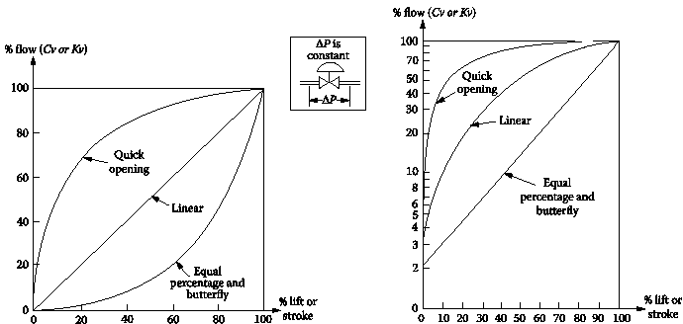

*Figure: Inherent flow characteristics of quick opening, linear and equal percentage control valves*

The inherent characteristics of a control valve describe the relationship between the controller output signal received by the valve actuator and the flow through that valve, assuming that:

1.The actuator is linear (valve travel is proportional with controller output). 2.The pressure difference across the valve is constant.

1. The process fluid is not flashing, cavitating, or approaching sonic velocity (choked flow).

In a linear valve, travel is linearly proportional to capacity and therefore the theoretical gain is constant at all loads.

In equal-percentage valves, a unit change in lift will result in a change in flow rate, which is a fixed percentage of the flow rate at that lift. For example, in Figure 6.7b, each percentage increase in lift will increase the previous flow rate by about 3%. Therefore, the theoretical gain of equal-percentage valves is directly proportional to flow rate and increases as the flow rate increases. On a logarithmic chart (left side of Figure 6.7b), the equal-percentage characteristics correspond to a straight line having a slope that corresponds to its fixed percentage.

In quick-opening valves, the gain decreases with increasing flow rates. Figure 6.7b shows the quick-opening valve characteristics with the same total lift as for the other plug types. If the travel of the quick-opening plug is restricted so that the distance of 100% lift travel corresponds to only 1/4of the seat diameter, then the valve characteristics will approach linear (if the hydraulic resistance is constant) with the gain being nearly constant.

### CALIBRATION

For any pneumatic control valve the operating pressure is from 3 psig to fully open at 15 psig. It means a pneumatic control valve opens fully at 15 psig and closes at 3 psig.

To calibrate it, prepare the following,

* One mercury manometer 0 tp 1000mm,Hg,
* One air pressure regulator for 20psig supply and air hoses,
* 3 to15 psi output Bourdon Tube pressure gauge,
* Micrometer screw pressure regulator and air pressure supply.
* Prepare a Tee with the air supply at the center.
* Connect one leg to the mercury manometer
* Other equalizer leg to the control valve
* A tee on top of the valve.
* An output gauge connected to the tee.
* Both the manometer and control valve should receive equal pressure from the pressure regulator. (A 15psig pressure is 775 mm mercury).
* Set the mercury manometer to an equivalent of 15 psig,775mmHg,
* Prepare a table of equivalent pressure from 3, 6, 9, 12 and 15psig.
* The valve should be fifty percent open at 9 psig and 25% open at 6 psig, likewise, it should close at 3 psig and 75% open at 12 psig fully opened at 15 psig.
* The pressure variation may be done with the micrometer type pressure regulator at the pressure supply.
* Note out the readings and plot a graph.

### Calibration loop diagram

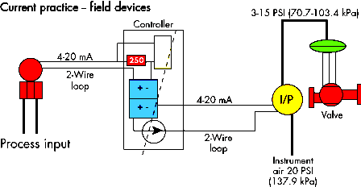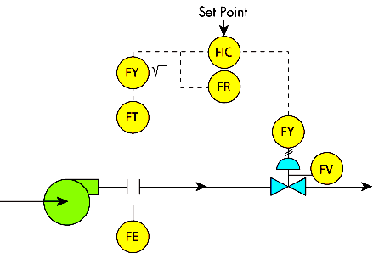

**Block diagram**

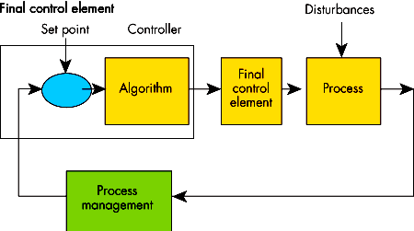

### SELECTION CRITERIA

Control Valve Selection made based on the following:

* + Decide Flow Direction and characteristics
  + Calculate Cv
  + Select Higher Cv from available
  + Select Valve size, trim size for available range
  + End Conn. and rating selection
  + Leakage class selection
  + Material Selection
  + Actuator selection
  + Packing and bonnet type selection
  + Accessories selection

This section attempts to discuss all basic aspects of control valve selection and application.

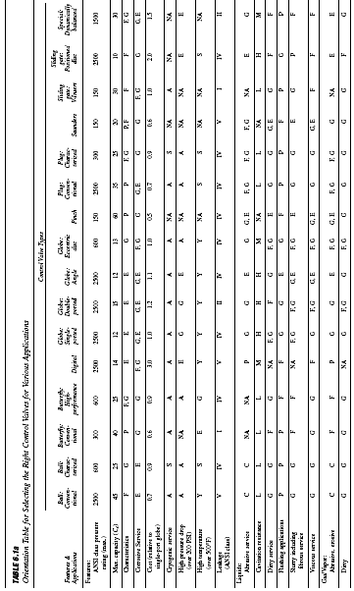

In selecting control valves, the properties of the process fluid must be fully considered. The process data should be carefully and accurately determined because even small variations in temperature or pressure can cause flashing or cavitation. Considerations include such obvious variables as pressure, temperature, viscosity, slurry, or corrosive nature, or the less obvious factors of flashing, cavitation, erosion, leakage, sterilization, and low flow rates.

Different engineers have developed different rules of thumb in selecting valve characteristics for the various types of control loops. These recommendations vary in complexity. Shinskey, for example, recommends the use of equal percentage valves for heat-transfer control and the use of linear valves for all flow, level, and pressure control applications, except vapor pressure, for which he recommends equal percentage valves. Driskell suggests that for relatively constant valve differential pressures, quick-opening valves should be used for square root-type flow loops, equal-percentage valves for temperature and liquid pressure, and linear valves for all others. If the valve differential pressure varies with load, his quick opening recommendation shifts to linear, and his linear recommendation shifts to equal-percentage

### CONSTRUCTION:

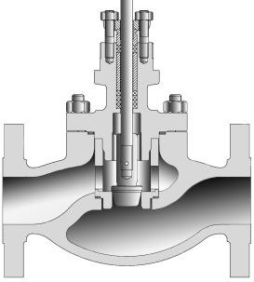

**MIL 21104 low pressure construction**

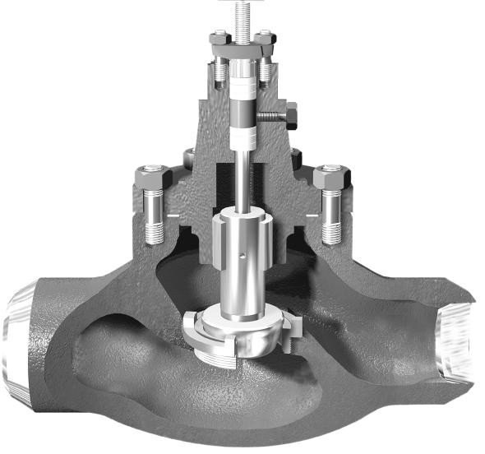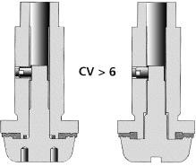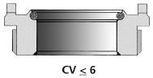

8

11

4

3

1

2

5

6

9B

22

7

10

12

14

13

15

**MIL 21000 Standard Constructions**

### MIL 21000 Soft Seated Plug & Seat Construction

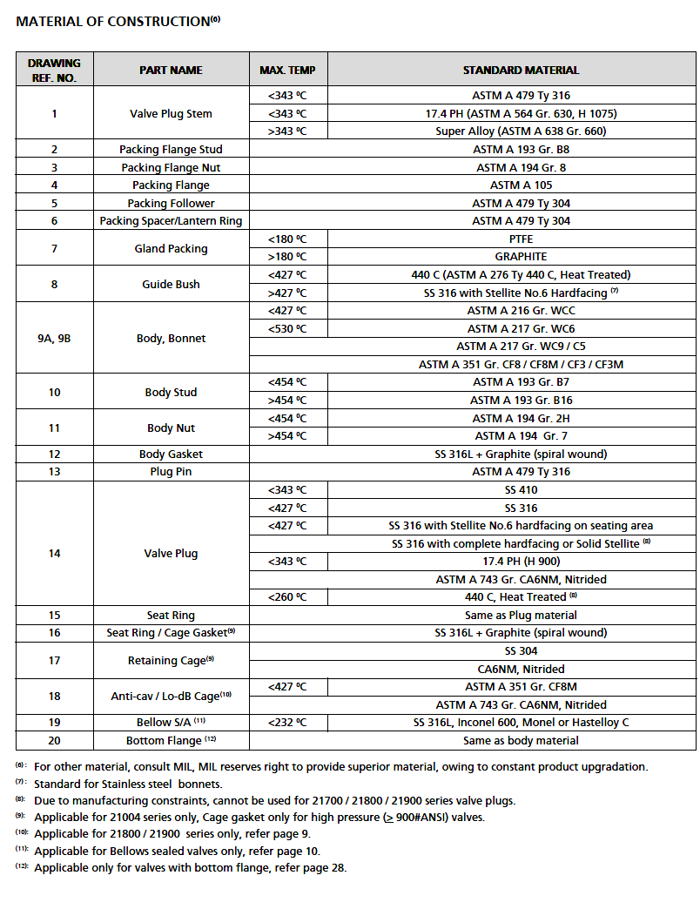

**21100 SERIES (LINEAR / EQUAL% / ON-OFF)**

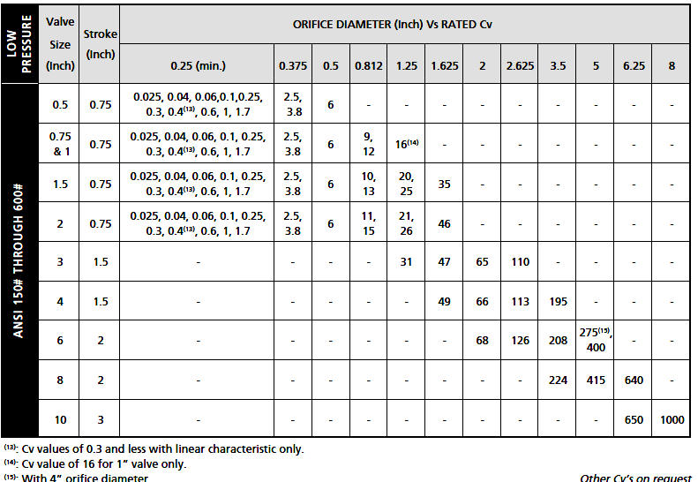

15

16

17

### CONFORMATION TO STANDARDS

* SAA - Standards Association of Australia.
* ANSI - American National Standards Institute.
* API - American Petroleum Institute.
* PNGS - Papua New Guinea Standards.
* ASME - American Society of Mechanical Engineers.
* ASTM - American Society for Testing and Materials.
* NACE - National Association of Corrosion Engineers.
* MSS - Manufacturers Standardisation Society of the Valve and Fittings Industry.

### APPLICATIONS

Control valves are manufactured for selected applications, i.e.:

Valves Model MIL 2100 and 2500 series are limited to Critical Hazardous Liquefied Gases

Valve Model 1900 limited to Hot Oils and steam.

All Control valves, due to their ―single seat‖ design are limited to applications without any cavitations.

Control valves are used in industries like

* Chemical Processing
* Petroleum Production & Refining
* Power Generation
* Test Labs etc for the following applications

Attemperator; boiler feed & discharge; chemical lines; condensate lines; crude & refined product lines; cryogenics; hydraulic lines; level control; mine dewatering; nitrogen purge; pressure control, pressure let-down; process lines; pump discharge; refrigeration; soot blower; steam lines; water lines

### PARTIAL LIST OF SUPPLIERS

* Aalborg Instruments & Controls
* Accutech
* Barksdale
* Barton instrument systems
* Bosch rexroth pneumatics
* Bristol babcock
* Brooks instrument
* Control instruments corp
* Controlair, Inc.
* Dwyer instruments
* Eckardt—invensys flow control
* Emerson process management, Rosemount div.
* Endress + hauser, Inc.
* Eurotherm controls, Inc.
* Fisher controls international, Inc.
* Flow-tek, Inc.
* Foxboro co.
* Hirschmann electronics, Inc.
* Hoffer flow controls, Inc.
* Invensys flow control
* Magnetrol intl., Inc.
* Omega engineering, Inc.
* [Precision Controls.](http://www.processregister.com/Precision_Controls/Supplier/sid155930.htm)
* [Crawley & Ray (Founders & Engineers) Pvt. Ltd](http://www.crawleyandray.com/butterfly-valves.html)
* [Oswal Industries Limited, Mumbai](http://www.oswal-valves.com/)
* [International Impex India](http://www.internationalimpexindia.com/stainless-steel-valves.html)

# ROTARY ACTUATORS

### DESCRIPTION

A rotary actuator is an [actuator](http://en.wikipedia.org/wiki/Actuator) that produces a [rotary](http://en.wikipedia.org/wiki/Rotation) motion, torque, or an oscillating action by using compressed air or fluid power to turn a shaft in a predetermined arc of motion. Durability, efficiency, and compact size are hallmarks of good actuator design. They are great for generating massive torque.The simplest actuator is purely mechanical, where linear motion in one direction gives rise to rotation. Other actuators are powered by [pneumatic](http://en.wikipedia.org/wiki/Pneumatic) or [hydraulic power,](http://en.wikipedia.org/wiki/Hydraulic_power) or may use energy stored internally through springs. The motion produced by an actuator may be either continuous rotation, as for an [electric](http://en.wikipedia.org/wiki/Electric_motor) [motor](http://en.wikipedia.org/wiki/Electric_motor), or movement to a fixed angular position as for [servos](http://en.wikipedia.org/wiki/Servo) and [stepper motors.](http://en.wikipedia.org/wiki/Stepper_motor) A further form, the [torque motor](http://en.wikipedia.org/wiki/Torque_motor), does not necessarily produce any rotation but merely generates a precise torque which then either causes rotation, or is balanced by some opposing torque

### SYMBOLS

6 6

*Hydraulic Pneumatic*

### FIGURE

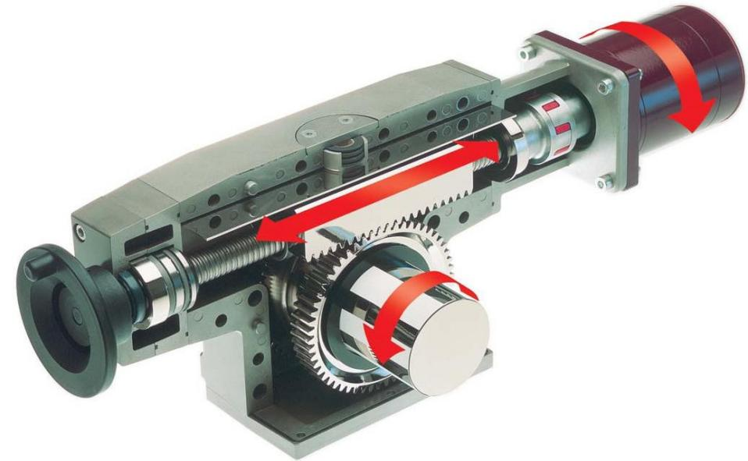

***SKF CRAB series rotary actuator***

SKF CRAB series rotary actuators are designed to provide partial rotary motion, fast or slow, heavy or light duty, complex or simple arrangements. The design of the rotary actuator enables very high torque. Since the gearing is produced in one stage, through the use of a ball screw, it enables a high degree of efficiency. Moreover, they are not sensitive to either high or low temperatures. Rotary actuators have few moving parts. At the heart of the design lies a ball screw supported in a ball bearing, a gear rack connected to the ball screw nut and a gear wheel/output shaft. When the ball screw rotates, the gear rack makes a linear movement. This causes the gear wheel and output shaft to rotate.

### SPECIFICATIONS

**Technical data of CRAB 17 series rotary actuator**

* Maximum angular working range : infinity
* Gear ratio : 1:52
* Maximum angular speed : 180/s
* Efficiency factor : 50%
* Max. Instantaneous out put torque : 200N
* Max. Axial load : 5000N
* Max. Tilting torque : 100Nm
* Back lash : 0.25
* Start current (E110C/E220C) : 2.1/0.8A
* Start torque : 0.3Nm
* Temperature range : -20C to 60C
* Weight : 3 kg

### PRINCIPLE OF OPERATION

**Rotary actuators** convert the motion and pressure of air or fluid flow to mechanical torque and rotational motion. In general the available torque is determined by the supply pressure typically 5 – 10 bar and the rotational speed by the air or fluid flow rate. Rotary actuators use a considerable volume of air typically 1 to 2 cubic meters per minute per kilowatt at an operating pressure of 5 to 6 bar.

A **pneumatic rotary actuator** mainly consists of a piston, a cylinder, and valves or ports. The piston of rotary actuator is enclosed by a diaphragm, or seal, which remain the air in the higher portion of the cylinder, permitting air pressure to force the diaphragm downward, moving the piston beneath, which in turn shifts the valve stem, which is linked to the interior parts of the rotary actuator. Pneumatic rotary actuators may only have one spot for a signal input, top or bottom, depending on action required. The superior the size of the piston of rotary actuator, the larger the output stress can be.

Having a superior piston of rotary actuator can also be good if air supply is low,

permitting the same forces with less input of rotary actuator. This pressure is transported into the valve stem, which is hooked up to moreover the valve plug in rotary actuators, butterfly valve etc. superior force is required in high pressure or high flood pipelines to allow the valve to overcome these forces, and permit it to move the valves moving parts to manage the material flowing inside the rotary actuators.

**Hydraulic rotary** actuators use a pressurized, incompressible fluid to rotate mechanical

components. They are faster and more powerful than pneumatic actuators because the high pressures used in hydraulic systems produce greater torque. Hydraulic rotary actuators use two types of rotational elements: circular shafts and tables. Typically, circular shafts include a keyway while tables include a bolt pattern for mounting other components. To convert linear motion into [shaft](http://www.globalspec.com/datasheets/1363/areaspec/output_shaft) rotation, helical spline teeth on the shaft engage matching splines on the inside diameter of a piston. As hydraulic pressure is applied, the piston is displaced axially within the housing and the splines cause the shaft to rotate. When a control valve is closed, hydraulic fluid is trapped inside the housing and the shaft is locked in place. Single-piston devices drive a rack that rotates the pinion.

Double-piston and four-piston devices drive racks on both sides of the pinion. Single- chamber and double-chamber rotary vanes that are actuated by pressurized air are also available.

### Pneumatic Rotary Actuators Types

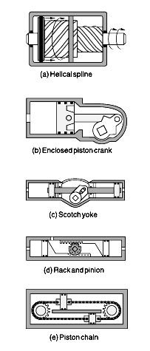

*Figure shows the various pneumatic actuators design types*

### INSTALLATION/MOUNTING

* + SKF rotary actuators are delivered ready to mount. They are compact units with few component parts in relation to their capabilities.
  + Their simple, robust construction ensures reliable performance for many years of operation. Four bolts are needed for mounting.

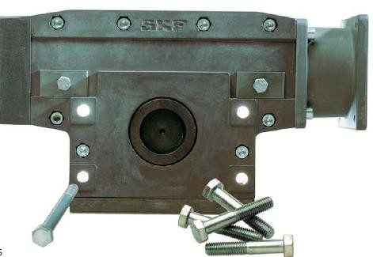

* + To avoid excessive wear and premature failure, it is essential that very little or no thrust or overhung load be imposed on the actuator's output shaft unless it is equipped with bearings (such as tapered-roller bearings) to accommodate these loads.
  + Use a flexible shaft coupling to eliminate side loading due to shaft misalignment. When side loading is unavoidable, support the output shaft with auxiliary bearings if the actuator is not equipped with adequate bearings to support such a load.
  + Actuators coupled to gear trains belong in this category. Some helical and rack- and-pinion designs are available with integral bearings that can support significant overhung loads without additional external bearings.
  + To bleed trapped air, mount the actuator so the supply ports are on top. Or provide a suitable air bleeding device for the system. Larger rotary actuators often have built-in bleed valves.
  + In continuous-cycling applications, where hot hydraulic fluid may collect near the actuator, arrange for greater fluid circulation. Heat exchangers may be required. Do not install rotary actuators where contaminants are likely to collect — for example, at the system's low point.

### INSPECTION AND TESTING

* + This section describes factors that must be considered when using Rotary Actuators in a test system.
  + The thrust and side loads that may be encountered during testing are generally the result of the following factors:
  + Specimen shortening or lengthening due to torsional force
  + Specimen shortening or lengthening due to temperature
  + Misalignment of the test specimen when initially mounted
  + Reaction base or T-slot table twisting
  + Permanent deformation of the specimen due to torsional force

### SELECTION CRITERIA

* + Type key, CRAB 17

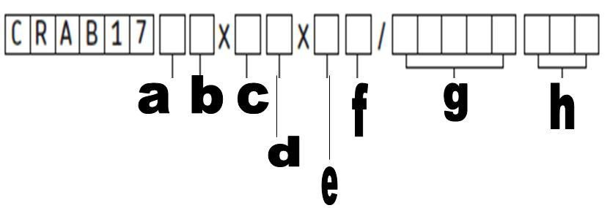

a - Gear 1, 2, 4

b - Emergency manoeuvre none-, Hand crank A, Release on shaft\* B c - Shaft design

Solid 1

Solid with key way 2 Hollow with key way 3

Hollow with adapted to limit switch unit 4 Hollow with splines 5

Customized design 6 d - Limit switches None -, Switch S e - Motor direction

Rear R Upwards U Front F Downwards D

f - Motor assembly Right R, Left L g - Motor

C12C C12C

C24C C24C

C90C C90C E110C E110C E220C E220C

h - Options for CxxC motors

Without cable - Encoder E Without cover N EMC filter M Cable 2 m T2

Cable with plug 2 m T2P Cable with plug 1 m T1P

### DESIGN AND CONSTRUCTION

**Helical spline rotary actuator**

A helical spline rotary actuator, also known as a sliding spline actuator, consists of a cylindrical housing, a shaft, and a piston sleeve. Both the inside of the piston sleeve and the shaft (where it meets the piston) are splined with matching teeth. The device is hydraulically sealed so that the application of pressure to a port will drive the piston sleeve. This pressure also causes the sleeve to rotate as it moves, thereby turning the shaft.

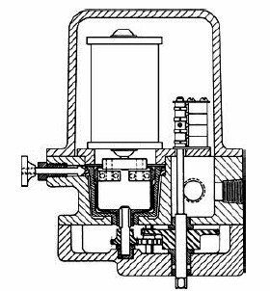

### Enclosed piston crank actuator

An enclosed piston crank actuator, Figure b, has an adjustable arc of up to about 100°.This actuator is compact and has few mechanical problems. Built-in bearing support overcomes side thrust forces. Fail-safe versions are equipped with a spring that returns the shaft to a safe position in case of power failure or loss of fluid. Torque generation follows a sinusoidal distribution. Maximum torque is produced at mid-stroke. Therefore, these actuators should be selected to drive a load based on their minimum torque.

### Scotch-yoke actuator

A scotch-yoke actuator, Figure has two pistons connected rigidly by a common rod. The central drive pin on the rod engages a double yoke keyed to the output shaft which turns through arcs to 90° maximum. Torque outputs at the beginning and end of the stroke (breaking torque) is twice that at mid-point (running torque). This characteristic is efficient because many applications require high breaking torques to move and accelerate the load. Fail-safe, single-acting, and double-acting models are available. Efficiencies range from 70% to 95%.

### Rack and pinion rotary actuator

The rack and pinion rotary actuator is perhaps one of the most familiar, as its design lends its name to certain automotive steering systems. Generally in a rack and pinion actuator, pressurized fluid propels a piston inside a hydraulic cylinder, and the piston drives a toothed rack. The teeth of the rack interlock with those of a rotating pinion, which is turned as the piston drives the rack. The pinion is typically affixed to a shaft, and thereby provides the system with rotational power as it turns.

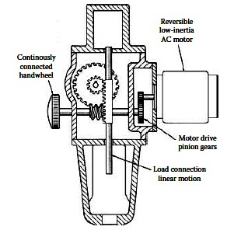

In a rack-and-pinion actuator, a long piston with one side machined into a rack engages a pinion to turn the output shaft. This gear set principle is adaptable for use in fail-safe, single-acting and double-acting models. Where balanced loading on the bearings is required, two bi-directional pistons with parallel racks are used; both racks engage the one centrally-located pinion. Rotation to 1,800° and torque to 50 million lb-in. are available. Torque is constant and equal in both directions. Multiple-position rack-and- pinion actuators are available that rotate the output shaft to several positions by varying the pressure porting. Output positions can be in any sequence, allowing the actuator to stop at or pass any intermediate position.

### Piston-chain actuator

In a piston-chain actuator, Figure e, a circular drive chain is held taut over two sprockets. One sprocket converts linear motion into torque output; an idler sprocket maintains tension. Two piston-shaped links are located at equal distances on the chain; one piston is larger than the other. The housing containing the mechanism has two parallel piston chambers and a port on each of the two opposite ends. Pressurized fluid entering a port acts against both pistons; the chain moves in the same direction as the larger piston because of the differential forces being exerted. The smaller piston seals the return side of the chain to prevent fluid leakage. Rotation is reversed by reversing porting.

### Bladder rotary actuator

A typical bladder rotary actuator uses expandable bladders to drive a specialized arm, which is attached to the rotating shaft. When significant pressure is applied to a bladder, it expands and moves the accompanying arm; the movement of the arm turns the output shaft. Vane actuators work by a similar means, but use fluid filled chambers to drive a vane attached a drive shaft.

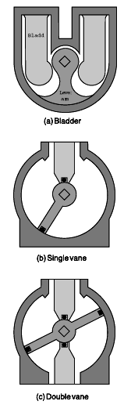

### Single-vane actuator

A single-vane actuator, Fig. has a cylindrical chamber in which a vane connected to a drive shaft rotates through an arc to 280°. Two ports are separated by a stationary barrier. Differential pressure applied across the vane rotates the drive shaft until the vane meets the barrier. Rotation is reversed by reversing pressure fluid at the inlet and outlet ports.

### Double-vane actuator

A double-vane actuator, Figure has two diametrically opposed vanes and barriers. This construction provides twice the torque in the same space as a single-vane actuator; however, rotation is generally limited to 100°.

### CONFORMATION TO STANDARDS

* + ISO 9001:2000 CERTIFIED QMS
  + ISO 521 standards
  + NAMUR standards

### APPLICATIONS

* Among the many applications for rotary actuators are positioning, switching, opening/closing, and feeding tasks
* Many applications for rotary actuators include mixing, lifting, turning, positioning containers, and operating valves to name just a few.
* Rotary actuators are utilized for the automation of industrial valves and can be utilized in all kinds of technical procedure plants such as wastewater handling plants, power plants and yet for refineries.
* Using rotary actuators, major manufacturers in high power switching, are able to design reliable motorize remote-controlled switches. This automatic switching ensures continuity of supply by by-passing a line fault in the event of failure. A high degree of automation and trouble-free production are two of the motor industry‘s most important requirements. For their assembly process, they have installed rotary actuators in order to hold the work pieces exactly in position during the assembly operation. This resulted in increased safety both for the operators and the process.
* Hydraulic rotary actuators are used in a variety of marine, mining, military, construction, and recycling applications. For example, some devices are used to provide propeller steering for outboard hydraulic propulsion systems used on marine vessels such as barges. Other devices are used in bulldozers, excavators, and other earth moving equipment for performing extensive grading and sloping with different angles. Hydraulic rotary actuators are also used in self-propelled aerial work platforms and in many vehicle steering systems.

### PARTIAL LIST OF SUPPLIERS

* + Exlar
  + Moog Flo Tork
  + Helac
  + Emerson
  + Siemens
  + ABB Group
  + ASCO-Automatic Switch Co. (Division of Emerson)
  + Bosch-Rexroth Corp.
  + Bray Controls-Bray International, Inc.
  + Danfoss
  + Detroit Coil Co.
  + Emerson Process Management
  + GE Water Technologies
  + Honeywell Automation and Control
  + Humphrey Products Co
  + Invensys-Eurotherm
  + Keystone Valve USA Inc.
  + Metso Automation Inc.



### Single-vane actuator

A single-vane actuator, Fig. has a cylindrical chamber in which a vane connected to a drive shaft rotates through an arc to 280°. Two ports are separated by a stationary barrier. Differential pressure applied across the vane rotates the drive shaft until the vane meets the barrier. Rotation is reversed by reversing pressure fluid at the inlet and outlet ports.

### Double-vane actuator

A double-vane actuator, Figure has two diametrically opposed vanes and barriers. This construction provides twice the torque in the same space as a single-vane actuator; however, rotation is generally limited to 100°.

### INSTALLATION/MOUNTING

* + SKF rotary actuators are delivered ready to mount. They are compact units with few component parts in relation to their capabilities.
  + Their simple, robust construction ensures reliable performance for many years of operation. Four bolts are needed for mounting.



* + To avoid excessive wear and premature failure, it is essential that very little or no thrust or overhung load be imposed on the actuator's output shaft unless it is equipped with bearings (such as tapered-roller bearings) to accommodate these loads.
  + Use a flexible shaft coupling to eliminate side loading due to shaft misalignment. When side loading is unavoidable, support the output shaft with auxiliary bearings if the actuator is not equipped with adequate bearings to support such a load.
  + Actuators coupled to gear trains belong in this category. Some helical and rack- and-pinion designs are available with integral bearings that can support significant overhung loads without additional external bearings.
  + To bleed trapped air, mount the actuator so the supply ports are on top. Or provide a suitable air bleeding device for the system. Larger rotary actuators often have built-in bleed valves.
  + In continuous-cycling applications, where hot hydraulic fluid may collect near the actuator, arrange for greater fluid circulation. Heat exchangers may be required. Do not install rotary actuators where contaminants are likely to collect — for example, at the system's low point.

### TESTING

* + This section describes factors that must be considered when using Rotary Actuators in a test system.
  + The thrust and side loads that may be encountered during testing are generally the result of the following factors:
  + Specimen shortening or lengthening due to torsional force
  + Specimen shortening or lengthening due to temperature
  + Misalignment of the test specimen when initially mounted
  + Reaction base or T-slot table twisting
  + Permanent deformation of the specimen due to torsional force

### SELECTION CRITERIA

* + Type key, CRAB 17



a - Gear 1, 2, 4

b - Emergency manoeuvre none-, Hand crank A, Release on shaft\* B c - Shaft design

Solid 1

Solid with key way 2 Hollow with key way 3

Hollow with adapted to limit switch unit 4 Hollow with splines 5

Customized design 6 d - Limit switches None -, Switch S e - Motor direction

Rear R Upwards U Front F Downwards D

f - Motor assembly Right R, Left L g - Motor

C12C C12C

C24C C24C

C90C C90C E110C E110C E220C E220C

h - Options for CxxC motors

Without cable - Encoder E Without cover N EMC filter M Cable 2 m T2

Cable with plug 2 m T2P Cable with plug 1 m T1P

### CONFORMATION TO STANDARDS

* + ISO 9001:2000 CERTIFIED QMS
  + ISO 521 standards
  + NAMUR standards

### APPLICATIONS

* Among the many applications for rotary actuators are positioning, switching, opening/closing, and feeding tasks
* Many applications for rotary actuators include mixing, lifting, turning, positioning containers, and operating valves to name just a few.
* Rotary actuators are utilized for the automation of industrial valves and can be utilized in all kinds of technical procedure plants such as wastewater handling plants, power plants and yet for refineries.
* Using rotary actuators, major manufacturers in high power switching, are able to design reliable motorize remote-controlled switches. This automatic switching ensures continuity of supply by by-passing a line fault in the event of failure. A high degree of automation and trouble-free production are two of the motor industry‘s most important requirements. For their assembly process, they have installed rotary actuators in order to hold the work pieces exactly in position during the assembly operation. This resulted in increased safety both for the operators and the process.
* Hydraulic rotary actuators are used in a variety of marine, mining, military, construction, and recycling applications. For example, some devices are used to provide propeller steering for outboard hydraulic propulsion systems used on marine vessels such as barges. Other devices are used in bulldozers, excavators, and other earth moving equipment for performing extensive grading and sloping with different angles. Hydraulic rotary actuators are also used in self-propelled aerial work platforms and in many vehicle steering systems.

### PARTIAL LIST OF SUPPLIERS

* + Exlar
  + Moog Flo Tork
  + Helac
  + Emerson
  + Siemens
  + ABB Group
  + ASCO-Automatic Switch Co. (Division of Emerson)
  + Bosch-Rexroth Corp.
  + Bray Controls-Bray International, Inc.
  + Danfoss
  + Detroit Coil Co.
  + Emerson Process Management
  + GE Water Technologies
  + Honeywell Automation and Control
  + Humphrey Products Co
  + Invensys-Eurotherm
  + Keystone Valve USA Inc.
  + Metso Automation Inc.
  + Micro Mo Electronics Inc
  + Norgren-Herion

# DIAPHRAGM ACTUATORS

### DESCRIPTION

An actuator is that portion of a valve which responds to the applied signal & causes the motion resulting in modification of the fluid flow. Diaphragm actuator uses a flexible diaphragm to which a variable air pressure is applied to oppose a spring. The combination of diaphragm & spring forces acts to balance the fluid forces on the valve. It produces linear motion to move the valve. These actuators are ideal for use on valves requiring linear travel, such as globe valves. A linkage or other form of linear to rotary motion conversion is required to adapt these actuators to rotary valves, such as butterfly type. The stem positioning is achieved by a balance of forces acting on the stem. These forces are due to pressure on the diaphragm, spring travel, & fluid forces on the valve plug.

Fisher 657 and 667 spring-opposed diaphragm actuators position the valve plug in the valve in response to varying controller or valve positioner pneumatic output signals applied to the actuator diaphragm. Zero setting of the actuator is determined by the compression of the actuator spring. Span is set by both the actuator spring rate and the number of springs available. The 657 actuator is direct-acting; the 667 is reverse-acting. These actuators are designed to provide dependable on-off or throttling operation of automatic control valves.

### SYMBOL

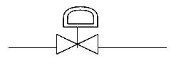

**FIGURE**

*Valve with Diaphragm actuator*

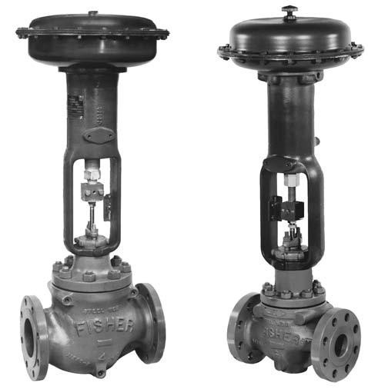

*Fisher diaphragm actuators Type 657 and type 667*

### SPECIFICATIONS

* **Standard Operating Pressure Range:**

− **657 and 667:** 0.2 to 1.0 bar (3 to 15 psig) or 0.4 to 2.0 bar (6 to 30 psig)

− **657-4 and 667-4:** 0.2 to 1.9 bar (3 to 27 psig)

* + **667 Size 76:** 0.4 to 2.0 bar (6 to 30 psig) or 0 to 3.1 bar (0 to 45 psig)

### Output Indication:

* + Stainless steel disk or pointer and graduated scale

### Stroking Speed

* + Dependent on actuator size, travel, spring rate, initial spring compression, and supply pressure. If stroking speed is critical, consult your Emerson Process Management sales office

### Operating Temperature Range(1)

* + Standard Construction (Nitrile Elastomers): -40 to 82C (-40 to 180F)
  + Optional Construction (Silicone Diaphragm): -40 to 149°C (-40 to 300°F)
  + Maximum Valve Packing Box Temperature: 427C (800F) with cast iron yoke

### Signal Connections

* + Sizes 30 - 60 and 667 Size 76: 1/4 NPT internal
  + Sizes 70 and 87: 1/2 NPT internal
  + Size 80 *657:* 3/4 NPT internal with 1/4 NPT internal bushing ; *667:* 1/2 NPT internal with 1/4 NPT internal bushing
  + Size 100: 1 NPT internal with 1/4 NPT internal bushing

### Construction Materials

* **Diaphragm Casing**
  + *Sizes 30* - *87:* Steel
  + *Size 80:* Cast iron or steel
  + *Size 100:* Cast aluminum

### Diaphragm

* + *Sizes 30* - *87:* Nitrile on nylon, Silicone on
  + polyester
  + *Size 100:* Nitrile on polyester

### Diaphragm Plate

* + *657 Sizes 30*- *60, 100:* Cast aluminum
  + *657 Sizes 70* - *87:* Cast iron or steel
  + *667 Sizes 30* - *60, 100:* Cast aluminum or steel
  + *667 Sizes 70* - *87:* Cast iron or steel

### Yoke

* + *Sizes 30* - *80:* Cast iron or steel
  + *Size 100:* Steel
* **Actuator Spring:** Steel
* **Spring Adjustor:** Steel
* **Spring Seat:** Steel or cast iron
* **Actuator Stem:** Steel
* **Travel Indicator:** Stainless steel
* **O-Rings:** Nitrile
* **Seal Bushing:** Brass
* **Stem Connector:** Zinc-plated steel

### PRINCIPLE OF OPERATION

By varying the pneumatic loading pressure on the actuator diaphragm, the valve plug within the body will open, close or throttle. When the loading pressure is increased within a direct-acting diaphragm actuator the actuator stem moves downward, compressing the spring. A decrease in pressure will cause actuator stem to move upward with the decompression of the spring (Figure). The valve plug action of the Type 657 Actuator can be set to ―push down to close‖ or ―push down to open‖ and will then either open or close the control valve upon failure of the loading pressure. When the loading pressure fails, the diaphragm of the actuator moves to the extreme upward position and performs the selected action.

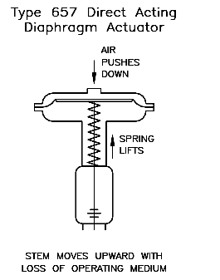

Generally, the diaphragm pressure range is 3 to 15 PSI or 6 to 30 PSI, but other ranges may be used. Pressure within the valve body creates forces on the valve plug which directly affect the actual operating diaphragm pressure range. When pressure conditions in the valve body are different from those indicated in the factory settings, the valve may not stroke completely over the indicated range. To achieve correct travel for the diaphragm pressure range utilized, a simple spring adjustment is necessary.Note; however, that the actuator spring has a fixed pressure span and that adjustment of the spring compression simply shifts this span up or down to make the travel of the valve correspond with the diaphragm pressure range. Equations can be derived from a summation of forces on the valve plug adopting the positive direction downward.

### PA – KX – PVAV=0

*Where*: *P*=Diaphragm pressure *A*=Effective diaphragm area *K*=spring rate

*Pv*= Valve pressure drop

*Av*=Effective inner valve area

By using sign convention,-PA + KX - P v Av = 0; If the flow direction is reversed, PA - KX + P v A v = 0; likewise, reversing the flow direction, -PA + KX + P v A v = 0

These equations are simplified because they do not consider friction & inertia. Friction occurs in the valve stem packing, in the actuator stem guide and in the valve plug guide or guides. Usually for static valve actuator sizing problems, negligible error is introduced by ignoring the friction terms.

### Reverse Action

All 667 actuators are reverse acting. Applying air pressure to the lower diaphragm casing forces the actuator stem upward against the opposing spring force. When this loading pressure is reduced, the spring moves the actuator stem downward. Should the loading pressure fail, the spring forces the stem to the extreme downward position. These actuators provide fail-closed action for push-down-to-close valves and fail-open action for push-down-to-open valves.

### Direct Action

All 657 actuators are direct acting. Applying air pressure to the upper diaphragm casing forces the actuator stem downward. When this pressure is reduced, the opposing spring force moves the actuator stem upward. Should the loading pressure fail, the spring forces the stem to the extreme upward position. This provides fail-open action for push-down- to-close valves and fail-closed action for push-down-to-open valves

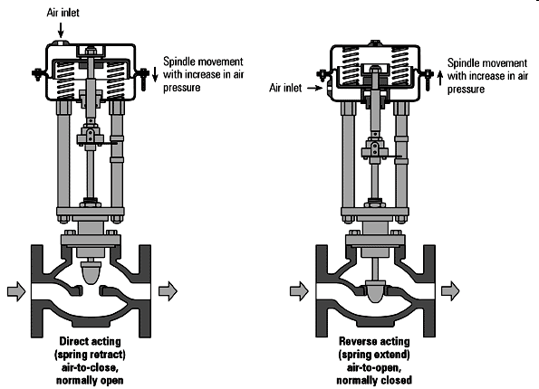

### INSTALLATION

* + The Type 657 Diaphragm Actuator is usually delivered furnished mounted on a CVS Controls valve body. When installing the valve body into the pipeline, consult the instructions for that particular valve body. The loading pressure is connected to the NPT connection in the top of the diaphragm case (1/4‖ for sizes 30 through 60, 1/2‖ size 70). With larger sizes, it may be beneficial to reduce the connection down to 1/4‖.
  + Pipe or tubing may be used, and should be run to the output pressure connection on the automatic controller. Avoid transmission lag in the control signal by keeping the length of pipe or tubing as short as possible. When long distances are involved, install a valve positioner on the actuator. If the valve positioner is provided as part of the original equipment, the loading pressure connection will be made at the manufacturing facility.
  + If the Type 657 Diaphragm Actuator is shipped alone for field mounting, it should be mounted onto the valve body and secured in place with the yoke locknut. Clamp the actuator stem and valve plug stem together using the stem connector to provide the proper valve travel. For ease of service, ensure that the control valve is located for easy access and serviceability with room above for accessibility. Ensure that sufficient room is provided below should removal of the actuator and valve plug be necessary.

### Disassembly

* If the actuator is installed on a control valve, isolate or bypass the control valve.
* Shut off the diaphragm loading pressure and remove the pipe or tubing from the loading pressure connection in the top of the diaphragm case.
* Turn the lower bearing seat (key 14) down, away from the spring case to relieve all spring compression.
* If the entire actuator is to be removed from its mounting, disconnect the actuator stem (key 10) from the stem connector, clevis, etc., and remove the jam nuts (key 23). Loosen the cap screws that hold the yoke (key 9) to its mounting plate or bracket, and lift the entire actuator from its mounting.
* Remove the diaphragm case cap screws and nuts (keys 19 and 20) and lift the upper diaphragm case (key 1) off the actuator. Remove the diaphragm (key 2).
* Lift out the diaphragm plate (key 4) and stem (key 10). They may be separated by removing the cap screw (key 3).
* Take out the actuator spring (key 6).
* The lower diaphragm case (key 5) can be removed from the yoke, if required, by loosening the travel stops and cap screws (keys 7 and 8).
* Remove the lower spring seat (key 11) and thrust bearing (key 13). Unscrew the lower bearing seat (key 14) from the adjusting screw (key 12).
* Remove the set screw (key 22) and remove the adjusting screw to complete disassembly.

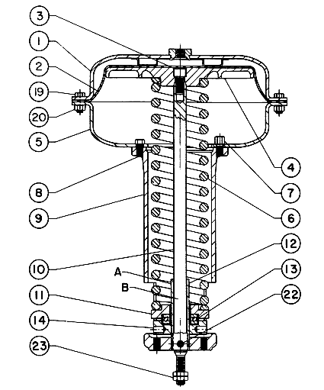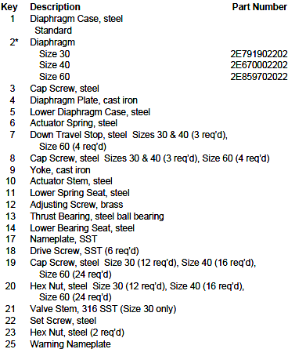

### Assembly

* Apply Lubriplate MAG-1 lubricant, or equivalent, to the adjusting screw threads (key 12) and screw this into the yoke (key 9). Replace set screw (key 22). The set screw should engage the machined thread relief in the adjusting screw.
* With the eared portion up, screw the lower bearing seat (key 14) all the way onto the adjusting screw.
* Apply Lubriplate MAG-1 lubricant, or equivalent, to the thrust bearing (key 13) and position it on the lower bearing seat (key 14). Lay the lower spring seat (key 11) on top of the thrust bearing assembly.
* Mount the lower diaphragm case (key 5) to the top of the yoke (key 9) using the travel stops and cap screws (keys 7 and 8). Alternate screws and travel stops on the sizes 30 and 40.
* Position the actuator spring (key 6) on the lower spring seat.
* Attach the diaphragm plate (key 4) to the actuator stem (key 10) with the cap screw (key 3). Apply Lubriplate MAG-1 lubricant, or equivalent, to the stem. Place this assembly, actuator stem first, into the yoke with the actuator stem through the spring adjustor (key 12).
* Position the diaphragm (key 2) on the diaphragm plate (key 4) and align the holes with the lower diaphragm casing (key 5). Attach the upper diaphragm case (key 1) to the lower diaphragm casing (key 5) using the cap screws and nuts (keys 19 and 20).
* If the actuator has been removed from its mounting, position it on its mounting plate or bracket, and secure with cap screws.
* Attach the pressure pipe or tubing to the loading pressure connection on top of the upper diaphragm case.
* Attach the actuator stem to the stem connector or clevis and adjust the travel

### DESIGN AND CONSTRUCTION

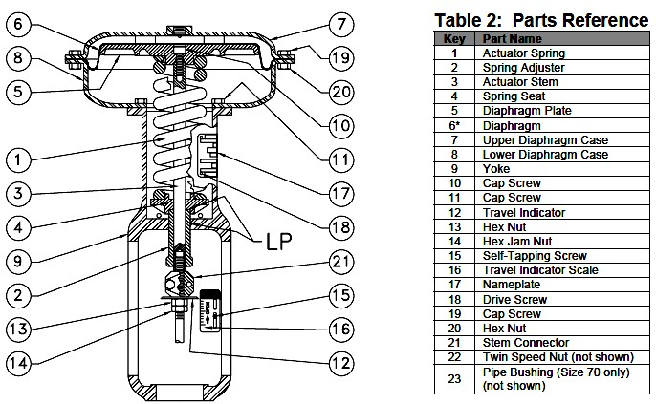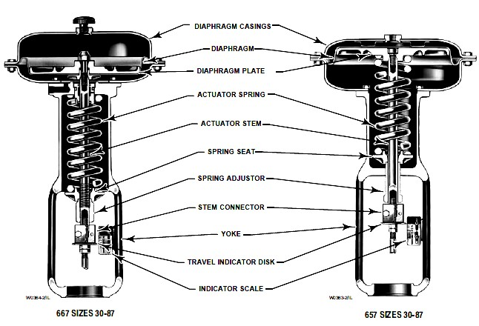

**CONFORMATION TO STANDARDS**

* + ISO 9001:2000 CERTIFIED QMS

### APPLICATIONS

* On-off or throttling service
* Input signal range
* Maximum supply pressure
* Valve body type and size with which the actuator will be used
* Valve plug travel
* Actuator thrust required with actuator stem both fully retracted and fully extended
* Stroking time requirements, if critical
* Seismic requirements, if critical
* Ambient temperature range

### PARTIAL LIST OF SUPPLIERS

* + Fisher
  + Eckardt
  + Richter
  + CVS
  + Foxboro
  + Honeywell
  + Bartan

# DAMPER WITH LOUVER

### DESCRIPTION

Dampers and louvers are used to control the flow of gases and vapors. These streams usually flow in large ducts at relatively low static pressures. There are both ―commercial‖ and ―process control‖ quality dampers on the market. Commercial quality units are used for the less-demanding applications, such as heating, ventilation, and air conditioning (HVAC), while the process control-quality units can handle higher pressures, higher temperatures, and corrosive vapors. The process control-quality units also can provide superior leakage and control characteristics.

Dampers are also used to control the flow of solids or to throttle the capacity of fans and compressors. There is no clear distinction between butterfly valves and butterfly dampers or between slide-gate valves and guillotine dampers. The design features of these dampers are quite similar to their control valve counterparts. Dampers in general are large in size, and their operating and shut-off pressures are limited to lower values. The diameters of the largest dampers can exceed 20 ft (6 m).

### SYMBOL

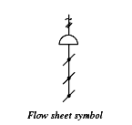

**FIGURE**

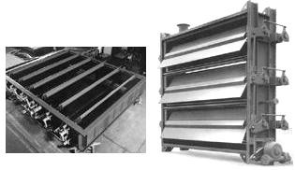

*Louver type damper*

### SPECIFICATIONS

* **Type of Designs:**
  1. Multiple blade or louver.
  2. Rotating disc, including multiple disc.
  3. Radial vanes.
  4. Ins-type variable orifice.

### Design Pressure:

* Type A designs can usually handle up to 10in. H2O (2.5kPa) shut-off differentials,
* Type D units can handle up to 15 psid (103kPa)

### Materials of Construction:

* Steel, galvanized steel, aluminum & fiberglass; stainless steel used in special case.

### Sizes:

* Type A dampers are available up to 6 ft X 8 ft (1.8 m X 2.4 m) for HVAC applications and even larger sizes for boilers and other industrial applications.

### Leakage through Each Ft2 (0.092 m2 of Damper Area):

* At 3in H2O (0.75kPa) shut-off pressure differential: the leakage of standard type A units is 50 SCFM (250 l/s/m2); special low-leakage type A, 5 SCFM (25 l/s/m2); positive-steel type B. 0.5 SCFM (2.5 l/s/m2)

### PRINCIPLE OF OPERATION

Dampers and louvers are used to control the flow of air in a process system or enclosed area. Dampers are usually motorized or manually-adjustable for flow control. Louvers are often fixed for a constant flow rate. The louver type of damper consists of several blades mounted parallel across a duct, with centrally pivoted shafts extending out through a frame and driven by a linkage.

The drive for a louver is simple, needing only 90° of motion. The torque requirement can vary widely over damper life, if corrosion and thermal effects are severe. Electric motors, air cylinders, and oil cylinders are able to actuate louver dampers with little difficulty. Louver dampers are best applied to balance or control flow. The normal leak path of 0.7% of duct area produces a three to five percent leak rate in average applications. As a general rule, a damper should be used in the middle third of the control range for best results. This gives equal percentage in either direction should the need arise.

A variety of options are available. Metallic spring seals, sealed (dust tight) blade ends, shear seals, and many materials are available. Leakage performance of a louver depends on ratio of flowing to shutoff pressure, design temperature, number of blades, and blade edge treatment. Since the first two are system related, the last two are the usual areas of improvement. Reduction of number of blades reduces leak path to the limit that a single blade has only perimeter leakage

### INSTALLATION

[Installation of EACC-401 lower and damper (designed to protect air intake and exhaust openings in building exterior walls.)]

Maximum single section size for Model EACC-401 is 60"W x 96"H, and individual sections are designed to withstand wind loadings of 25 pounds per square foot (100 mph wind equivalent). Larger sizes require field assembly of equal size louversections required to make up the overall louver size. Angles, clips, splice plates, bolts, and other fasteners required to install louvers and/or assemble louver sections are not provided with the louvers and must be supplied by the installing contractor. Louver assemblies (larger than 60"W x 96"H) require bracing or support from building structure at louver section joints to provide overall structural integrity. Details shown are general in nature.

Additional information on louver installation may be found in AMCA Publication #501, Louver Application Manual.

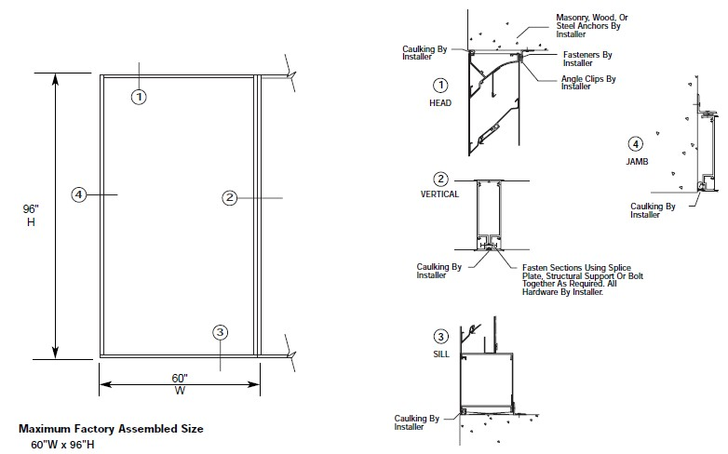

Louvers meeting specifications shall be furnished and installed where shown on the plans and/or as described in schedules. Louvers shall be combination drainable type incorporating both stationary and adjustable blades within a single 4" louver frame.

Adjustable blades or damper section shall be of low-leakage design incorporating pressure activated vinyl blade edge and compressible stainless steel jamb seals. When closed, adjustable blades provide an extremely tight seal to air leakage and weather. Each stationary blade shall incorporate an integral drain gutter and each jamb shall incorporate an integral downspout so water drains to blade end, then down the downspouts and out at the louver sill rather than cascading from blade to blade.

Each factory-assembled louver section shall be designed to withstand wind loadings of 25 pounds per square foot (100 mph wind equivalent). Louvers larger than 60"W x 96"H shall be built up by the installing contractor from factory assembled louver sections.

Louver frames, mullions, and section joints shall be adequately supported from the building structure to withstand this same wind loading.

### SELECTION CRITERIA

Criteria for damper selection includes leakage when closed, control characteristics, and cost.

### DESIGN AND CONSTRUCTION

**Damper Designs**

Dampers and louvers can be grouped according to their shapes into parallel-blade, disc and multiple-disc, radial vane, and variable-orifice designs. Within each design category, there can be subdivisions according to leakage rates, materials of construction, actuator designs, or accessories provided.

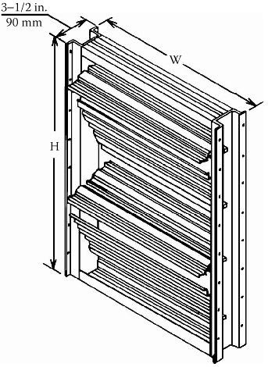

*Figure1.1: shows dimension for standard commercial damper frames, including their areas.*

**Multi blade dampers** consist of two or more rectangular vanes mounted on shafts that are one above the other, which are interconnected so they rotate together (Figure 1.2).The vanes are operated by an external lever, which can be positioned manually, pneumatically, or electrically. In the **uni-rotational louver** (parallel damper) design, the vanes remain parallel at all rotational positions. In a counter-rotational louver (opposed blade), alternate vanes rotate in opposite directions. Both designs are illustrated in figure

* 1. below

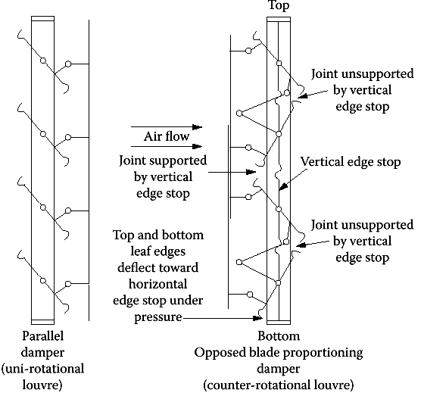

*Figure1.2: the design of the parallel-blade and opposed blade dampers, which are also referred to as uni-rotational and counter-rotational louver designs.*

Flow guides are sometimes installed between adjacent vanes in order to improve the effectiveness of throttling. In Figure 1.4, the blade-angle vs. flow characteristics of a parallel-blade damper and a butterfly valve are shown. The sensitivity of this design is very high at mid-flow while the last 30° of rotation is relatively ineffective. The flow characteristics of butterfly valves are similar though some-what superior to those of louvers. Figure 1.5 shows an opposed-blade damper with equal percentage linkage. As less and less of the total system pressure drop is assigned to the damper, the characteristics of this damper shift toward quick opening. Figure 1.6 gives the pressure drop across wide-open dampers. Ideally the wide-open pressure drop should be between 4 and 8% of the pressure difference across the closed damper. If the damper is sized so that closed pressure difference is between 12 and 25 times the pressure drop, when the damper is open, its apparent characteristic will be nearly linear (see curves C and D in Figure 1.5).

**Low-Leakage Designs** The parallel-blade damper cannot provide tight shut-off because of the long length of unsealed seating surfaces. In low-leakage damper designs, blade seals are installed along the seating surfaces of the blades, resulting in the reduced leakage characteristic .There are a number of variations in the blade-edge seal designs. Some of these designs are illustrated in Figure 1.3 below.

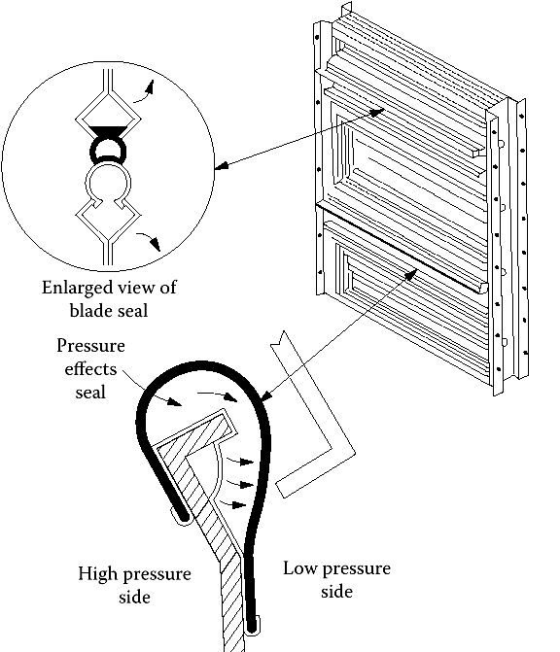

*Figure 1.3: various blade edge seal designs of the damper*

### Flow characteristics

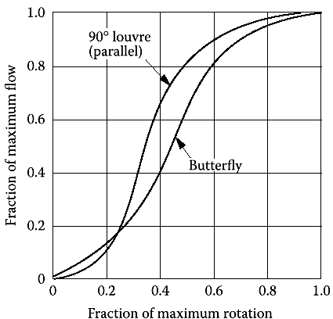

*Figure1.4: the blade-angle vs. flow characteristics of a parallel-blade damper and a butterfly valve*

The flow characteristics of a parallel-blade damper are similar to those of a conventional butterfly valve. The flow characteristics of an opposed-blade damper approach equal- percentage characteristics when the total system pressure drop is through it and it shifts its characteristics toward quick opening as the damper receives less and less of the total pressure differential.

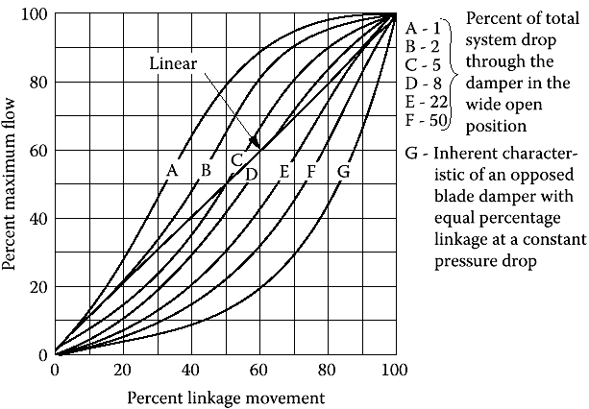

*Figure1.5: Flow characteristics of opposed-blade damper with equal percentage linkage* Pressure drop through wide open dampers are shown in the figure. The free area ratio of an open damper is the total open area between the blades, divided by the nominal area

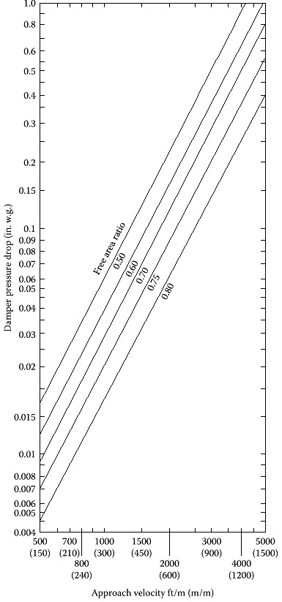

*Figure1.6: Pressure drop through wide open dampers*

### APPLICATIONS

Dampers are suitable for control of large flows at low pressures where high control accuracy is not a requirement. Typical applications of these units include air conditioning systems and furnace draft control. Variable-orifice or iris dampers are smaller than other dampers, offer better control quality, and can also be used to control vertical solid flows.

### PARTIAL LIST OF SUPPLIERS

* Air Clean Damper Co. Arrow United Industries
* Babcock & Wilcox Co.
* Bachmann Industries
* Belimo Air Controls
* Damper Design Inc.
* Flextech Industries
* FMC Corp.
* Honeywell Sensing and Controls
* Johnson Controls
* Louvers & Dampers Inc.
* Miracle Vent Inc.
* Polymil Products Inc.
* Ruskin Air & Sound Control
* Safe-Air/Dowco
* Vent Products Co.
* Young Regulator

I/P & P/I CONVERTERS

### Topic Description Page no

* + I/P CONVERTERS 107
  + P/I CONVERTERS 117

**DESCRIPTION**

# I TO P CONVERTERS

A ―current to pressure‖ converter (I/P) converts an analog signal (4 to 20 mA) to a proportional linear pneumatic output (3 to 15 psig). Its purpose is to translate the analog output from a control system into a precise, repeatable pressure value to control pneumatic actuators/operators, pneumatic valves, dampers, vanes, etc

### SYMBOL

***i/p converter, electric. into pneum. Standardized signal***

### FIGURE

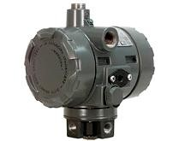

***Fisher I to P -100 electro pneumatic transducer***

### SPECIFICATIONS

* **Input Signal:**
  + Available as standard with 4-20 mA.
  + User configurable by dip switch for split ranging.

### Output Signal:

− 0.2 to 1.0 bar (3 to 15 psig), 0.4 to 2.0 bar (6 to 30 psig), or 0.14 to 2.3 bar

(2 to 33 psig).

* + User configurable by dip switches selection and zero and span potentiometer adjustment

### Supply Pressure:

* + Recommended: 0.3 bar (5 psi) higher than upper range limit of output signal
  + Maximum: 3.4 bar (50 psig)
  + Medium: Air or Natural Gas

### Operating Ambient Temperature Limits

− −40 to 85C (−40 to 185F)

### Maximum Output Air Capacity:

* + 8.0 m3/hr (300 scfh) at 1.4 bar (20 psig) supply pressure

### Performance:

* + Reference Accuracy: ±1.0% of full scale output span; includes combined effects of hysteresis, linearity, and dead band
  + Independent Linearity: ±0.75% of full scale output span
  + Hysteresis: 0.4% of full scale output span
  + Frequency Response: Gain is attenuated 3 dB at 6 Hz with transducer output signal piped to a typical instrument input
  + Temperature Effect: ±0.14% per degrees Celsius (±0.075% per degrees Fahrenheit) of span
  + Supply Pressure Effect: 0.2% of full scale output span per psi supply pressure change
  + Vibration Effect: Less than 1% of full scale output span when tested to ISA S75.13
  + Electromagnetic Compatibility: Meets EN 61326-1 (First Edition)

### Connections:

* + Supply and Output Pressure: 1/4 NPT internal Connection
  + Vent: 1/4 NPT internal
  + Electrical: Standard 1/2 NPT
  + Wire Size: 18 to 22 AWG

### Construction Materials:

* + Housing: Low-Copper aluminum with polyurethane paint
  + O-rings: Nitrile
  + Diaphragms**:** Nitrile

### Adjustments:

* + Zero and Span: Trim potentiometers (20 turn) for zero and span adjustments are located under the housing cap
  + Switch: Allows input signal split range and user-configurable 0.14 to 2.3 bar (2 to 33 psig) output

### PRINCIPLE OF OPERATION

The Type 100 I/P Transducer are an electro-pneumatic device which uses a converter module that converts a milli ampere input to a proportional pressure output. The converter module uses small parts of minimum mass, which are balanced symmetrically around a pivot point at the center of the mass. This balanced arrangement results in a high performance instrument that reduces sensitivity to vibration.

The transducer receives a 4-20 mA DC input signal and transmits a proportional user field-configurable pneumatic output pressure to a final control element. The input signal and output pressure range of the transducer is indicated on the nameplate, attached to the housing The pneumatic output range are typically 0.2 to 1.0 bar (3 to 15 psig), 0.4 to 2.0

bar (6 to 30 psig), and 0.14 to 2.3 bar (2 to 33 psi).

A typical application is in electronic control loops where the final control element is a control valve assembly that is pneumatically operated. The converter module receives a standard DC current input signal from a control device to operate coils in a force balanced beam system which in turn controls bleed air through an integral nozzle/flapper arrangement. The nozzle pressure provides the input signal to operate the relay as shown in the figure. Relay output pressure is applied, through tubing, directly to the final control element or valve/actuator assembly.

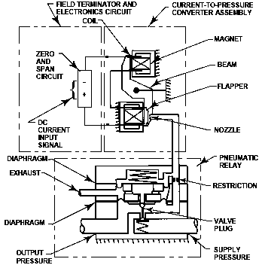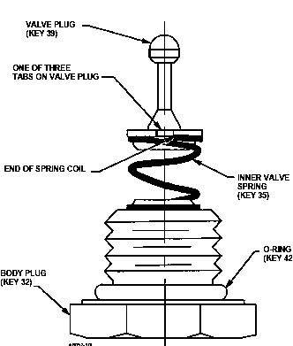

***Figure1: Fisher i2P-100 Transducer Schematic and figure2: Valve Plug, Inner Valve Spring and Body Plug Assembly***

### MOUNTING

***Figure3: Fisher i2P-100 Electro-Pneumatic Transducer***

Figures 4 and 5 below are typical mounting configurations. Standard mounting hardware is provided for mounting on the actuator, a pipe stand, or surface mount. Field wiring connections are made to the terminal block accessible under the housing cap, via the 1/2 NPT conduit connection. Dimensions are shown in figures 5, 6, 7, and 8.

**Vibration Resistance**—The transducer, used a standard valve/actuator mounted application, exhibits an output shift of less than 1 percent of span when tested to ISA S75.13.

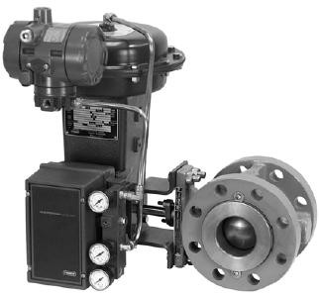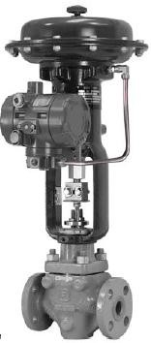

*Figure4: Fisher i2P-100 Electro-Pneumatic Transducer Mounted on a Rotary Actuator Figure5: Fisher i2P-100 Electro-Pneumatic Transducer Mounted on a Sliding-Stem Actuator*

### INSTALLATION

* The i2P-100 transducer has been designed and approved for use with either air or natural gas as the supply medium.
* If using natural gas as the pneumatic supply medium, natural gas will be used in the pneumatic output connections of the transducer to any connected equipment.
* In normal operation the unit will vent the supply medium into the surrounding atmosphere unless it is remotely vented.
* When using natural gas as the supply medium, in a non-hazardous location in a confined area, remote venting of the unit is required. Failure to do so could result in personal injury, property damage, and area re-classification.

### Special Conditions of Use

* + 1. When product is used with natural gas as the pneumatic medium, the maximum working pressure of the natural gas supply is limited to 50 psi.
    2. When product is used with natural gas as the pneumatic medium the product shall be provided with the proper remote venting.

### Pneumatic Connections

* As shown in figure, all pressure connections on the transducer are 1/4 NPT internal connections. Use 3/8-inch tubing for all pressure connections.
* Use a filter regulator with standard 5 micrometer filter, or equivalent, to filter and regulate supply air. Supply pressure must be clean, dry air or non corrosive gas.
* An output pressure gauge may be installed on the regulator to indicate the supply pressure to the transducer. Also, as an aid for calibration, a second gauge may be installed on the transducer to indicate transducer output pressure.
* Connect the nearest suitable supply source to the1/4 NPT IN connection on the filter regulator or to the 1/4 NPT SUPPLY connection on the transducer case (if the filter regulator is not attached).

### Dimensions and Connections

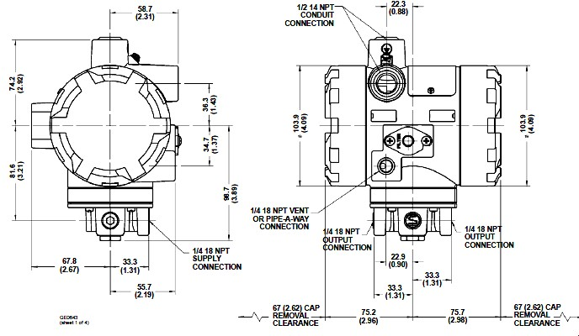

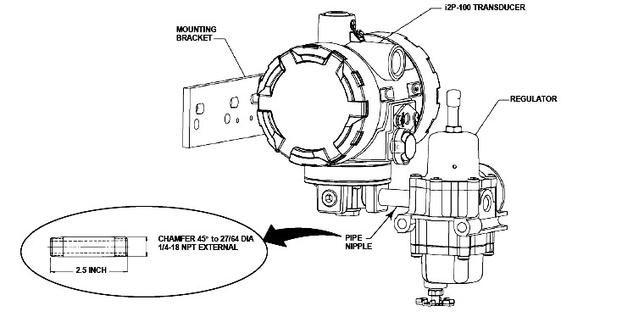

*Typical Fisher i2P-100 mounting with 67CFR Filter Regulator*

### Electrical Connections

* Use the 1/2 NPT conduit connection for installation of field wiring.
* Refer to next figures when connecting field wiring from the control device to the transducer.
* Connect the positive wire from the control device to the transducer ‗‗+‘‘ terminal and, the negative wire from the control device to the transducer ‗‗−‘‘ terminal.
* Do not over tighten the terminal screws.
* Maximum torque is 0.45 Nm (4 lbfin.).
* Connect the transducer grounding terminal to earth ground.
* Grounding terminals are provided both inside and outside the transducer housing.

### Typical Field Wiring Diagram

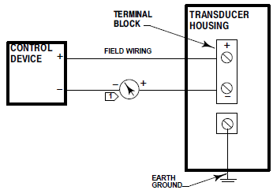

**Equivalent Circuit**

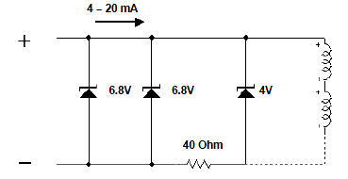

### CALIBRATION

***Equipment Required***

* Choose a current or voltage source that is capable, without switching ranges, of driving the transducer through its entire input range.
* Switching ranges on a current or voltage source will produce spikes or mid-scale reverses in the input signal presented to the transducer, causing errors. ]
* The current source should be capable of delivering 30 mA with 30 VDC maximum compliance voltages.

***Calibration Procedure:***

1. Remove electronics module cover.
2. Input and output ranges are selectable by dip switch selection.
3. Adjust dip switch settings and zero and span as necessary to achieve the desired input/output range.
4. If a current source other than the control device is used as the input source, disconnect the control device and connect the current source positive terminal to the transducer ‗‗+‘‘ terminal and the current source negative terminal to the transducer‗‗−‘‘ terminal.
5. Check the supply pressure to ensure it is at the recommended pressure.
6. Adjust the input current to the low mA DC.
7. The output pressure should be 0.2 bar (3 psig). If not, adjust the ZERO potentiometer until the output pressure is 0.2 bar (3 psig).
8. Adjust the input current to the high mA DC.
9. The output pressure should be 1.0 bar (15 psig).If not, adjust the SPAN potentiometer until the output pressure is 1.0 bar (15 psig).
10. Repeat steps 5 through 8 until the output pressure is within the referenced accuracy requirements without further adjustment.
11. If a current source other than the control device was used, disconnect the current source and reconnect the control device.

### CONFORMATION TO STANDARDS

* Pressure Equipment Directive (PED) 97 / 23 / EC. It was designed and manufactured in accordance with Sound Engineering Practice (SEP)
* CSA—Intrinsically Safe, Explosion proof, Type n, Dust-Ignition proof
* FM—Intrinsically Safe, Explosion proof, Type n, Non-incendive, Dust-Ignition proof
* ATEX—Intrinsically Safe & Dust, Flameproof & Dust, Type n & Dust
* IECE x—Intrinsically Safe, Flameproof, Type n IEC60079-0:2004, IEC60079- 1:2001,IEC60079-11:2006, and IEC60079-15:2005

### APPLICATIONS

* I/P converters are commonly used in connection with process controls in various applications, for example where an electric signal is utilized to control a diaphragm-actuated pneumatic valve, cylinder, or positioner.
* For positioning steam and fuel valves and/or the associated servos.
* Especially suitable as intermediate element between electric measuring devices and pneumatic controllers, or between electric control devices and pneumatic

### PARTIAL LIST OF SUPPLIERS

* Fisher Emerson
* Sensotek
* Omicron
* Woodward
* Samsomatic
* ABB
* Watson smith
* Control valves.

# P TO I CONVERTER

### DESCRIPTION

P to I converters are used as an interface between pneumatic and electric measuring and control devices, for example, for connecting pneumatic transmitter to electrical equipment, such as controllers, computers or control systems. P/i Converter converts a pneumatic signal to a standardized electrical signal, especially suitable as intermediate elements between pneumatic and electric control and measuring equipment. The input variable is a standardized pneumatic signal and the output variable is a standardized electrical signal. The Type 6134 Converters are designed for two-wire connection and are available as a rail-mounting unit or field unit.

### SYMBOL

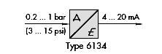

**FIGURE**

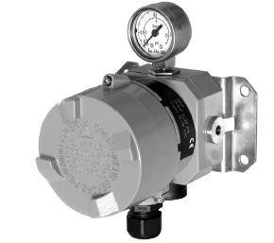

*P/i Converter Type 6134*

### SPECIFICATIONS

* **P/I converter types**
  + type 6134-04-rail mounting unit

− type 6134-03, 13, 23-field unit

### Input:

* + 0.2 to 1.0 bar (3 to 15 psi), over loadable up to 5 bar (72.5 psi)

### Output:

* + 4 to 20 mA

### Auxiliary power:

* + two-wire network 24 V- voltage range 12 to 30 V

### Performance

* + Characteristics: out put linear to input
  + Hysterisis: negligible
  + Ripple of the output signal:  0.5%
  + Temperature influence: for zero and span:  0.15%/10K
  + EMC noise emission: EN 61 000-6-3
  + EMC noise immunity : EN 61 000-6-2

### Ambient conditions

* + Ambient temperature: for IP 20 is (-20C to 70C); for IP 54/1P 65 without explosion protection (-20C to 70C) and (-40C to 70C- only with IP 65); with explosion protection (-20C to 70C); (-40C to 60C- only with IP 65)
  + Storage temperature: for IP 20 (-40C to 80C); for IP54/IP65 (-40C to 80C)

### PRINCIPLE OF OPERATION

The pressure p of the standardized pneumatic signal is converted into an electrical DC voltage signal by a capacitive ceramic pressure sensor The DC voltage signal which is proportional to the pressure is amplified in the measuring amplifier to a defined level. Both the lower range value and span can be adjusted using potentiometers on the front panel. The constant DC voltage source is used to supply the DC voltage at a constant level. Control equipment can be connected to the output circuit.

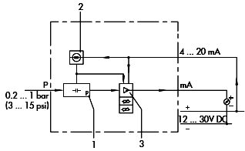

*Functional diagram of type 6134 p to I converter for two-wire connection*

Where P is the pneumatic input signal 1 capacitive sensor for pressure

1. constant voltage sources
2. measuring amplifier and potentiometers for adjusting SPAN and ZERO

### Output circuit:

* In two-wire systems, the maximum permissible load at the output of Type 6134 is:
* UB = US – UA
* RB = UB/ 20 mA
* UB Maximum permissible load impedance
* RB Maximum permissible load
* US Supply voltage of the two-wire circuit
* UA 12 V, minimum natural voltage of the Type 6134

### INSTALLATION

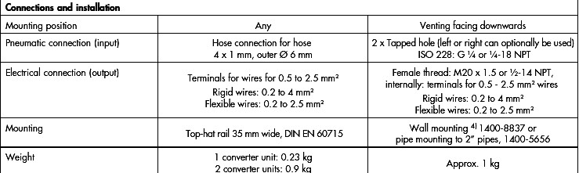

**CALIBRATION**

***Calibration Adjustments***

* + Multi turn span and zero potentiometers with Non-interactive, multi turn span and zero approximately ±20% of span adjustment range

### CONFORMATION TO STANDARDS

* For Type 6134-1-EC Type Examination Certificate: PTB 04 ATEX 2023 2004- 03-19 II 2 G EEx ia IIC T6
* For Type 6134-2-EC Type Examination Certificate: PTB 03 ATEX 1214 2003- 11-06 II 2 G EEx d IIC T6

### APPLICATIONS

Controlling a positioning cylinder in the paper and printing industry. The electric signal coming from a controller or a PLC (e) is converted to a pneumatic signal (p) by the e/p converter. The pressure signal is used to position a cylinder which, in turn, moves a roller that keeps the paper under a certain tension

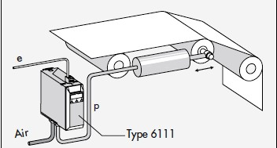

### Controlling a valve

Valves equipped with small pneumatic actuators can be controlled directly by an e/p converter. The e/p converter receives the electric signal from a controller or a PLC. The e/p converter can also control a pneumatic positioner.

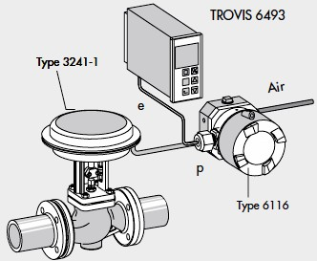

### Pressure control

The p/e converter measures the pressure in the pipeline and converts it to an electric signal. The controller uses the electric signal to calculate the control signal which is passed on by the positioner to finally close or open the pneumatic control valve

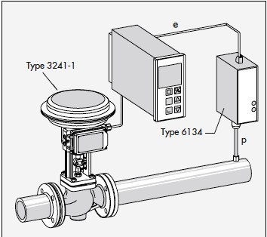

### PARTIAL LIST OF SUPPLIERS

* + Samson
  + Azbil
  + Dahl
  + Sitec
  + Shanghai
  + Andltdsti

POSITIONERS & VOLUME BOOSTERS

### Topic Description Page no

* + - PNEUMATIC AND ELECTRO PNEUMATIC POSITIONERS…….123
    - VOLUME BOOSTERS 135

**DESCRIPTION**

# POSITIONERS

Process control loop may be described in terms of process variables and control elements. The control elements include a sensor, transmitter (usually lumped with the sensor), controller and final control element. Positioners are part of a control loop. If not specified properly or if not maintained properly, they can have an unacceptable effect on process control, costing both maintenance time and materials.

A valve positioner is a device in the control loop of a flow, pressure, or level control process that improves valve response to changes in the demand signal from a process controller. The positioner is used to limit control valve dead band, mitigate friction- induced nonlinearities, change valve flow characteristics, permit double-acting actuator operation, increase shutoff forces, allow for split-ranging, and add loop gain to decrease the effects of process

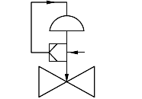lag and dead band.

### SYMBOL

*Valve with diaphragm actuator and attached positioner*

### FIGURE

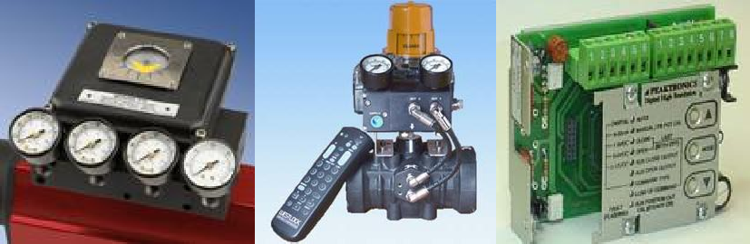The enemies of all closed loops are dead time and non-linearity. *Dead time* is the delay associated with a control loop response. *Non-linearity* is the failure of a control loop to respond to an error with the same magnitude of response over the range of control.

Positioners can help to mitigate these problems. One of the positioner‘s functions is to help combat dead time by supplying additional *gain,* or amplification, to the control loop. Gain increases response time and, therefore, improves the control loop‘s ability to deal with disturbances. However, too much gain can also be a problem, causing instability in the loop. To mitigate process non-linearity, positioners can be adjusted or characterized

to produce an output that algebraically subtracts the non-linearity over the range of control. This is done by characterizing a cam.

**4-20 ma**

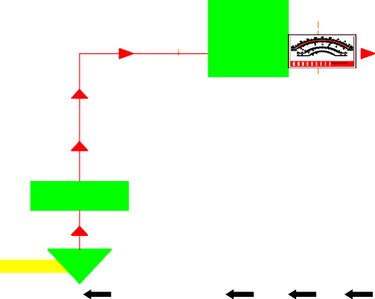

**Set Point Controller**

Sensor

***Automated Control Loop***

### PNEUMATIC POSITIONERS

**Positioner**

Actuator

A

**Valve**

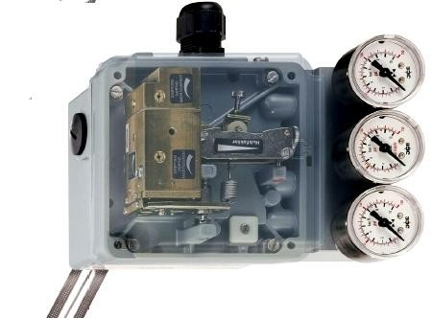

*Foxboro Eckardt SRP981 Pneumatic Positioner*

The Pneumatic Positioner SRP981 with pneumatic input 0.2-1 bar is designed to operate pneumatic valve actuators. Positioner ensures that the position of the valve plug is directly proportional to the controller output pressure, regardless of packing box friction, diaphragm actuator hysteresis or off-balance forces on the valve plug. This also provides the means of changing the effective output pressure range of a controller or changing the valve action.

### SPECIFICATIONS

* Signal range 0.2 to 1 bar (3 to 15 psig)
* Stroke 8 to 100 mm (0.3 to 4.0 in), extended stroke range on request
* Angle range up to 120°
* Supply air pressure up to 6 bar (90 psig).
* Built-in pressure gauges (optional)
* Low air consumption and Low vibration effect in all directions
* Single or double-acting
* Mounting on linear actuators according to IEC 534, Part 6 (NAMUR)
* Mounting on rotary actuators according to VDI/VDE 3845
* Protection class IP54, IP65 (on request)
* Explosion protection : Basic unit: II 2 G c IIC (ATEX-constructive design)
* Accessories: II 2 G EEx ia IIC acc. to ATEX; Accessories: ―Intrinsic Safety‖ according to FM and CSA

### Modular system for accessories:

* Built-in independent inductive limit switches in 2-wire, 3-wire or micro switch- technology (optional)
* Independent position feedback 4 to 20 mA (optional)
* Booster Relays with an air capacity of up to 110,000 ln/h (3,884 scfh)
* Connection Manifolds and gauges

### PRINCIPLE OF OPERATION

**Building Blocks:** Within any positioner is a set of discrete components that function together. In all cases, a motion of one of these components causes a series of events that result in a counter-motion. This motion may be the simple movement of components or a result from the application of force.

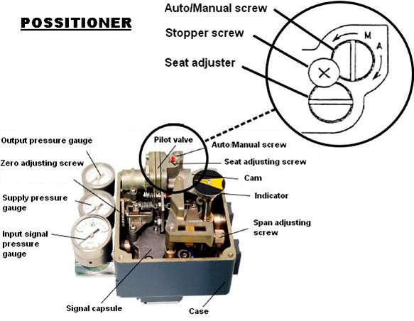

**Input signal conversion:** The pneumatic input is converted to a mechanical motion. Positioner gain may be developed here using a pneumatic amplifier. In such cases, the positioner is referred to as a two-stage device.

**Output signal generation**: A mechanical motion causes a directional control valve to change position and supply air to (or exhaust air from) the actuator. Positioner gain will normally be developed here, usually through the use of spring or spring-like devices.

**Output signal correction:** The gain developed earlier is reduced to zero.

### Input Signal Conversion:

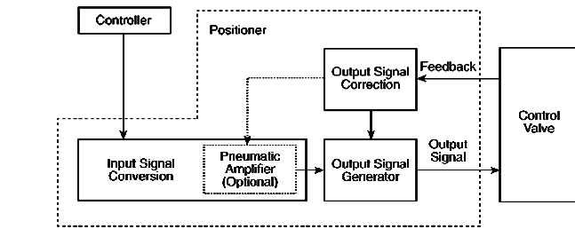

* + Input signal can be sent to the positioner is one of two ways:
  + A pneumatic signal (3–15 psig [20.7–103.4 kPa], 6–30 psig [41.4–206.8 kPa] 3– 27 psig[20.7–186.2 kPa], etc) directly from the controller
  + An electrical signal (4–20ma, 10–50ma, 0–10v) from the controller that is converted to a pneumatic signal by a current to pneumatic (I/P) converter or a voltage to pneumatic (E/P) converter that is either external or internal to the positioner.
  + The pneumatic signal must be converted to a mechanical motion. This conversion process always begins with a diaphragm or bellows chamber. The changing pressure is transformed to a linear motion. The linear motion is now used directly to position a directional control valve within the positioner, or it is used to modulate the flapper of a nozzle-flapper.

### Output Signal Generator:

* + Connecting the Input Converter to Output Generator. The input signal converter sends a linear motion that is used by the output signal generator in one of two ways:
  + The linear motion is used directly to cause the output signal generator to move and to transmit an output signal. For example, an input diaphragm linear motion is connected directly to the stem of a sliding spool directional control valve.
  + The linear motion is used to move a balance beam that causes the output signal generator to move and to generate an output signal.
  + The term *output signal generator* describes the function of several different types of mechanisms that are used to provide the output signal.

### Output Signal Correction (Feedback)

* The output signal correction is to use the feedback to nullify or balance the output when the desired position is achieved.
* The output signal correction is also the point in the positioner loop in which the output can be modified, or characterized to mitigate process non-linearity.

### Interface between Valve and Positioner:

* To begin the balancing process, a rod, bracket, or other suitable device is attached to the stem. The device is mechanically routed to the positioner (for example, using linkages) to provide the appropriate motion used by the positioner: rotation or linear push-pull. If the motion is rotation, the input to the positioner is a lever.

### Positioner Input:

* Any amount of movement of the stem always results in the same but proportional amount of movement at the positioner. There may be an interface that allows the input range to be adjusted, but the motion remains linear.
* Sometimes it is necessary to modify this input. This is where the rotary motion comes in. Rotary motion is used in the positioner to modify the feedback in a non- linear way if desired. The reason for making it non-linear is to compensate for some non-linearity in the control loop.
* The universal method for doing this is by using a cam. Input from the stem causes the input lever to rotate the cam.
* Output signal correction uses feedback to nullify or balance the output when the desired position is achieved. Balancing involves one of two principles-motion balance and force balance.
* The motion-balance positioners use nozzle-flapper devices. These positioners use a beam, commonly called a balance beam that moves about a pivot.
* In the force-balance device, the input signal creates a force that is resisted by an opposing force created by the feedback mechanism. One of the easiest ways to identify a force-balance device is the existence of stem feedback being applied through a spring, which is called a *range spring*.

### INSTALLATION

1. **MOUNTING TO ROTARY ACTUATORS**
   * Remove the transparent cover plate from the housing of the attachment kit.
   * Mount the housing of the attachment kit on rotary actuator or armature
   * Move actuator into the desired starting position (rotation angle =0°).
   * Mount cam 24 in accordance with the direction of rotation of the actuator.
   * Fasten feedback lever 30 for the rotary actuator onto shaft 15 of positioner.
   * Mount positioner on housing of the attachment kit. Attach spring 31 to feedback lever 30 and cam follower 32 against cam. Screw positioner to housing of attachment kit.
   * Mounting of feedback lever on shaft of positioner is performed at a stroke of 0 %

### MOUNTING TO LINEAR ACTUATORS Single-acting diaphragm actuators:

* + Check whether the actuator is in the safety position required by the process. (Does the actuator open or close with spring force?)
  + The mounting side is selected from the table below in accordance with the direction of action and the required direction of movement of the spindle for an increasing input signal.

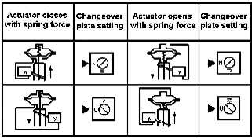

### Double-acting diaphragm actuators

* + For double-acting positioners the changeover plate 13 always stays in the ―N‖ setting.
  + The assignment of the input signal to the direction of movement of the actuator spindle is determined by the selection of the mounting side of the positioner and the piping of the positioner outputs to the actuator

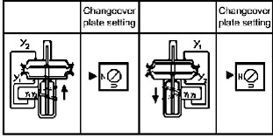

### CALIBRATION

* The goal of calibration, or alignment, is to ensure that the positioner is functioning correctly within design tolerances, for example, start and stop points and travel.
* It ensures that the fidelity between the input signal and the position of the valve is established.
* Basic calibration is an alignment process.
* When the process is completed, the actuator should operate in accordance with the manufacturer‘s specifications.
* The basic calibration process consists of **three steps** which are:

1. Bench set confirmation
2. Feedback linkage alignment, including cam alignment
3. Zero and span adjustment

### Bench set confirmation:

* Bench set is expressed as a pressure range from the start of the actuator stroke to the valve‘s rated travel.
* Spring adjustments must be made to meet the most important set point.
* On air-to-open valves, the *start* pressure is important for a valve that requires positive shutoff by the spring (the spring provides the seat load).
* On air-to-close, the *end* pressure value is important to have enough force to overcome the spring force and the valve friction and to seat the valve.

[Note: The bench set pressure range is not the same as the pressure required to stroke the valve in actual service. Making the adjustment while the valve is in service may result in unsatisfactory performance and/or make the valve inoperable.

### Feedback linkage alignment:

* The purpose of this alignment is to ensure that the zero and span of the feedback mechanism position correspond to the fully open (closed) and fully closed (open) valve travel positions.
* The positioner is not in service during the performance of this alignment.
* Either pressure is supplied directly to the actuator, or the hand-wheel is used to position the valve.

### Zero and Span Adjustment:

* The purpose of the zero and the span adjustments is to synchronize the valve position to positioner demand.
* The positioner can be calibrated to give zero or full supply pressure rather than 3 psig or 15 psig (20.7 kPa or 103.4 kPa).
* This can be a distinct advantage in providing tight closure of a control valve to prevent seat damage.
* Zero adjustments are always done in conjunction with span adjustments.
* After the span has been adjusted, the zero adjustment must be re-verified to ensure that the zero adjustment has not changed.

### CONFORMATION TO STANDARDS

* ATEX + CENELEC
* BP RP 30-1(Instrumentation & Control-Design & Practice)
* BP RP 32-1( Inspection & Testing of new equipment in manufacture)
* BS 5501-Electrical apparatus for potentially explosive atmospheres)
* BASEEFA (British Approval Services For Electrical Equipment in Flammable Atmosphere)
* IEC60529(degrees of protection provided by enclosures (IP Code)) viz EEx ia IIC T4, IP65
* IEC60534 Part 4
* ISO 9001

### APPLICATIONS

* Limiting Control Valve Dead Band
* Mitigating Stiction or Stick-Slip
* Change Valve Response
* Control Double Acting Actuator
* Increase Shutoff Forces
* Split-Ranging

•

### PARTIAL LIST OF SUPPLIERS

* Bailey
* Conoflow
* Fisher
* Masoneilan
* Valtek
* Moore

### ELECTRO PNEUMATIC POSITIONER

Electro pneumatic is used for controlling movement of final control element such as Linear Cylinder, Diaphragm Control valve or Rotary actuator device which accepts directly variable electronic signal & E/P positioner is a precision with the help of auxiliary high pressure supply accurately controls movement of final control element corresponding to set point.

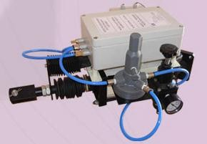

### SPECIFICATIONS

***Electrical Characteristics***

* + Input : 4-20 mA; 216 ohms
  + Open loop gain\*\* : approximately 100
  + Zero adjustment : vernier screw
  + Span adjustment : tension adjustment on force balance spring
  + Range selection : indexed and calibrated stroke scale,

***Performance Characteristics***

* + Conformity :  2% of span
  + Ambient Temp. range : -400c to + 800c
  + Air consumption : 0.21 scfm @ 20 psig

: 0.29 scfm @ 35 psig

* + Exhaust capacity : 3.3 scfm @ 20 psig, approximately

: 5.4 scfm @ 35 psig

* + Orientation effect : Insignificant
  + Max. supply pressure : 75psi
  + Output : Determined by supply pressure
  + Load sensitivity : Output pressure change of 1.2 psi

### PRINCIPLE OF OPERATION

**Operating System** Positioner receives mainly three inputs such as:

* 230 V a. c. 50 C/s, power supply
* 4-20 MA-Input signal (Control)
* Potentiometer - Output (Feedback)

The microprocessor based instrument amplifier of the positioner receives variable input control signal & potentiometer output feedback signal. Microprocessor compares these values & depending upon vectorial difference decides & fires the corresponding relay which in turn triggers solenoid to admit & exhaust air from actuator. The system is based on modulation of signal & its time function. The microprocessor precisely calculates the time function & accurately positions. The movement of actuator standard instrument available with input control signal of 4-20 MA. However system can be modified for accepting other variable depending upon specific requirement.

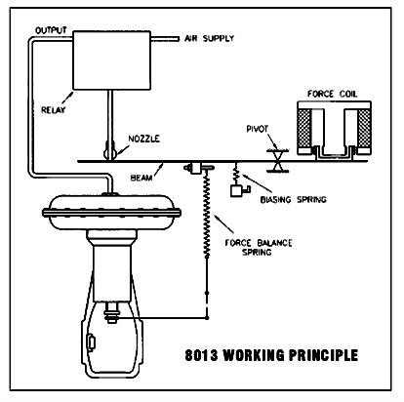

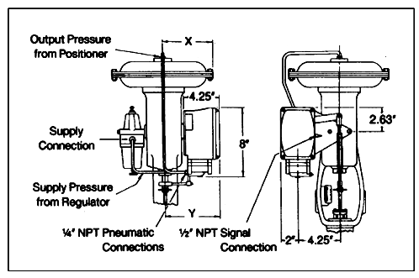

### INSTALLATION

* + Before mounting the positioner, the relationship of the actuator to the valve must be determined. The actuator can be mounted in-line or cross-line to the valve.
  + In addition, the actuator can be mounted right-side- up or inverted.
  + If a spring-return actuator is used, the actuator can be set up to fail with the valve closed or with the valve open.
  + The following notes pertain to Positioner Mounting Guide below.

1. ―Inverted‖ actuator position and ―Cross-Line‖ actuator mounting applies to sizes 10–20 39 Series actuators only.
2. For spring-return actuators only: ―Fail-Open‖ actuators have a ―9‖ in position 3 of the ordering code.
3. To change cam to reverse-acting, remove and reinstall upside down

### CALIBRATION

The following beam alignment and calibration procedures are applicable.

### Beam alignment:

* The purpose of beam alignment is to ensure the correct mechanical position of parts so the valve positioner can be calibrated.
* Provide the appropriate supply pressure. Also, provide an input signal to the positioner which can be manually set at the midpoint of the desired input signal range.
* Shut off the supply pressure to the valve positioner. Connect or reconnect the necessary tubing from the valve positioner output to the actuator supply connection. Connect the input to the valve positioner and set the input signal value at midrange.
* Move the flapper assembly to approximately position 6 in the proper operating quadrant of the beam (direct or reverse acting), and apply supply pressure to the valve positioner.
* Apply an input signal equal to the low value of the input signal range.
* Apply an input signal equal to the high value of the input signal range and observe the actuator stem travel.
* Repeat steps 3 and 4 until the correct travel is achieved. Each time the flapper position is changed in step 4, repeat step 3 to provide proper zero.

### DESIGN AND CONSTRUCTION

* The basic model MIL 8013 Positioners are used with reciprocating control valves.
* Its linkage is designed for actuators with a straight axial motion.
* Feed back linkage is connected directly to the actuator stem.
* The model MIL 8013 has a stroke and zero adjustment assembly and may be split ranged with various controller signals.
* Electro-pneumatic positioners provide precise and reliable valve positioning and superior dynamic response.

Key design characteristics of the MIL 8013 positioner are:

* Dynamic Response and Positioning Accuracy: The MIL 8013 Positioners are force-balance electro pneumatic devices which, by directly comparing valve stem position with controller DC output signal, provide dynamic response and positioning accuracy not obtainable with transducer and pneumatic positioner combination.
* Split-ranging Controller: In addition, the positioners provide an accurate means of split ranging controller output signal for sequential operation of two or more control valves by a single controller.
* Corrosion Resistance and Vibration Resistant
* Direct Action and Reverse Action

Construction characteristics of electro pneumatic positioner:

* The die cast Aluminium housing provides outdoor weather resistance and a sealed conduit connection.
* Electrical circuit is easily adapted to a variety of input signals. It utilizes a powerful, Hyflux, Alnico V Magnet with high quality force coil with a high dielectric bobbin and mechanically protected windings.
* Terminal board has a jack type terminal post to receive coil leads, and also serves as a mounting unit for components necessary to adapt the positioner to various electrical signals.
* The case has a ½. / ¾. NPT conduit for electrical connection by cable gland or other means.
* Relay is high capacity type for fast stroking speeds. It may be mounted in any one of four positions to facilitate piping.
* A plunger provides for cleaning the sapphire orifice in the removable metering tube.

### APPLICATIONS

* Linear cylinder
* Rotary actuator
* PN diaphragm control valve

### PARTIAL LIST OF SUPPLIERS

* Cheshire
* Rosemount
* M System Technology Inc
* Alpha Valve & Controls, Inc.

# VOLUME BOOSTERS

### DESCRIPTION

Volume Boosters are used to multiply the available volume of the air signal. The Fisher VBL volume booster (figure) is used in conjunction with a positioner on a throttling control valve to increase stroking speed. The booster incorporates fixed dead band, soft seat construction, and an integral bypass restriction to eliminate positioner saturation problems that can occur with volume boosters that do not have these features. Adjustment of the integral bypass restriction is necessary for system stability. This adjustment does not affect the dead band of the volume booster, but does permit the control valve to respond to small input signal changes without sacrificing steady state accuracy. It also allows the booster to deliver high volume output for fast stroking when large, rapid input signal changes occur. The volume booster, when used in conjunction with a positioner/ actuator, is used only to improve stroking speed. It is not recommended for other applications requiring a high accuracy, instrument type volume booster. If the volume booster is to be used only with an actuator, for on /off control, the integral bypass restriction on the booster must be closed (turned fully clockwise).Connectors and piping can be installed with the VBL volume booster for diagnostic testing.

### pi_06_06FIGURE

**SPECIFICATIONS**

### Input Signal Positioner output

* Maximum Input Signal Pressure:5.5 bar (80 psig)
* Input to Output Pressure Ratio :Fixed at 1 to 1
* Supply Pressure Ranges: When used in conjunction with a positioner or other pneumatic accessory, always pipe the positioner and volume booster with one common supply through a Fisher 67 or 95H regulator .A high capacity filter, such as the Fisher 262K, should be installed in the supply line to the regulator. Supply pressure also must not exceed the maximum pressure rating of the actuator.

### Nominal Dead band

* Percent of Supply Pressure(2):5.5 bar (80 psi) configuration— 9%
* Operative Temperature Limits:−40 to 93C (−40 to 200F)

### Connections

* Input Signal: 1/4 NPT
* Supply and Output: 1/2 NPT

### Construction Materials

* Body: Aluminum
* Diaphragms: HNBR with nylon fabric
* Upper and Lower Valves: HNBR
* O− Rings: HNBR
* Connectors for Diagnostic Testing: Stainless steel or brass

### Approximate Weight

* Aluminum Body: 1.0 kg (2.2 lb)
* Maximum Flow Coefficients See table 1

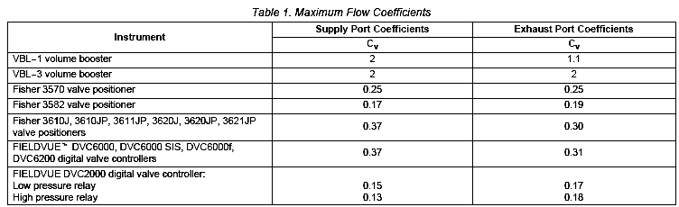

### PRINCIPLE OF OPERATION

One of the main characteristics of boosters is high exhaust capacity. It has rolling diaphragms of the static balancing type to eliminate the effects of off-balancing forces acting on the relatively large inlet & exhaust valve seats. A sensing tube connecting the outlet to the inner diaphragm chamber provides an aspirating effect under high flow conditions to provide additional valve shift.

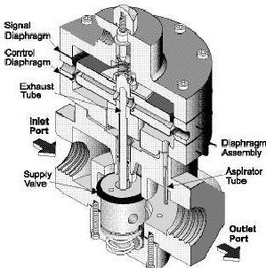

Under equilibrium conditions the signal air acting on the top diaphragm is balanced by the outlet pressure pushing the lower diaphragm. Any imbalance of these forces causes a change in position of the valve plug. Because of the restriction, large input signal changes register on the booster input diaphragm sooner than in the actuator. A large, sudden change in the input signal causes a pressure differential to exist between the input signal and the output of the booster. When this occurs, the diaphragms move to open either the supply port or the exhaust port, whichever action is required to reduce the pressure differential.

The port remains open until the difference between the booster input and output pressures returns to within the dead band limits of the booster. With the bypass restriction adjusted

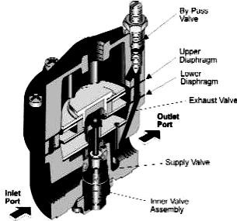for stable operation, signals having small magnitude and rate changes pass through the bypass restriction and into the actuator without initiating booster operation. Both the supply and exhaust ports remain closed, preventing unnecessary air consumption and possible saturation of positioner relays.

### INSTALLATION

* Figures below show typical installations for the VBL volume booster on piston and diaphragm actuators.
* A single regulator that supplies both the positioner and booster is recommended. The supply medium must be clean, dry, oil free air or non-corrosive gas.
* Keep in mind that many actuators require larger casing or cylinder connections to take full advantage of the booster‘s ability to deliver its high− volume output.
* Ensure that the supply pressure is connected to correspond with the flow arrow on the booster.
* Verify that the capacity of the regulator meets the stroking capacity requirements.
* Shut off system pressure to the booster to prevent air from escaping. It is not necessary to remove the booster from the air line.
* Remove the six Screws from the top and bottom of the unit.
* Remove the two Valve Assemblies.
* Wash the Valve Assemblies with a solvent. Exercise care to prevent damage to diaphragms and valve facings. Avoid solvents such as acetone, carbon tetrachloride and trichloroethylene.
* Replace the assemblies carefully. Ensure that the small vents in the Spacer Ring are clear.

### Typical Installation with Piston Actuator

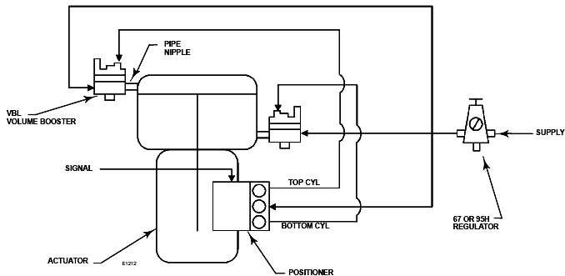

**Typical Installation with Diaphragm Actuator**

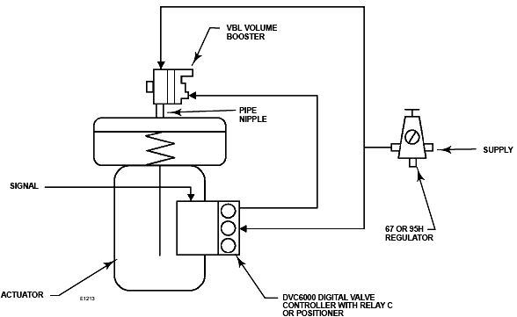

### CALIBRATION

* The volume booster has a bypass restriction adjustment for stable actuator performance.
* A 3 to 9 controller signal should be changed to a 3 to 15 PSIG output signal.

### CONSTRUCTION

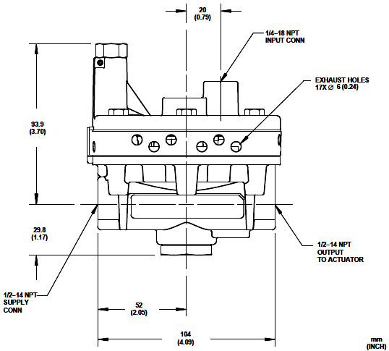**DIMENSIONS**

### EXPLODED VIEW

**CONFORMATION TO STANDARDS**

* Complies with the requirements of ATEX Group II Category 2 Gas and Dust

### APPLICATIONS

* It is ideally suited for a variety of applications including the operation of air systems that require rapid valve or cylinder action.
* For automation or remote controlling of the back pressure or relief operation typically found in tank systems and other pressurized systems.
* To meet most control element requirements
* For Valve and valve actuation systems.
* It is ideally suited for systems that require input isolation or increased forward flow capacity.
* To increase the frequency response of a control valve.

### PARTIAL LIST OF SUPPLIERS

* Fisher Emerson
* Fairchild
* Samson
* Control Air Inc.

RELAYS AND CONTACTORS

### Topic Description Page no

* + - PNEUMATIC RELAY 219
    - FAIL SAFE RELAY 225
    - CONTACTORS 230

**PNEUMATIC RELAYS**

### DESCRIPTION

A relay is a mechanical device that connects one circuit to another. It should be thought of as a switch. The function of a relay is to open or close an electrical contact or a group of contacts in response to a ―signal,‖ which is a change in some electrical condition. The contact closures of +the relay can be used to select other circuits or to turn on or off various devices or operations.

Pneumatic relays are those which are attached to circuits that conduct compressed air rather than a flow of electrons. In these systems, when the presence of compressed air is flowing through one circuit, the force of that energy opens up a switch and begins to flow into a second circuit and there needs to be a sensor present so that the switching can occur.

A pneumatic relay supplies controlled output pressure to a load or utilization device, such as an actuator or a piston, in response to an input signal, a pressure or a force. Pneumatic relays are in common use as field instruments mounted in pipeline systems for controlling the process fluid. In typical pneumatic relay device, a multiple diaphragm assembly includes a pilot diaphragm defining a common wall between a pilot chamber and an exhaust chamber. A supply chamber is coupled or extended from the output chamber and interconnected thereto by a suitable spring-loaded valve assembly.

Pneumatic relays are required to function in either a proportional or an on/off mode.

### SYMBOL

 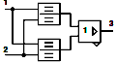

### FIGURE

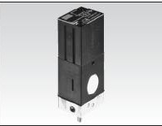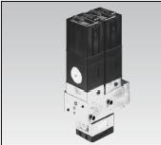

**SPECIFICATIONS**

* + Pressure Rating : 100 psig max.
  + Temp. Limits : -40˚F to +180˚F
  + Port Sizes : Tapped for 1/4‖ NPT with 1/8‖ internal ports
  + Dimensions : 2.5‖ Dia. x 3.5‖
  + Materials Aluminum : Plated Steel, Neoprene, Brass and Stainless Steel
  + Available Capacities : Relays can handle microvolt to kilovolts, microamperes

to kilo amperes, with response speeds from milliseconds to any longer period

* + Power and Frequency : Relays can be actuated by microwatts but usually use

milli watts. They will operate from DC to RF

* + Environmental Limits : Some relays can operate from –50° to 400°F (–45° to

204°C), from vacuum to 400 PSIG (2.8 MPa), and to 100 G shock or vibration

* + Sizes : From 0.03 in.3 (0.47 cc) up

### Snap-acting, Pneumatic Relays Mite Series 70/71/73/74/85

* + Mite Series of pneumatic relays offer precise control of air or gas service.
  + Their snap-acting design automatically trips on either an increasing or decreasing signal.
  + Mites are rugged, compact units engineered for high density applications.
  + They are constructed to last and ―make decisions‖ with crisp precision, cycle after cycle.
  + Mite series of pneumatic relays are engineered to switch, lock or vent various ports based on either an increasing or decreasing pneumatic signal.
  + Their passive design, as well as precise, unerring and immediate decision making abilities make them the ideal solution to critical safety and emergency process controls found in the petroleum, chemical, gas-field or pharmaceutical industries.
  + Their rugged, simple construction provides uncompromising reliability and long term performance with either air or gas service.

### PRINCIPLE OF OPERATION

* Mite series 70 is a Snap-acting control relay with manual reset and it trips to vent one control signal while simultaneously locking up another. It is set to trip on either an increasing or decreasing control signal, the Mite 70 will vent one port to atmosphere while it locks up the pressure in a second line.
* The tripped position is then held indefinitely until the control signal is restored and a manual reset button is pushed. The trip point is adjustable from 1 to 100 psi with a simple screw stem. The Mite 70 can also be tripped on demand from a separate remote signal.
* Use the Mite 70 to open safety valves in emergency situations, trigger an alarm while locking up a valve or actuate diaphragm motor valves, air cylinders or other pneumatic actuators.

### M I T E 7 0 O P E R AT I O N

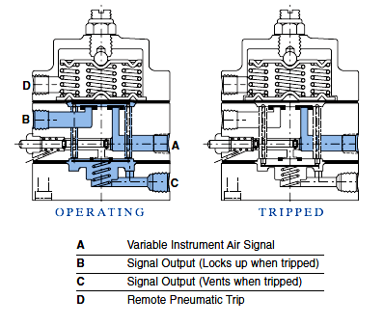

**INSTALLATION**

* The Control Air Precision Air Relay is designed for air service only.
* The Maximum supply pressure is 150 PSI.
* A filter (5 micron is recommended) should be installed ahead of the relay to prevent foreign matter in the air line from affecting the performance of the relay.
* Clean all air lines thoroughly to remove dirt and scale.
* Apply a small amount of compound to the male threads only and install the relay so that flow is in accordance with the IN and OUT ports.
* Make sure all connections are right and that the exhaust vents in the side of the relay are not blocked shut.
* The relay can be mounted in any position without affecting its operation.
* A pressure gauge may be attached to the relay by removing the gauge port plug.

### CALIBRATION

**Procedure for adjustment of bias:**

1. Shut off, or disconnect the pilot-pressure air line.
2. Remove the pipe plug at the top of the relay.
3. Adjust the servo-control capsule by rotating the adjusting screw with a screwdriver.

When viewed from the top:

* 1. Turning the screw clockwise will increase the output pressure relative to any give signal pressure.
  2. Turning the screw counter-clockwise will decrease the output pressure relative to any give signal pressure. The output pressure will change about 7 psi for each quarter turn of the screw.

1. Replace the plug in the top of the relay, making sure it is seated firmly so that it does not leak.
2. Allow the signal pressure to actuate the relay, and verify the output pressure to check your adjustments.
3. The above procedure can be used to ―zero‖ the relay for a direct 1:1 output relative to the signal pressure, or it may be used to provide positive or negative bias to the relay.

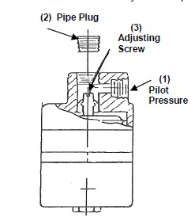

### SELECTION CRITERIA

* + In order for relays to be applied satisfactorily, the relay functions must be clearly understood and relay characteristics must be established.
  + The relay must be selected to fit the need, and the circuitry must be designed to properly couple the relay with the rest of the system. Thus, it is usual to begin the selection process by determining how much energy must be controlled and how much energy is available in the signal that operates the relay.
  + One must also consider the number of contacts needed. It may be necessary to use two cascaded relays, if signal energy is too small, or two paralleled relays to provide enough contacts.
  + Ambient conditions must also be considered.
  + One must answer such questions as whether sealed relays needed, whether there a space
  + Problem, whether there a vibration, shock, or temperature problem etc.

### CONFORMATION TO STANDARDS

* + ISO 9001

### APPLICATIONS

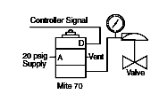

* Actuate an on-off valve when controller signal increases to set point. Supply pressure at ―A‖ is transmitted to valve from ―C‖ when Mite is operating. When trip occurs, valve is vented to atmosphere.
* Close an on-off valve in a gas line when line pressure drops below a set point. Supply pressure at ―A‖ is transmitted to valve from ―C‖ when Mite is operating. When gas line pressure–monitored at ―E‖–drops below set point, trip occurs, and valve operator is vented to atmosphere

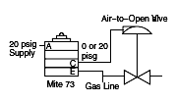

### PARTIAL LIST OF SUPPLIERS

* + Dahl
  + Fair Child
  + Honey Well
  + Ruelco
  + ControlAir Inc
  + Rockwell automation
  + FOXBORO ECKARDT
  + ABB
  + Allied Controls
  + American Relays
  + Barnbrook Systems Ltd.
  + BLP
  + CII
  + CIT Relay
  + Danfoss
  + Daquan Relay Factory
  + Deltrol Corp.
  + Dold Industries, Ltd.
  + Greenwich Electronic
  + Idec

# FAIL SAFE RELAY

### DESCRIPTION

B/W Series 5510 Control Modules were developed especially to provide an intrinsically safe and economical means of detecting and controlling a wide range of processing variables in areas containing explosive atmospheric mixtures. Tested and listed by UL for use in applications involving Class I, II, and III locations, these compact solid-state modules are designed to prevent an external probe or pilot control circuit from releasing sufficient electrical energy to ignite even the most flammable gases or vapors classified in Groups A, B, C, and D, and combustible dusts or fibers classified in Groups E, F, and G.

### FIGURE

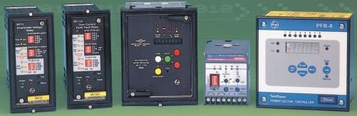

**SPECIFICATIONS**

* + Voltage: 115 or 230 volts AC. 50/60 Hz.
  + Load Contacts: Single pole, double throw.
  + Contact Ratings: 10 amperes resistive load at 277 VAC or 30 VDC; 360va at 240 VAC - pilot duty, 1/3 Hp at 240 VAC, 1/4 Hp at 120 VAC.
  + Power Required: 2 volt - amp, 1.5 watts.

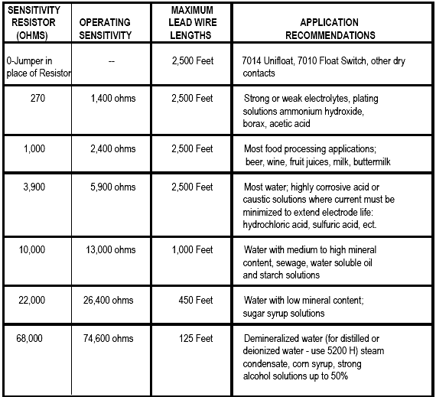

* + Control Circuit Energy: Inherently limited to less than 11.3 milli ampere at 11.3 volts AC to assure intrinsically safe operation under any abnormal fault condition.
  + Module Types and Options -- B/W Series 5510 Module can be supplied for either 120 volt or 240 volt 50/60 Hz. incoming line voltage and can be supplied open chassis or in a NEMA 1, NEMA 4, NEMA 7 or NEMA 12 enclosure.
  + Failsafe Relay Contacts -- The 5510 Module uses two electromechanical relays K1 and K2 for its output contacts in order to provide the most reliable and versatile output functions. One standard module can be used for pump up, pump down, high alarm, or low alarm functions. While providing the necessary control functions, the module can also provide the power failure release for pump or alarm circuits. Load relay K1 is energized when power is first applied to the 5510 Module. Load relay K2 is energized when the sensing circuit is completed. This operation allows load circuits to open or close on power loss to the 5510 Module as needed (i.e. pump circuits open, alarm contacts open or close on loss of power).
  + Module Sensitivity -- Operating sensitivity is important only in level control applications where the module is operated from electrodes and the liquid is used as a conductor to complete the external sensing circuit. Since liquid resistances vary, various operating sensitivities can be field installed. In such applications, the module must have sensitivity greater than the specific resistance of the liquid being controlled. One or two sensitivity resistors of equal value should be selected from the package provided and installed according to the application drawings and chart. When operated from a B/W 7014 Unifloat® multi-level sensing system, 7010 Float Switch or other pilot switching device, a jumper wire (s) is recommended in place of the resistor. Regardless of sensitivity ratings, all B/W Series 5510 Modules are designed to operate continuously with external probe or pilot circuit resistances as low as zero without damaging the module. This permits intrinsically safe operation at all times from electrodes or pilot switches.

### PRINCIPLE OF OPERATION

A customized current limiting transformer is used to convert the incoming line voltage into an 11.3 volt AC sensing circuit. The sensing circuit is comprised of a series of op- amp/comparators which compare the voltage created by the resistance of the liquid to the voltage created by an internal sensitivity resistor. Based on the comparison, the output of the op-amp/ comparator either turns relay K2 on or off through a driving transistor. The AC sensing circuit will minimize electrolysis when used from electrodes for conductive liquid applications. Multiple load relays are used in the design to allow control operations to open pump circuits, or open or close alarm circuits on power failure while maintaining proper functionality. This design feature provides better circuit design at lower cost. A short time delay is designed into the module to eliminate nuisance tripping due to liquid wave action or other quickly cycling inputs.

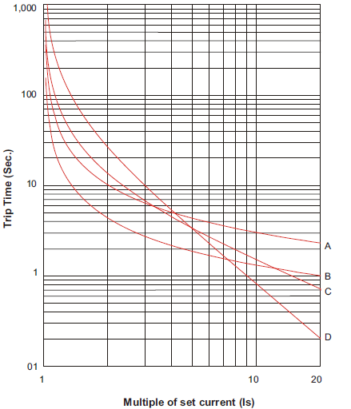

SERVO MOTORS AND MOTION CONTROLLERS

### Topic Description Page no

* SERVO MOTORS 238
* MOTION CONTROLLERS 241

# SERVOMOTORS

### DESCRIPTION

Servo motors are used to control motion in a variety of electro-mechanical industries, from robotics to CNC manufacturing to aerospace technology. Servo motors are part of a closed-loop system, known as a servo motor system**,** that doesn't use a stepper motor. Servo motor systems are comprised of several parts namely a control circuit, servo motor, shaft, potentiometer, drive gears (depending on the type of servomotor), amplifier and either an encoder or resolver. Servo motors must have the ability to:

* operate at a range of speeds without overheating;
* operate at zero speed while retaining enough torque to hold a load in position; and
* operate very low speeds for long periods without overheating. The three basic types of servo motors used in servo motor systems are:
* AC servo motors (based on induction motor designs);
* DC servo motors (based on direct current motor designs); and
* Brushless servo motors (based on synchronous motor designs).

### SYMBOL

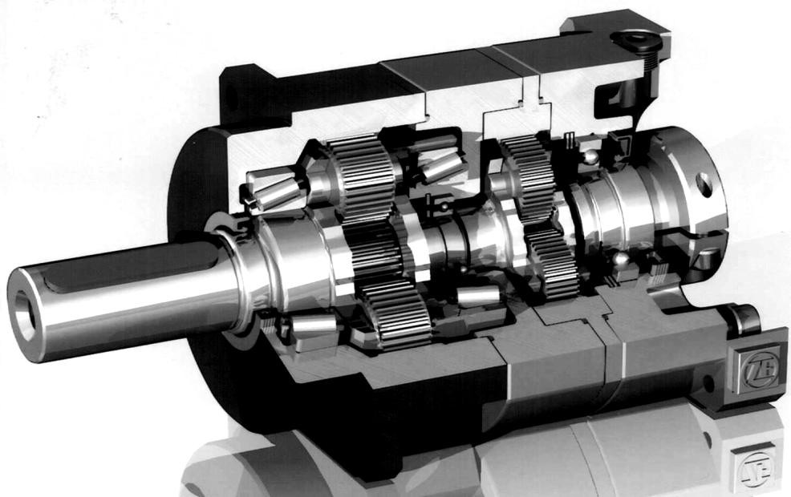**FIGURE**

### SPECIFICATIONS

* Type : DC brush type, permanent magnet field
* Horse Power rating : 6 HP.
* Rated motor voltage : 150 V (DC).
* Rated motor current : 80 Amp (Continuous).
* Rated motor speed : 2250 rpm.
* Continuous stall torque: 47 N-m.
* Peak Torque : 111 N-m.
* Torque Sensitivity : 0.56 N-m / Amp.
* Back E.M.F. Constant: 59 V / krpm.
* Armature resistance : 0.045 Ohm.
* Armature inductance : 0.33 mH.
* Tacho sensitivity : 17 V / krpm.

### PRINCIPLE OF OPERATION

The servomotors used in industry today are used in a closed-loop servo system. To under- stand how the servomotor is used in the system, it is first necessary to review the entire system. Figure indicates a block diagram of a typical servo system.

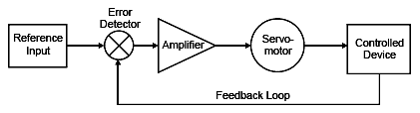

*Typical servo system block diagram*

A reference input (typically called a velocity input) is sent to the servo amplifier, which controls the speed of the servomotor. Directly mounted to the machine (or to the servomotor) is a feedback device (either an encoder or resolver). This device changes mechanical motion into electrical signals and is used as a *feedback loop*. This feedback loop is then sent to the *error detector*, which compares the actual operation with that of the reference input. If there is an error, that error is fed directly to the amplifier, which makes the necessary corrections. The servo has a 3 wire connection: power, ground, and control. The power source must be constantly applied; the servo has its own drive electronics that draw current from the power lead to drive the motor. The control signal is pulse width modulated (PWM), but here the duration of the positive-going pulse determines the position of the servo shaft

Servo motors are used in closed loop control systems in which work is the control variable. The ability of the servo motor to adjust to differences between the motion profile and feedback signals depends greatly upon the type of controls and servo motors used.

* Three basic types of servo motors are used in modern servo systems:

1. ac servo motors, based on induction motor designs;
2. dc servo motors, based on dc motor designs; and
3. ac brushless servo motors, based on synchronous motor designs.

Ac servo motors are used in servo systems that move light loads. Large ac motors are too inefficient for servo use when large loads are to be moved. Large ac motors are too inefficient for servo use. To move large loads, the ac motor draws excessive amounts of

power, and is difficult to cool. Hence, ac servo motors are used primarily to move light loads. Most of the ac servo motors are of the two-phase or split-phase induction type. Fundamentally, these motors are constant-speed devices, although their speeds can be varied within limits by varying the amplitude of the voltage to one of the motors stator windings.

Dc servo motors are used when the load becomes heavy; the workhorse dc servo motor can control heavy loads, and are widely used in servo systems. The speed and direction of the dc servo motor can be varied easily by varying the armature current.

### AC SERVO MOTORS

* The principle of rotating magnetic fields is the key to the operation of most ac motors. Both synchronous and induction types of motors rely on rotating magnetic fields in their stators to cause their rotors to turn.
* A magnetic field in a stator can be made to rotate electrically, around and around. Another magnetic field in the rotor can be made to chase it by being attracted and repelled by the stator field. Because the rotor is free to turn, it follows the rotating magnetic field in the stator.
* Rotating magnetic fields may be set up in two-phase or three-phase machines. To establish a rotating magnetic field in a motor stator, the number of pole pairs must be the same as (or a multiple of) the number of phases in the applied voltage. The poles must then be displaced from each other by an angle equal to the phase angle between the individual phases of the applied voltage.

### Two-Phase Rotating Magnetic Field

* A rotating magnetic field is probably most easily seen in a two-phase stator. The stator of a two- phase induction motor is made up of two windings (or a multiple of two). They are placed at right angles to each other around the stator. The simplified drawing in figure illustrates a two-phase stator.

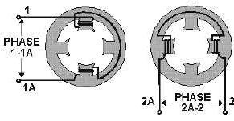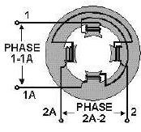

* To analyze the rotating magnetic field in a two-phase stator, refer to next figure.
* The arrow represents the rotor. For each point set up on the voltage chart, consider that current flows in a direction that will cause the magnetic polarity indicated at each pole piece. Note that from one point to the next, the polarities are rotating from one pole to the next in a clockwise manner. One complete cycle of input voltage produces a 360-degree rotation of the pole polarities

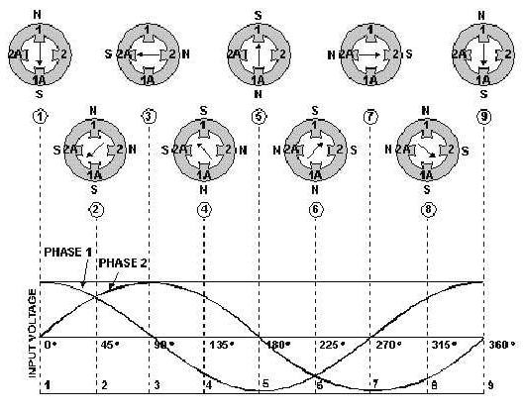

### Three-Phase Rotating Fields:

* The three-phase induction motor also operates on the principle of a rotating magnetic field. Figure, views A-C show the individual windings for each phase. Figure, view D, shows how the three phases are tied together in a Y-connected stator. The dot in each diagram indicates the common point of the Y-connection. You can see that the individual phase windings are equally spaced around the stator. This places the windings 120º apart.

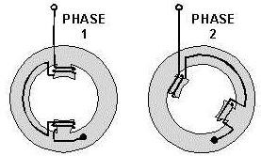 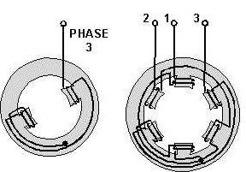

* The three-phase input voltage to the stator of figure is shown in the graph of this figure below. Use the left-hand rule for determining the electromagnetic polarity of the poles at any given instant. In applying the rule to the coils in the previous figure, consider that current flows toward the terminal numbers for positive voltages, and away from the terminal numbers for negative voltages.

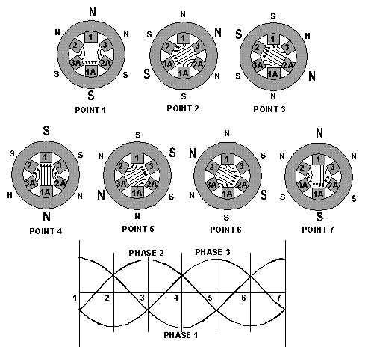

### DC SERVO MOTORS

* The control characteristics of dc servo motors are superior to those of ac servo motors. The dc servo motor can control heavy loads at variable speeds.
* Most dc servo motors are either the permanent magnet type, which are used for light loads, or the shunt field type, which are used for heavy loads.
* The direction and speed of the dc motor's rotation is determined by the armature current. An increase in armature current will increase the motor's speed. A reversal of the motor's armature current will change the motor's direction of rotation.
* Typical dc servo motor system with either encoder or resolver feedback. Some older servo motor systems use a tachometer and encoder for feedback.
* The digital servo motor controller directs operation of the servo motor by sending velocity command signals to the amplifier, which drives the servo motor.
* An integral feedback device (resolver) or devices (encoder and tachometer) are either incorporated within the servo motor or are remotely mounted, often on the load itself. These provide the servo motor's position and velocity feedback that the controller compares to its programmed motion profile and uses to alter its velocity signal.

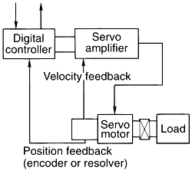

### BRUSHLESS MOTORS:

* Brushless motors are similar to AC motors since a moving magnet field causes rotor movement. Brushless motors are also similar to PM DC motors since they have predicable linear characteristics.
* Within the brushless category are two basic motor types: trapezoidal and sine wave motors.
* The trapezoidal motor is really a brushless DC servo, whereas the sine wave motor bears a close resemblance to the AC synchronous motor.
* To turn this motor into a brushless design, we must start by eliminating the windings on the rotor. This can be achieved by turning the motor inside out.
* In other words, we make the permanent magnet the rotating part and put the windings on the stator poles.
* We still need some means of reversing the current automatically – a cam-operated reversing switch could be made to do this job (Fig.).

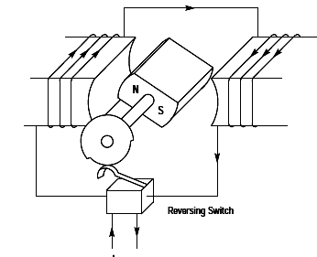

* Obviously such an arrangement with a mechanical switch is not very satisfactory, but the switching capability of non-contacting devices tends to be very limited.
* However, in a servo application, we will use an electronic amplifier or drive which can also be used to do the commutation in response to low-level signals from an optical or hall-effect sensor (see Fig).
* This component is referred to as the commutation encoder.

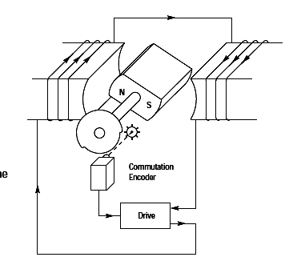

* A typical brushless motor has either two or three sets of coils or ―phases‖ (see Fig).
* The motor shown in Fig. is a two-pole, three-phase design. The rotor usually has four or six rotor poles, with a corresponding increase in the number of stator poles.
* This doesn‘t increase the number of phases—each phase has its turns distributed between several stator poles.

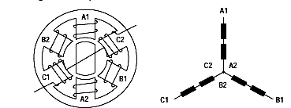

### The Sine Wave Motor

* In the sine wave motor (sometimes called an AC brushless servo), no attempt is made to modify the basic sinusoidal torque characteristic.
* By applying a constant current to one winding of a three phase motor, a torque is generated.
* Since the winding distribution is sinusoidal, torque is not distributed evenly as the shaft is rotated through 360 degrees. As shown, the resulting torque generated is a function of the shaft angular position.

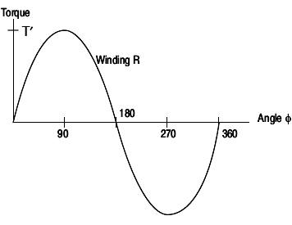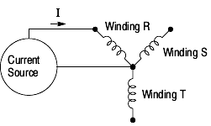

### The Trapezoidal Motor

* With a fixed current level in the windings, the use of this extended portion of the sinusoidal torque characteristic gives rise to a large degree of torque ripple.
* We can minimize the effect by manipulating the motor design to ―flatten out‖ the characteristic –to make it trapezoidal, (Fig.).
* In practice, this is not very easy to do, so some degree of non-linearity will remain.

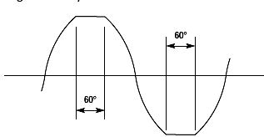

### INSTALLATION

**Connection:** To connect the servo motor to the input signal and the power supply:

* Connect the red lead of the servo motor to the positive voltage on the separate 5V power supply
* Connect the black lead of the servo motor to 0V on both the power supply for the electronics and the separate power supply
* Connect the blue lead of the servo motor to the input signal (providing the stream of pulses).

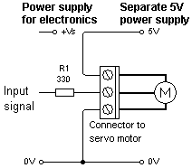

Before connecting the servo motor, use a multi meter to check that the terminal on the connector that will be connected to the:

1. Red lead to the servo motor is at +5V;
2. Black lead to the servo motor is at 0V.

### APPLICATIONS

* Servomechanisms were first used in military fire-control and marine navigation equipment.
* Today servomechanisms are used in automatic machine tools, satellite-tracking antennas, remote control airplanes, automatic navigation systems on boats and planes, and antiaircraft-gun control systems.
* Other examples are fly-by-wire systems in aircraft which use servos to actuate the aircraft's control surfaces, and radio-controlled models which use RC servos for the same purpose.
* Many auto focus cameras also use a servomechanism to accurately move the lens, and thus adjust the focus. A modern hard disk drive has a magnetic servo system with sub- micro meter positioning accuracy.

### PARTIAL LIST OF SUPPLIERS

* Metronix
* Parker Hannifin
* Penton
* Mclennan
* Sanwa
* Fanuc
* [Allen Bradley](http://www.tigertek.com/allen-bradley-servo-repair.html)
* [Bosch, Indramat & Rexroth](http://www.tigertek.com/bosch-servo-motor-repair.html)
* [Siemens](http://www.tigertek.com/siemens-servo-motor-repair.html)
* [Lenze](http://www.tigertek.com/lenze-servo-motor-repair.html)

**DESCRIPTION**

# MOTION CONTROLLERS

Motion control is a sub-field of [automation,](http://en.wikipedia.org/wiki/Automation) in which the position and/or velocity of machines are controlled using some type of device such as a hydraulic pump, linear actuator, or an [electric motor](http://en.wikipedia.org/wiki/Electric_motor), generally a [servo.](http://en.wikipedia.org/wiki/Servomechanism) Motion control is widely used in the packaging, printing, textile, [semiconductor production](http://en.wikipedia.org/wiki/Semiconductor_device_fabrication), and assembly industries. The **motion controller** is the heart of a motion control system. A **motion controller** [controls](http://en.wikipedia.org/wiki/Motion_control) [the motion](http://en.wikipedia.org/wiki/Motion_control) of some object. Frequently motion controllers are [implemented](http://en.wikipedia.org/wiki/Implementation) using digital [computers,](http://en.wikipedia.org/wiki/Computers) but motion controllers can also be implemented with only [analog](http://en.wikipedia.org/wiki/Analog_computer) components as well. Motion control provides high-level functions so you can efficiently implement custom applications based on building blocks to create solutions for common tasks like precise positioning, synchronization of multiple axes, and movement with defined velocity, acceleration, and deceleration. Motion tasks are usually mission-critical and often operate machines that could harm humans around them. Motion controllers are used to achieve some desired benefit(s) which can include:

* increased position and speed [accuracy](http://en.wikipedia.org/wiki/Accuracy)
* higher speeds
* faster [reaction time](http://en.wikipedia.org/wiki/Reaction_time)
* increased [production](http://en.wikipedia.org/wiki/Production%2C_costs%2C_and_pricing) and reduction in costs
* smoother movements
* [integration](http://en.wikipedia.org/wiki/Digital_integration) with other [automation](http://en.wikipedia.org/wiki/Automation)
* [integration with other processes](http://en.wikipedia.org/wiki/System_integration)
* ability to convert desired specifications into motion required to produce a product
* increased information and ability diagnose and [troubleshoot](http://en.wikipedia.org/wiki/Troubleshoot)
* increased consistency and improved efficiency
* elimination of hazards to humans or animals

### FIGURE

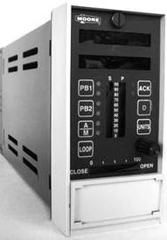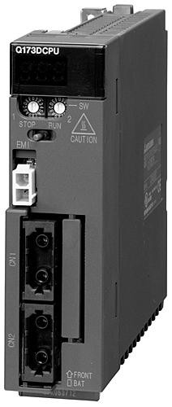

*Moore 353Process Automation Controller Mitsubishi Q172D motion controllers*

### SPECIFICATIONS

* + Model No.: 353A4F1NNLNNNAX
  + P/N No.:16353-222
  + Serial No. : 01559621

### Typical Input and Output Capacity:

* + Xmtr.Power.Supply.Out. - 25V @ 120 mA
  + Analog input voltage. - 0 to 5 Vdc @ 30uA
  + Analog output current. - 4 to 20 mA @ 800 Ohms
  + Digital input voltage. - 0 to 30 Vdc @ 5 mAdc
  + Digital output current. - 100 mA @ 30 Vdc
  + Rly. Out. - 5A @ 120V, 2.5A @ 240 Vac
  + Max. Ambient Temp - 50°C

### Power input requirements

* Voltage Input - 85-264 Vac, 47-63 Hz
* AC power ride through time - 25 msec. (minimum)
* Power - 25 Watts, 40 VA (maximum)
* Wire Size, Recommended - 18 AWG (0.96 mm2)
* Rear Terminals - H - Hot; N - Neutral; G - Ground, Green Screw
* Over-current Protection - 20A maximum fuse or circuit breaker

### MPU controller board specifications

Analog Inputs:

* Input Range -0-5 Vdc (standard calibration 1-5 Vdc)
  + Zero - 0-1 Vdc
  + Span - 4-5 Vdc
  + Type - Single ended
  + Accuracy - 0.10 %
  + Resolution - 0.024 %
  + Software Output Type - Analog [configurable (default 0.0-100.0)]
  + Normal Mode Rejection - >50dB @ 60Hz.
  + Input Impedance - >1 mega ohm
  + Maximum Continuous Input - Without Crosstalk: +7, -30 Vdc

- Without Damage: ±30 Vdc

Analog Outputs:

* + Standard Calibration - 4-20 mAdc
  + Zero - 4 mAdc +/- trim
  + Span - 16 mAdc +/- trim
  + Current Limits - 2.4 mA to 21.6 mA
  + Accuracy - 0.1%
  + Resolution - 0.003%
  + Software Input Type - Analog [configurable (default 0.0-100.0)]
  + Signal Reference - Neg. (-) output tied to station common
  + Output Load - 800 Ohms
  + Over-voltage Protection - 30 Vdc Digital Inputs:
  + Logic ―1‖ Range - 15-30 Vdc
  + Logic ―0‖ Range - 0-1 Vdc
  + Over-voltage - +/-30 Vdc
  + Minimum Required ON time - >Scan Time
  + Software Output Type - Digital
  + Isolation - 100 Vdc Digital Outputs:
  + Type - Open Collector Transistor (emitter tied to common)
  + Load Voltage - +30Vdc maximum
  + Load Current - 100 mA maximum
  + Off State Leakage Current - < 200 uA @ 30 Vdc
  + Transmitter Power - 25 Vdc +/-3V, 120 mA, short circuit protected
  + The Moore 353 motion controllers offers the control system designer the ultimate in flexibility and capability for the implementation of continuous solutions and batch solutions.
  + At the heart of the Moore 353 is a powerful MPU Controller board that uses the latest in microprocessor technology. It includes on-board I/O and reusable function blocks, and it is capable of solving a vast array of control implementations including single loop, cascade, and dual loop. Available MPU board I/O is listed in the table below.

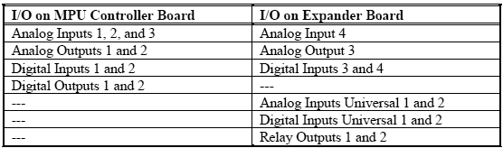

* + The controller can be completely configured from the operator faceplate or, as mentioned above, configured remotely using i|config™, the optional PC-based Graphical Configuration Utility. An optional Real Time Clock/Configuration Board (RTC/CB) is available to quickly transfer a configuration from one controller to another when downloading a configuration over a network is not available. The RTC/CB also provides a real time clock function**.**

***Network communication options are listed in the following table.***

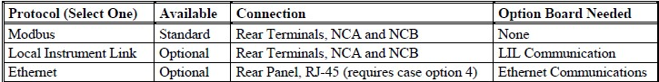

### PRINCIPLE OF OPERATION

Motion control is an industry term used to describe a range of applications that involve movement with varying degrees of precision. Many motion control applications require only that an object be moved from one place to another with limited concern for acceleration, deceleration, or speed of motion. On the opposite extreme are machine tool applications which require the precise coordination of all aspects of motion, including a high degree of coordination for multiple simultaneous movements.

*Axis:* Single-axis motion involves controlling one rotational axis. This is typically a motor shaft that can be driven forward or reverse. Mechanisms are often used to translate the rotational motion into linear motion. Multi-axis control involves control of multiple rotational axes, each of which could be converted into linear motion. Some applications require the control of multiple axes, with each axis operating independently. Other applications require varying degrees of coordination for multiple axes ranging from synchronizing the start of motion control for multiple axes to the highly coordinated multiple-axis control required for machine tool applications.

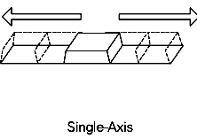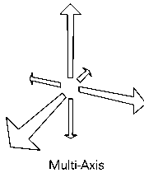

### Motion Control System Components

The following diagram illustrates the essential components of a motion control system.

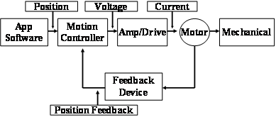

*The motion controller is the heart of the motion control system.*

Motion controllers require a load (something to be moved), a [prime mover](http://en.wikipedia.org/wiki/Prime_mover) (something to cause the load to move), some [sensors](http://en.wikipedia.org/wiki/Motion_sensor) (to be able to sense the motion and monitor the prime mover), and a controller to provide the [intelligence](http://en.wikipedia.org/wiki/Artificial_intelligence) to cause the prime mover to move the load as desired.

### INSTALLATION

**Installation considerations**

* + Motion controller is intended for flush panel mounting in a vibration free instrument panel or rack in an indoor or sheltered location. Mount a single controller in a single-station panel cutout or mount several controllers in a row in a multiple-station panel cutout.
  + For a watertight panel, mount each controller in a single-station cutout. Controllers have been supplied with either ―direct entry connectors‖ or ―side entry connectors.‖ Connector types, panel cutout dimensions, and overall controller dimensions are shown in Mechanical installation.
  + The controller can be mounted in a user-supplied enclosure located out-of-doors or in a location whose environmental parameters exceed controller operating specifications. A thin bead of silicon sealant is often applied between the controller‘s Display Assembly and the mounting panel to prevent air or liquid leakage at this joint.
  + Do not mount the controller where direct sunlight can strike the faceplate or case. Direct sunlight can make the displays difficult to read and will interfere with heat dissipation
  + Mount the controller either horizontally or with a backward tilt (i.e. the front of the case higher than the rear). If the controller is to be mounted with some electronic recorders or with pneumatic recorders or stations, tilt back restrictions for these units can have a bearing on panel design and layout.
  + Route electrical power to the controller through a clearly labeled circuit breaker, fuse, or on-off switch that is located near the controller and is accessible by the operator. The breaker or switch should be located in a non-explosive atmosphere unless suitable for use in an explosive atmosphere.
  + Thermocouple inputs are accommodated with an I/O Expander board and a Reference Junction temperature sensor. At the factory, two Reference Junctions are included in a Range Resistor and Reference Installation Kit.

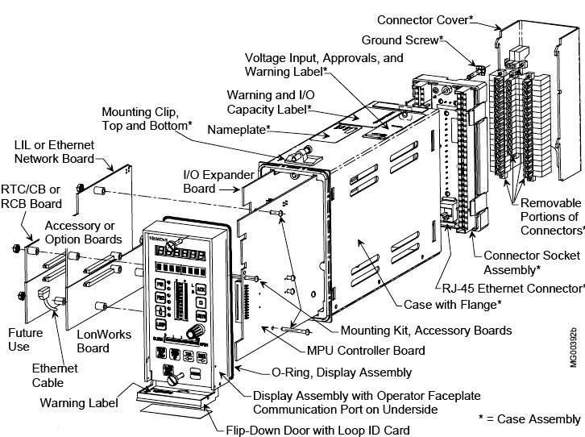

***Moore 353 motion controller, Exploded View***

### Environmental considerations

* Operate a controller within its environmental specifications to help ensure reliable, trouble-free operation with minimum down time.
  + TEMPERATURE: Keep the air surrounding an operating controller below 50°C (122°F). Check air temperature periodically to ensure that this specification is not being exceeded.
  + Forced air ventilation is recommended when controllers are mounted in a partially or completely enclosed panel or cabinet (e.g. NEMA 1); as shown at right. When clean air is present, exhaust fans are often mounted across the top of a panel and louvers formed in the panel bottom. Air is then drawn upward between the station cases. When air contains particulate matter, fans and filters are generally located at the panel bottom and louvers at the top. Filtered air is now forced upward between the station cases. Filters must be serviced periodically.

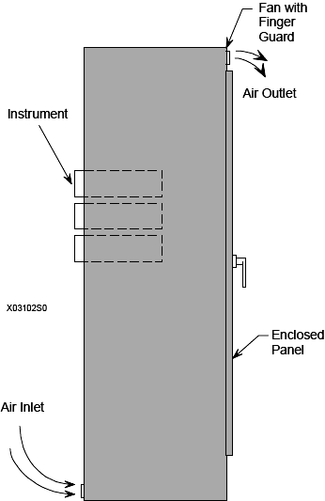

***Forced Air Ventilation for Enclosed Panels***

* + CONTAMINANTS: The controller case is slotted to permit circulation of clean cooling air. Liquids and corrosive gases must not be allowed to enter the case. Although 353 boards have a protective coating, the following steps can reduce contaminant related equipment malfunctions:
  1. Identify contaminants and implement methods to reduce their presence. 2.Install protective housing for field mounted controllers.

1. When cleaning equipment and surrounding area, especially the floor, either vacuum away all dust and dirt or use a dampened rag or mop. Sweeping or dry dusting recirculates dust and dirt.
2. Clean or replace all air conditioning filters, room air filters, and equipment filters regularly.
3. Inform all personnel with access to the equipment of the need for cleanliness

### Mechanical Installation

* The following subsections provide guidelines and procedures for mounting controllers in a panel or rack. The installation should be structurally rigid and the controllers should be squared in the panel or rack.
  + There are two case connector styles: direct entry and side entry13. To identify the connector style on a case, refer to the following table. Both styles have the same terminal functions and numbers. For example, Station/Transmitter Common is terminal 6 on the side entry and direct entry connectors. Circuit boards mate with either connector style (Refer the table following).

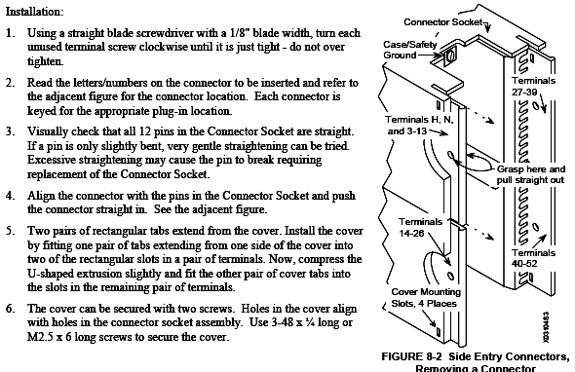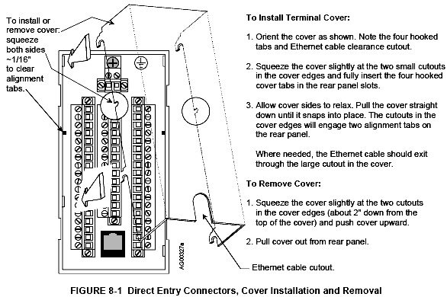

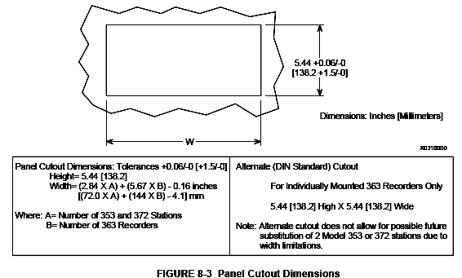

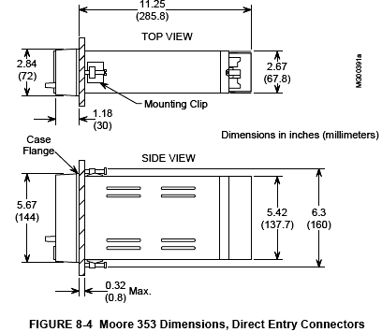

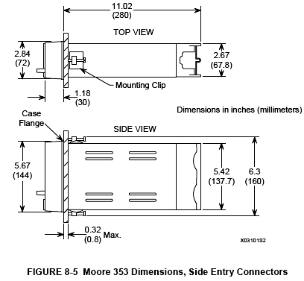

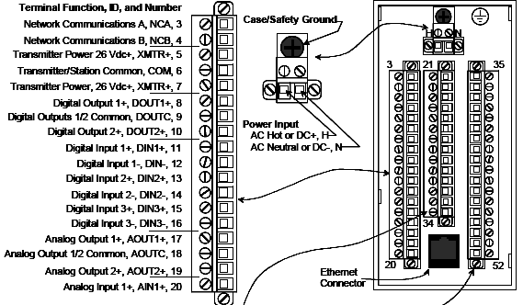

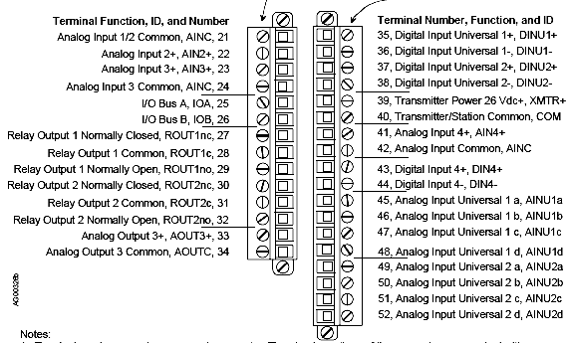

### CALIBRATION

* + A controller is factory calibrated to either the standard values listed specified by the purchaser at time of order. Field calibration should not be necessary. For those cases where inputs or outputs must be adjusted either to meet a local standard or for a more critical application, a field calibration can be performed. The field calibration becomes the default calibration.
  + A CAL VIEW mode is available in calibration to view the sensor input over the full range. The signal that is viewed, in the calibration verify mode, is 0 to 100% of span in basic units of measure (e.g., °C for temperature, mv for milli volts) and is not affected by the temperature units conversion, digital filter, scaling, or the output bias adjustment. The full block output in engineering units with these parameters applied can be seen in the VIEW mode within loop configuration.

### Calibration and calibration verification of the following function blocks:

* + AIN1-4 - Analog Input MPU board (3) and I/O Expander board (1)
  + AOUT1-3 - Analog Output MPU board (2) and I/O Expander board (1)
  + When field calibrating a controller for a critical application, consider the following:
* If the input is a current signal (e.g., 4-20 mA), use a precision current source. The

250 ohm precision range resistor installed across the input terminals for calibration should remain with the station, connected across that set of terminals, to eliminate the voltage drop variation due to resistor tolerance.

* Allow the Station to warm-up for an hour prior to calibration. The ambient temperature should be close to normal operating conditions. The controller must be off-line during calibration.

### ANALOG INPUT (AIN1-4)

Analog input function blocks have been factory calibrated for 1 to 5 Vdc inputs. Recalibration should not be required unless calibration parameters are to be changed. Periodic recalibration should not be necessary. To calibrate an analog input, use the following procedure**.**

1. At the controller‘s rear terminals, connect an electronic calibrator or precision reference source capable of supplying a voltage between 0.000 and 5.000 Vdc to the selected analog input terminals (e.g. AIN1 or AIN2). Ensure that terminal screws are tight.

2. If security is enabled, a level 1 or level 4 security combinations will be needed to store the results of a calibration.

3. Apply power to the station.

4. Press the ENTER CONF button to enter the configuration mode at the MENU level. Rotate the Pulser Knob to select ‗STATION‘ on the alphanumeric (lower) display.

5. Press the STEP DOWN button to choose options at the station level and rotate the Pulser Knob to select ‗CAL‘ on the alphanumeric display.

6. Press the STEP DOWN button to enter the FUNCTION BLOCK level. Rotate the Pulser Knob to select the desired input (e.g. AIN1 or AIN2).

7. Press the STEP DOWN button to enter the PARAMETER level.

8. Rotate the Pulser Knob to select the desired parameter, CAL ZERO, shown on the alphanumeric display.

9. Press the STEP DOWN button to enter the VALUE level (‗CAL‘ appears on upper display).

10. Set the precision voltage source to the zero input value (0.000 to 1.000 Vdc).

11. Press STORE to lock-in the desired value. If ENTER COM appears in the alphanumeric display, security is enabled and steps 1) through 5) must be performed to store the calibration. Otherwise, go to step 12.

1) The numeric display shows 000000 with the right-most digit flashing. Rotate the pulser knob to set the units digit to the correct number.

2) Press the TAG/← key to select the next digit, the tens digit. Rotate the pulser knob to select a number for that digit.

3) Move to and select the needed number for each remaining digit.

4) Press ENTER. If combination entered is incorrect, ―ACCESS/ DENIED‖ will be displayed and controller will return to the parameter level. Otherwise, go to step 12

12. Press the STEP UP button. Rotate the Pulser Knob to select the ‗CAL FULL‘ parameter.

13. Press the STEP DOWN button to enter the VALUE level (‗CAL‘ appears on upper display).

14. Set the voltage source to the full scale input value (4.000 to 5.000 Vdc).

15. Press STORE.

16. For verification perform the following steps:

1) Press STEP UP button. Rotate Pulser Knob to select ‗CAL VIEW‘ parameter.

2) Press STEP DOWN button to enter VALUE level. Set precision voltage source to zero input voltage. The display should read 0%.

3) Set source to full scale voltage. The display should read 100%.

17. If all points have been calibrated and verified, press EXIT button to leave the calibration mode and enter the operation mode. If additional function blocks are to be calibrated and verified, press the STEP UP button to enter the FUNCTION BLOCK level. Perform steps 2-16 for each function block.

If security is enabled, exiting the configuration mode will lock out the calibration mode until the security combination is re-entered

### ANALOG OUTPUT (AOUT1-3)

Analog output function blocks have been factory calibrated to 4-20 mAdc outputs. If recalibration is necessary use the following procedure.

1. At the controller‘s rear terminals, connect an electronic calibrator or digital multimeter capable of displaying 4.00 and 20.00 mAdc to the selected analog output terminals (AOUT1 or AOUT2)

2. If security is enabled, a level 1 or level 4 security combinations will be needed to store the results of a calibration.

3. Apply power to the station.

4. Press the ENTER CONF button to enter the configuration mode at the MENU level.

5. Rotate the Pulser Knob to select ‗STATION‘ on the alphanumeric (lower) display.

6. Press the STEP DOWN button to choose options at the station level and rotate the Pulser Knob to select ‗CAL‘ on the alphanumeric display.

7. Press the STEP DOWN button to enter the FUNCTION BLOCK level. Rotate the Pulser Knob to select the desired output (e.g. AOUT1).

8. Press the STEP DOWN button to enter the PARAMETER level. Rotate the Pulser Knob to select the desired parameter, CAL ZERO, shown on the alphanumeric display

9. Press the STEP DOWN button to enter the VALUE level (‗CAL‘ appears on display).

10. Rotate the Pulser Knob to set the zero output to 4.00 mA on the digital multimeter or electronic calibrator.

11. Press the STORE button to lock-in the desired value. (If ―ENTER COM‖ appears in the alphanumeric display, go to Section 12.1, step 13 for entering a level 1 or level 4 security combinations.)

12. Press the STEP UP button. Rotate the Pulser Knob to select the ‗CAL FULL‘ parameter*.*

13. Press the STEP DOWN button to enter the VALUE level (‗CAL‘ appears on display).

14. Rotate the Pulser Knob to set the full scale output to 20.00 mA.

15. Press STORE.

16. For verification perform the following steps:

1) Press STEP UP button and rotate Pulser Knob to select ‗CAL VIEW‘ parameter.

2) Press STEP DOWN button to enter VALUE level.

3) Rotate Pulser Knob to set display to 0.0%. Output current should be 4.00 mA.

4) Rotate Pulser Knob to set 100.0%. Output current should be 20.00 mA.

17. If all points have been calibrated and verified, press EXIT button to leave calibration mode and enter operation mode. If additional function blocks are to be calibrated and verified, press STEP UP button to enter FUNCTION BLOCK level. Perform steps 2-16 for each function block.

If security is enabled, the exiting the configuration mode will lock out the calibration mode until the security combination is re-entered.

### SELECTION CRITERIA

(As per the specifications mentioned above)

### CONFORMATION TO STANDARDS

* EN 50081-1:1992 electro magnetic compatibility – generic emission standard- part 1: residential, commercial and light industry
* EN 61000-6-2:1999 electro magnetic compatibility (EMC) – part 6-2: generic standards-immunity for industrial environments
* EN 61010-1:1993 safety requirements for electrical equipment for measurement, control and laboratory

### APPLICATIONS

* + Automated Test
  + Machines and Manufacturing
  + Medical
  + Research

### PARTIAL LIST OF SUPPLIERS

* + Siemens
  + Fanuc
  + Mitsubishi
  + Rockwell
  + Bosch
  + Rexroth Indramat
  + National Instruments
  + Emerson